Learning Sequence 3 – Preparing for Flood

Outcomes
- GE2-2 describes the ways people, places and environments interact
- GE2-4 acquires and communicates geographical information using geographical tools for inquiry

Inquiry questions
- How will we prepare for a flood?
- What do we need to take if we have to evacuate?
- How can we help keep ourselves and our animals safe?
- Know when to act

Learning intention
We are learning to process and communicate geographical information about people’s interactions with places and environments.

Geographical tools
- VISUAL REPRESENTATIONS – photographs, videos, icons, drawings

Introduction
“The community needs to know their flood risk as they have an important role to play in getting ready for future floods.”
Laura Wythes, then metro Zone Commander, NSW SES, September 2019 https://www.ses.nsw.gov.au/news/all-news/2019/the-risk-of-flood-is-real-in-the-hawkesbury-nepean-valley-do-you-know-your-flood-risk/
Floods can occur in any year, and sometimes without much warning. The community needs to be prepared. People need to know their flood risk, plan for flooding and evacuation, prepare emergency kits and know when to act in a flood emergency. There was a major flood in the Hawkesbury-Nepean Valley in 1990, and in February 2020 rainfall brought minor to moderate flooding to the valley, reaching 9.3 metres at Windsor. This flood is described as having a likelihood of approximately 1 in 5 (20%) chance per year – or virtually a 100% chance of happening at least once in an 80-year lifetime. The 1990 flood had about a 1 in 20 chance per year (5%) and rose more than four metres higher at Windsor. The largest flood on record in 1867 had about a 1 in 500 (0.2%) chance per year and peaked more than 10 metres higher at Windsor than the February 2020 event.
The teaching and learning activities in Learning Sequence 3 draw on students’ understanding of the characteristics of major flood events in particular the Hawkesbury-Nepean region developed in Learning Sequences 1 and 2. In this ‘respond and communicate’ step of the geographical inquiry process, students outline preparedness steps for a flood emergency and use video to communicate flood preparedness information.

Background notes for teachers
Refer to:
- Hawkesbury-Nepean Valley Regional Flood Study July 2019 Overview http://www.infrastructure.nsw.gov.au/media/2162/ec_insw_hawkesbury-nepean_fss-document_web.pdf
- Keeping Your Animals Safe in an Emergency – in the Hawkesbury Nepean Valley https://www.ses.nsw.gov.au/media/3173/keeping-your-animals-safe-in-an-emergency.pdf
- Geography K-10 Syllabus © 2015 NSW Education Standards Authority (NESA) for and on behalf of the Crown in right of the State of New South Wales https://educationstandards.nsw.edu.au/wps/portal/nesa/k-10/learning-areas/hsie/geography-k-10
- The NSW Government released Resilient Valley, Resilient Communities – Hawkesbury- Nepean Valley Flood Risk Management Strategy (Flood Strategy) in May 2017. The Flood Strategy details how the NSW Government, local councils, businesses and the community work together to reduce and manage the flood risk in the Hawkesbury-Nepean Valley. One of the actions in the Flood Strategy was to prepare a new regional flood study for the valley. This was published in July 2019 as three comprehensive documents plus an overview document (http://www.infrastructure.nsw.gov.au/media/2162/ec_insw_hawkesbury-nepean_fss-document_web.pdf) summarising the key findings for the community. A series of factsheets focusing on key areas was also published. These are available on the NSW SES website https://www.ses.nsw.gov.au/hawkesbury-nepean-floods
- Although this unit looks at flooding and the impacts it may have on individuals, families and communities, much of the information in this section is relevant to other natural disasters such as bushfires.
- More useful background information can be found on the Bureau of Meteorology website (www.bom.gov.au). This includes maps, radar and weather warnings.

Activity 3.1 – Planning for Floods

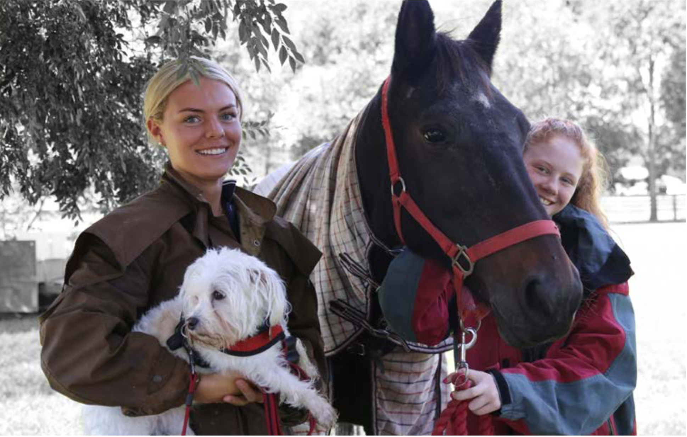
Image used in the NSW SES booklet, Keeping Your Animals Safe in an Emergency – in the Hawkesbury Nepean region https://www.ses.nsw.gov.au/media/3173/keeping-your-animals-safe-in-an-emergency.pdf
Approximate time required: 20 minutes (+ 1 hour if adding Red Cross Pillowcase Project)

Processing geographical information
- Pose the questions: How will we prepare for a flood? How can we help keep ourselves and our animals safe?
- View the photograph of the pet owners with their animals. Make connections: text-to-self, text-to-text, text-to-world. How could the dog and horse be moved to safety if there was a flood? What items would they need? Where could they go? What else would need to be planned and prepared for the pets in the picture? What about other types of pets such as cats, birds, fish?
- Brainstorm ways people and families should prepare for a flood. Identify the jobs or roles the students could undertake to help with their parent’s or carer’s plans and preparations. For instance, being responsible for planning what precious possessions they would take, collecting some clothes and school needs, loading pets into carry cases, collecting emergency pet kits.
- Incursion suggestion: Red Cross pillowcase project. This free one-hour session presented by members of the Red Cross encourages children to plan and contents of their pillowcase, should they need to evacuate.
- Read the NSW SES How to Prepare list https://www.ses.nsw.gov.au/hawkesbury-nepean-floods
- Students read page 3 of Keeping Your Animals Safe in an Emergency – in the Hawkesbury Nepean region https://www.ses.nsw.gov.au/media/3173/keeping-your-animals-safe-in-an-emergency.pdf (Many actions in the list also apply to people without animals.) Review and amend the brainstormed ideas.
- Students complete Worksheet 7 – Being prepared for floods.

Terminology
- Plan, prepare, emergency, risk, relocate, evacuate, responsible, rescue, warnings.

Background notes
- Keeping Your Animals Safe in an Emergency – in the Hawkesbury-Nepean Valley https://www.ses.nsw.gov.au/media/3173/keeping-your-animals-safe-in-an-emergency.pdf

Teaching tools
- Copy of photograph of pet owners with animals – on smart TV or devices
- Incursion suggestion – Red Cross Pillowcase Project (1 hour)
- NSW SES How to Prepare List (on screen)
- NSW SES Keeping Your Animals Safe in an Emergency (on screen)
- Worksheet 7 – one copy per student

Notes to parents/carers for use at home
If your family has a pet this is an excellent activity to complete with your child. Ask them to think about the things they would need to take for the pet if your family had to evacuate your home in an emergency. Consider practical things such as transport, safety, toileting, rehousing, food.
Within your family you may like to consider an evacuation plan. Assign roles to different family members according to their age and ability. Explain that being prepared is a big help in dealing with emergency situations and can help everyone to feel safer and in control. Ask your child about their special possessions they may like to include in their own packing. Ensure they also consider practical needs such as clean underwear, toothbrush and any medication such as a puffer.
The NSW SES website has some great information and ideas about how to prepare yourself and your family to deal with emergency situations.

Activity 3.2 – ‘Grab and Go’ Videos
Approximate time required: 30 minutes (+ 1 hour if using Red Cross Pillowcase Project)

Communicating geographical information
- Pose the questions: How will we prepare for a flood? What do we need to take if we evacuate?
- View the NSW SES YouTube video Protect What You Love (2:41min) https://youtu.be/6cs1CT9wr60
- Students ‘turn and talk’ to tell each other what three things they would take if they had to evacuate for a flood.
- Read the ‘Grab and Go’ suggestions on page 11 of Keeping Your Animals Safe in an Emergency – in the Hawkesbury Nepean Valley https://www.ses.nsw.gov.au/media/3173/keeping-your-animals-safe-in-an-emergency.pdf
- Students list what they would pack in a ‘Grab and Go’ kit for their pets and for themselves (#3things).
- Incursion Suggestion: Red Cross pillowcase project
- Students create 30-50 second video clips that promote flood preparation and evacuation ‘Grab and Go’ kits for pets or for people.
- Students complete Worksheet 8 – Grab and Go Video Storyboard.

Terminology
- Evacuation, emergency, kit.

Background notes
- Keeping Your Animals Safe in an Emergency – in the Hawkesbury Nepean Valley https://www.ses.nsw.gov.au/media/3173/keeping-your-animals-safe-in-an-emergency.pdf
- Red Cross Pillowcase Project - this would be ideal timing for a free one-hour presentation of the Red Cross Pillowcase Project.

Teaching tools
- Devices such as laptops or iPads or smart TV to watch NSW SES YouTube clip and video
- Red Cross Pillowcase Project – incursion suggestion
- Worksheet 7 – one per student

Notes to parents/carers for use at home
With your child, view the NSW SES YouTube video Protect What You Love. Ask your child what 3 things they would want to take with them if they had to evacuate. Your child may like to prepare a “Grab and Go” bag.
Explain that being prepared and knowing what you need to do in an emergency situation can help people to feel safer and more in control.

Worksheet 7 – Being prepared for floods
Name ____________________________

Instructions
- Read the NSW SES How to Prepare list https://www.ses.nsw.gov.au/hawkesbury-nepean-floods and page 3 of Keeping Your Animals Safe in an Emergency – in the Hawkesbury Nepean Valley. https://www.ses.nsw.gov.au/media/3173/keeping-your-animals-safe-in-an-emergency.pdf
- Summarise the key information and draw a picture or icon to illustrate each step in being prepared for floods.
IMAGE OR ICON | MAIN POINTS
 | Know your risk
 | Plan
 | Prepare
 | Act

Worksheet 8 – ‘Grab and Go’ Video Storyboard
Name ____________________________

Instructions
Create a storyboard for your 30-50 second video clip that promotes flood evacuation ‘Grab and Go’ kits for pets or for people. Include suggestions for contents of the kits.

