Learning Sequence 2 – Stories of Places that Flood

Outcomes
- GE2-1 examines features and characteristics of places and environments
- GE2-2 describes the ways people, places and environments interact
- GE2-4 acquires and communicates geographical information using geographical tools for inquiry

Inquiry questions
- What is it like when a place floods?
- How do people respond to floods?
- What is it like when places in the Hawkesbury-Nepean Valley flood?
- What can we learn from past flood events?
- How are places that flood similar and different?

Learning intention
We are learning about the features of, and human interactions with, different places impacted by floods.

Geographical tools
- VISUAL REPRESENTATIONS – picture books, photographs, video
- MAPS – online, story maps

Introduction
“While the Hawkesbury-Nepean Valley has been spared from flooding in recent years, it has flooded before and it will flood again.”
Laura Wythes, then Metro Zone Commander, NSW SES, September 2019 https://www.ses.nsw.gov.au/news/all-news/2019/the-risk-of-flood-is-real-in-the-hawkesbury-nepean-valley-do-you-know-your-flood-risk/
Flooding occurs in a variety of places across NSW, primarily from rising rivers following increased flows upstream caused by extreme rain events. The last major flood in the Hawkesbury-Nepean Valley was in 1990. The largest flood in living memory was in November 1961 when the water reached 14.5 metres above normal river height at Windsor. In February 2020 torrential rainfall over a few days led to minor to moderate flooding across the valley. People can learn from the records of past flood events when planning and preparing for future floods.
The teaching and learning activities in Learning Sequence 2 develop students’ understanding of the spread and impacts of floodwaters on places and the responses of people during and after flood events. The learning sequence uses stories of three different places, composed in three different media, to enable students to compare flood effects on the characteristics of places.
Note – some students may have had experiences of different types of flooding. Be sensitive to the impacts and trauma this may have caused for individuals and families.

Background notes for teachers
Refer to:
- Hawkesbury-Nepean Valley Regional Flood Study July 2019 Overview http://www.infrastructure.nsw.gov.au/media/2162/ec_insw_hawkesbury-nepean_fss-document_web.pdf
- Flood Risk in the Hawkesbury-Nepean Valley https://www.ses.nsw.gov.au/hawkesbury-nepean-floods
- Geography K-10 Syllabus © 2015 NSW Education Standards Authority (NESA) for and on behalf of the Crown in right of the State of New South Wales https://educationstandards.nsw.edu.au/wps/portal/nesa/k-10/learning-areas/hsie/geography-k-10

Activity 2.1 – Brisbane Floods
Approximate time required: 30-45 minutes

Acquiring and processing geographical information
- Pose the questions: What is it like when a place floods? How do people respond to floods?
- Share the picture book Flood by Jackie French and Bruce Whatley.
- Make connections: text-to-text, text-to-self, text-to-world.
- Recall the power of the floodwaters. Reflect on the colour, level, speed and power of the floodwaters. What words describe the water’s movement and power? Would it be safe to drive in floodwater? Would it be safe to swim, surf or kayak in a flood?
- Explore the different views of the flooded areas represented in the illustrations: bird’s-eye (aerial), eye-level, high-angle oblique. How do the different views position the reader?
- Use ‘connect, extend, challenge’ visible thinking strategy to enable students to reflect on the text and make connections between the text and their prior knowledge and understandings gained through Learning Sequence 1. Students write their responses on sticky notes to add to a chart for revisiting throughout the learning sequence.
- Explain that the text recounts the January 2011 Brisbane flood event and that the river depicted is the Brisbane River in Queensland.
- Students view before and after aerial photographs of the Brisbane floods on the ABC News page https://www.abc.net.au/news/specials/qld-floods/ They work in pairs using computers or devices and move the slider over the image to view the before and after flooding.
- Create a soundscape for the picture book Flood as a class, using voice and body percussion.
- ‘Step into the story’ for students to enact the sequence of the flood and responses by people. Combine movement, freeze-frames and the soundscape to represents the events, actions and emotions of the river and people depicted in the text: suspense, grief, fury, bravery, resilience, kindness, friendship, support.

Terminology
- Flood, surge, burst, sandbags, heroes, torrent, wreckage, friendship, kindness, friendship, support.

Background notes
- Flood by Jackie French (author) and Bruce Whatley (illustrator), Scholastic Australia, 2011
- Teacher Notes for Flood, Scholastic Australia http://www.scool.scholastic.com.au/schoolzone/toolkit/assets/pdfs/Flood.pdf

Teaching tools
- Access to devices such as laptops or iPads (1 between 2) to view ABC News page

Notes to parents/carers for use at home
Flood by Jackie French and Bruce Whatley is available on YouTube. You may like to read along with your child and then complete the reflection exercises together.
Creating a soundscape can be done using body percussion for example stamping feet for thunder, tapping fingers together for light rain, then building to a loud clap as the rain intensifies. Your child can also create a soundscape using home-made percussion “instruments”, such as a jar of rice or pasta, saucepan lids, bottles with varying amounts of water etc.

Activity 2.2 – Flood Story Maps
Approximate time required: 20 minutes

Acquiring and processing geographical information
- Pose the questions: What is it like when a place floods? How do people respond to floods?
- View the story map Lismore Flood Event June 2016 https://www.ses.nsw.gov.au/resources-folder/story-maps/ Students add to the ‘connect, extend, challenge’ chart compiled in Activity 2.1. In pairs they discuss their reactions and responses to the photo story.
- Compare the 2016 Lismore and 2011 Brisbane flood events. In what ways were the spread and power of the floodwaters, the impacts on places, and people’s responses similar and different? Students record their responses in the table in Worksheet 4.
- Students complete columns 1 and 2 of Worksheet 4 – Learning from Past Floods.
- Optionally, students undertake an independent inquiry into a place featured in the story map NSW Flood Events 2012 https://www.ses.nsw.gov.au/resources-folder/story-maps/ They locate the place on a map of NSW, describe the physical and human characteristics and flood risks. Students make comparisons to the geography of the Hawkesbury-Nepean Valley investigated in Learning Sequence 1.

Terminology
- Floodwaters, inundated, swollen, isolated, aerial view, flood boat, assistance, recede.

Teaching tools
- Access to devices such as laptops, iPads, or similar, to view NSW SES site re Lismore flood event
- Worksheet 4 – one per student

Notes to parents/carers for use at home
Your child will be able to access the NSW SES website with any device and internet access.
If you live in a flood-prone area your child may like to search for images of recent and historic local flooding.

Activity 2.3 – Hawkesbury-Nepean Valley in Flood
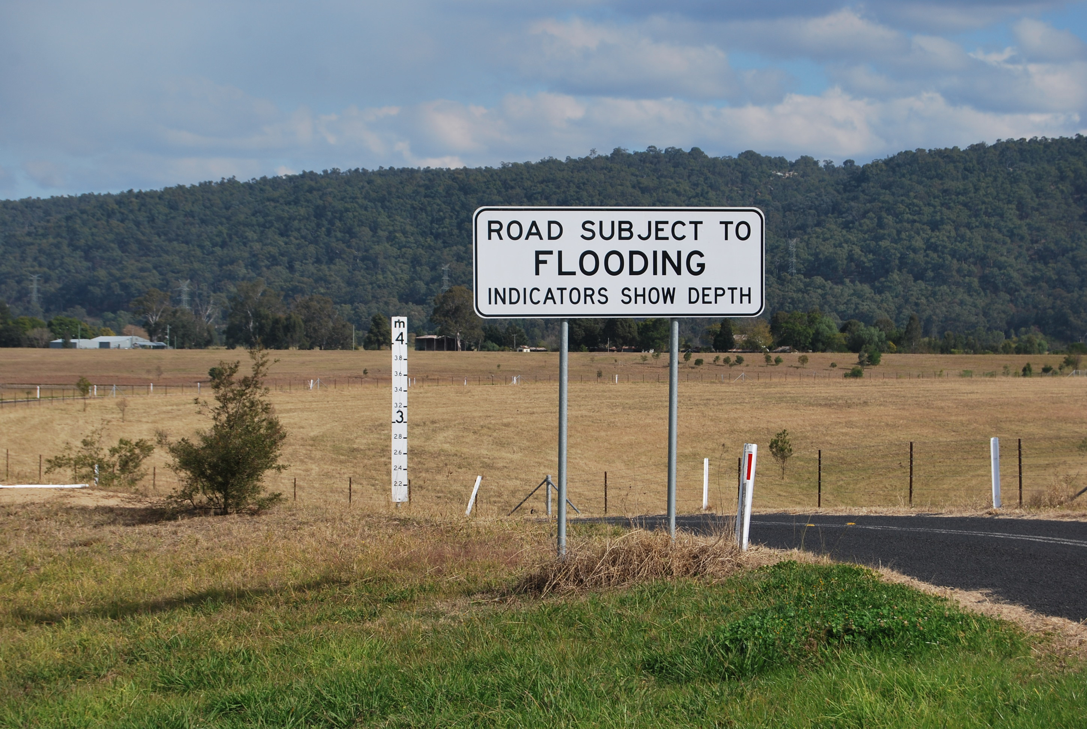Flood sign and depth indicator in the Penrith / Emu Plains floodplain of the Hawkesbury-Nepean Valley showing inundation levels. Image: Western Sydney University 2019

Approximate time required: 30 minutes

Acquiring and processing geographical information
- Pose the questions: What is it like when places in the Hawkesbury-Nepean Valley flood? What can we learn from past flood events?
- Students predict changes to the natural and human features in the flood sign photograph if the floodplain was inundated to a depth of 2.1 metres at the bottom of the sign, 3 metres and 4 metres. Measure the heights on the school building outside to gain a sense of the depths.
- View the NSW SES YouTube video It Will Flood Again (5:59min) https://youtu.be/jo9VbKbMZ6o
- Make connections: text-to-text, text-to-self, text-to-world. Students add to the ‘connect, extend, challenge’ chart compiled in Activity 2.1.
- Create a mind map of the key geographical facts, words, phrases and numbers that stood out in the video.
- Respond to the video as a text and analyse its purpose and audience. Reflect on its use of music, colour and visual information: photographs, video, newspaper headlines and graphics. How did they work together to communicate information and meet the text’s purpose?
- Compare the video to the Lismore Flood Event June 2016 story map and picture book, Flood, shared in Activities 2.1 and 2.2, comparing content, audience and purpose.
- Students view a selection of images of February 2020 Hawkesbury-Nepean flood
- Students add their responses in Column 3 of Worksheet 4
- Students complete Worksheet 5 – Comparing Stories of Floods.

Terminology
- Hawkesbury-Nepean Valley, population, height above, submerged, floodwaters, damage, isolated, stranded, affected, impacted, flood debris, deluge, evacuated, rescue.

Background notes
- English syllabus link: This activity supports the English K-10 Syllabus, Stage 2, Reading and Viewing 2, Outcome EN2-8B – ‘identifies and compares different kinds of texts when reading and viewing and shows an understanding of purpose, audience and subject matter’ https://educationstandards.nsw.edu.au/wps/portal/nesa/k-10/learning-areas/english-year-10/english-k-10/content/882

Teaching tools
- Copy of flood sign photograph, either physical copy or on screen
- Measuring tool (string, tape or similar) of 2.1m, 3m and 4m lengths
- Access to devices such as laptops or iPads to view NSW SES YouTube video
- Worksheet 4 and 5 – one per student

Notes to parents/carers for use at home
You can print a copy of the photograph for your child to complete the first part of the activity, or they can view it online on a device. They can use a ruler and compare the scale of the ruler to the scale on the sign to calculate possible flood levels.
The video can be watched on any device with internet access. Flood by Jackie French and Bruce Whatley is available on YouTube. Images of the February 2020 Hawkesbury-Nepean flood are available in the Gallery section of the NSW SES website.

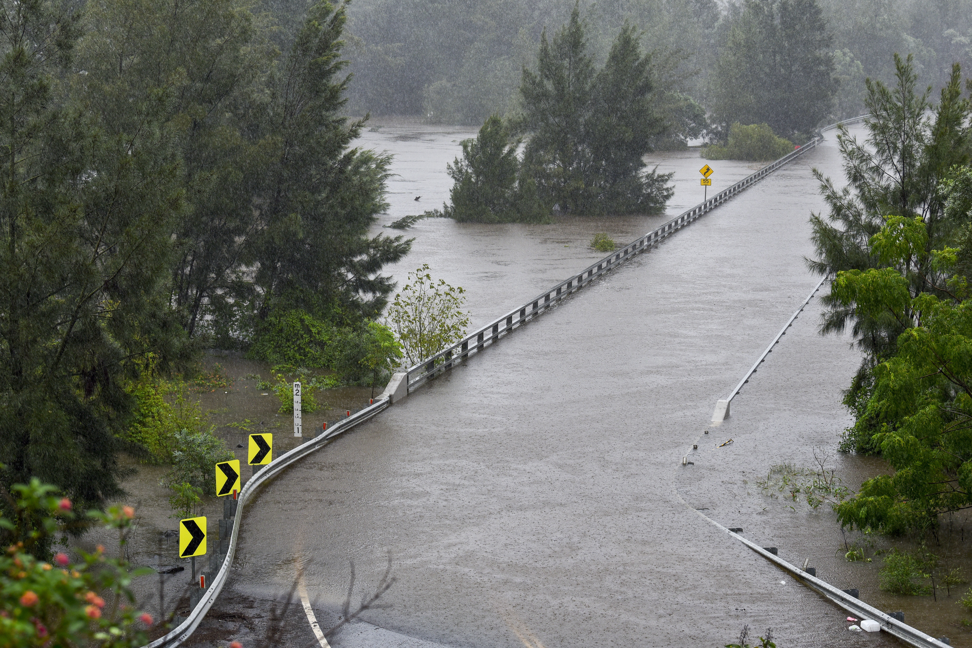
Activity 2.4 – Hawkesbury-Nepean Valley in Flood – February 2020
Yarramundi Bridge under floodwater, 10 February 2020. Image: Adam Hollingworth

Acquiring and processing geographical information
After a long period of drought, intense rainfall in February 2020 led to localised flooding in the Hawkesbury-Nepean Valley. The effects were felt across the region; however, this was a relatively small event in the history of flooding in the valley. Bridges at Yarramundi, North Richmond and Windsor were closed and submerged. People in Pitt Town Bottoms, Richmond Lowlands and Gronos Point were evacuated. Roads and transport were disrupted.
The flooding came very suddenly – Warragamba Dam storage rose 26.4% in three days. This speed of inflow convinced many people who had not experienced flooding in their memory that it was a major or even severe flood.
The following tables and images provide a comparison of river heights in 1867 and February 2020.

Location | River Height 1867 flood | River height 2020 flood
Penrith | 13.4m | 6m
Windsor | 19.18m | 9.3m
North Richmond | 20.14m | 11.4m

- Pose the questions: Find out the current total storage level for Greater Sydney and current storage level for Warragamba Dam on the Water NSW website:
https://www.waternsw.com.au/supply/Greater-Sydney/greater-sydneys-dam-levels
Have storage levels increased or decreased over the past week?
- Students view photographs of February 2020 floods on NSW SES website
- Make connections text-to-text, text-to-self, text-to-world.
- Compare the photos with the images of the Brisbane floods and the Lismore floods.
- Add responses to Worksheet 4 – Learning from Past Floods
- Complete Worksheet 6 – How Deep is the Flood Water?
Terminology
- Warragamba Dam, storage level, inflow, evacuation, deluged, submerged
Teaching tools
- Access to laptops, iPads, or similar, to view Water NSW and NSW SES website
- Worksheet 4 (from previous activity) and Worksheet 6 - one per student. Coloured pencils or textas.

Notes to parents/carers for use at home
If you have home internet your child will be able to view the websites on a device and complete the activity.

Worksheet 4 – Learning from Past Floods
Name ____________________________

Instructions
Use words, drawings or other representations to describe the key features of the 2016 Lismore, 2011 Brisbane and 2020 Hawkesbury-Nepean Valley floods.
JANUARY 2011 BRISBANE FLOOD | JUNE 2016 LISMORE FLOOD | FEBRUARY 2020 HNV FLOOD
Floodwaters | Floodwaters | Floodwaters
Impacts on places | Impacts on places | Impacts on places
People’s responses | People’s responses | People’s responses

- In what ways did the floods appear to be similar?

- In what ways did the floods appear to be different?

- What can we learn from these stories of floods?

Worksheet 5 – Comparing Stories of Floods
Name ____________________________

Instructions
Complete the table to compare two texts about floods in Australia. Choose from Flood (picture book) by Jackie French and Bruce Whatley, Lismore Flood Event June 2016 story map https://www.ses.nsw.gov.au/resources-folder/story-maps/ by NSW SES or It Will Flood Again video https://youtu.be/jo9VbKbMZ6o by NSW SES.
 | TEXT A | TEXT B
Title
Author and publication date
How is it published?
Subject matter
Key information
Geographical information
Geographical tools
Intended audience
What is the purpose of the text?
Why do you think this?
Is it a reliable source?
Why do you think this?

Worksheet 6 – How Deep is the Floodwater?
Name_____________________________________
Instructions
Using the information from the previous charts, show where the floodwater would have reached on the bridge, the house and the carpark. Use red for the 1867 flood and green for the February 2020 flood.
