Learning Sequence 1 – Geography of the Hawkesbury-Nepean Valley

Outcomes
- GE2-1 examines features and characteristics of places and environments
- GE2-2 describes the ways people, places and environments interact
- GE2-4 acquires and communicates geographical information using geographical tools for inquiry

Inquiry questions
- Where is the Hawkesbury-Nepean Valley? Where is the Nepean River? Where is the Hawkesbury River?
- What are the human and physical geographical characteristics of the valley?
- How do people interact with the places and environments in the valley?
- What if the river rises above its banks?
- What is the likelihood of flooding for places in the valley?
- What places will be flooded in the valley? Where does it flood near us?

Learning intention
We are learning to use maps and spatial technologies to acquire geographical information. We are learning about ways in which people, places and environments interact.

Geographical tools
- MAPS – online maps, flood maps
- SPATIAL TECHNOLOGIES – interactive flood maps, satellite images
- VISUAL REPRESENTATIONS – photographs, field sketches, video, 3D modelling, infographics
- FIELDWORK – local area

Introduction
“The Hawkesbury-Nepean Valley has the highest flood exposure in NSW, if not Australia. Over 130,000 people currently live in the valley, and many are not aware they live on a floodplain.”
Metro Zone Commander Wythes, NSW SES, September 2019 https://www.ses.nsw.gov.au/news/all-news/2019/the-risk-of-flood-is-real-in-the-hawkesbury-nepean-valley-do-you-know-your-flood-risk/
The Hawkesbury-Nepean Valley is a region in NSW that stretches along the Nepean and Hawkesbury rivers from Bents Basin near Wallacia to the Brooklyn Bridge at Brooklyn. The traditional custodians of the land on the southern banks of the Hawkesbury River are the Darug people. The river and the surrounding floodplains, lagoons and bushland provided rich resources for Aboriginal people. Today, the region has diverse land uses and a growing population. The rivers continue to flood. The valley’s unique physical geography creates a ‘bathtub effect’ where water can flow in from the catchment faster than it can get out. This may result in floods that can be dangerous to people.
The teaching and learning activities in Learning Sequence 1 examine locations, land uses and flood likelihood for different places within the Hawkesbury-Nepean Valley. This will develop students’ understanding of the varying physical and human characteristics of the region, their place within the region and the interactions between people, places and environments. The learning sequence primarily uses maps and spatial technologies to build skills and understandings.

Background notes for teachers
Refer to:
- Hawkesbury-Nepean Valley Regional Flood Study July 2019 Overview http://www.infrastructure.nsw.gov.au/media/2162/ec_insw_hawkesbury-nepean_fss-document_web.pdf
- Welcome to Country – Traditional Ties, Chapter One, Western Sydney University https://www.westernsydney.edu.au/driving_sustainability/sustainable_futures/community_and_engagement/dreaming_on_the_riverfarm_-_stories_from_the_hawkesbury/chapter_one
- Geography K-10 Syllabus © 2015 NSW Education Standards Authority (NESA) for and on behalf of the Crown in right of the State of New South Wales https://educationstandards.nsw.edu.au/wps/portal/nesa/k-10/learning-areas/hsie/geography-k-10

Activity 1.1 – Locating the Hawkesbury-Nepean Valley
Time required: 45 minutes

Acquiring and processing geographical information
- Pose the questions: Where is the Hawkesbury-Nepean Valley? Where is the Nepean River? Where is the Hawkesbury River? Why does the river have two names? What are the physical and human characteristics of the Hawkesbury-Nepean Valley?
- Locate Wallacia using Google Maps. Trace the Nepean River from Wallacia to the Grose River at Yarramundi. Note the change in name of the river to the Hawkesbury River.
- Trace the Hawkesbury River from Yarramundi to Brooklyn and to the Pacific Ocean. Use the language of the compass points to describe the journey of the river through each place and to the sea.
- Students locate the places: Bents Basin, Emu Plains, Penrith, Castlereagh, Yarramundi, Richmond, Windsor, McGraths Hill, Wilberforce, Sackville and Brooklyn.
- Students explore the landforms, land uses, places and waterways along the river using satellite view, street view and 360º photographs. Introduce the names of physical characteristics: valley, floodplain, gorge, creek, tributary. Recall and apply the land use terms introduced in Activity 1.1.
- Go outside to sketch views of the local area. Students create labelled field sketches looking out from the school boundaries or high points in the school. (10-15 minutes)
- Students complete Worksheet 1 – Places in the Hawkesbury-Nepean Valley. (5 minutes)

Terminology
- Valley, floodplain, lake, gorge, creek, tributary, suburb, town, village, north, south, east, west, north-east, south-east, north-west, south-west.

Background notes
- River names: Due to its history the river has two European names. The section upstream of the junction of the Grose River at Yarramundi was named the Nepean River by Watkin Tench. A separate expedition found a wide river mouth draining into Broken Bay and this was named the Hawkesbury River by Governor Arthur Phillip. It wasn’t until a further expedition over a year later that it was confirmed what was thought to be two rivers was in fact one. A traditional Aboriginal name for the Hawkesbury River is Deerubbin and for the Nepean River is Yandhai.
- Mathematics link: Refer to Mathematics K-10 Syllabus, Stage 2, Position 2 – ‘Students should be able to communicate using the following language: position, location, map, plan, legend, key, scale, directions, compass, compass rose, north, east, south, west, north-east, south-east, south-west, north-west.’ https://educationstandards.nsw.edu.au/wps/portal/nesa/k-10/learning-areas/mathematics/mathematics-k-10/content/1132

Teaching tools:
- Google maps via device such as laptops or iPads (can also work on large screen smart TV)
- Worksheet 1 – one copy per student. Coloured pencils or textas.

Notes to parents/carers for use at home
This activity can easily be completed on a computer or device using Google Maps. Encourage your child to look up the meanings of any unfamiliar words or terms.
Your child may like to go outside and draw a sketch of the local neighbourhood, then label the features.

Activity 1.2 – Places that flood in the Hawkesbury-Nepean Valley
Time required: 40 minutes

Acquiring, processing and communicating geographical information
- Pose the questions: What if the river rises over its banks? What areas will be affected by flooding?
- Go outside and tip water onto the ground to test directions of flow. Find the lowest areas of the school grounds likely to flood in an extreme rain or flood event. Plot these onto a school site map, indicating direction of flow. Note: This activity can also be completed following a rainstorm at school.
- Use ‘3-2-1 Bridge’ (visible thinking strategy) for students to record three predictions to the inquiry questions, two questions they wonder, and one analogy – ‘It will be like…’.
- View the NSW SES YouTube video Why Hawkesbury-Nepean Floods Are So Dangerous (2:30min) https://youtu.be/28SN9KixO2I
- Repeat ‘3-2-1 Bridge’ for new knowledge. Students share their initial and new knowledge, explaining reasons for changes in their thinking. (This is the ‘bridge’.) Listen to discussions, noting common questions, concerns or misconceptions worthy of clarification or class discussion.
- Students could also construct 3D sand models of one aspect of the physical geography and flooding effects described in the video. Challenge students to create models of a river bend, choke point, floodplain or gorge in tote trays with sand or the school’s sandpit. Students pour in water to observe the effects of the physical elements and water movement.
- Students create narrated videos of the 3D flood models in operation.
- If sandplay is not suitable, students could complete crumpled paper catchment model from Stage 3 (Stage 3, Sequence 1, Activity 1.2)

Terminology
- ‘Bathtub’ effect, tributary, gorge, choke point, downstream, extreme, dangers.

Background notes
- Hawkesbury-Nepean Valley Regional Flood Study July 2019 Overview http://www.infrastructure.nsw.gov.au/media/2162/ec_insw_hawkesbury-nepean_fss-document_web.pdf
- An example of a 3D sand model: YouTube video by Saferwoldcomm, Do-it-yourself Experiments – Flood (1:21min) https://youtu.be/VGV_HJhbths.

Teaching tools
- Buckets, watering cans, small cups suitable for pouring water
- Tote trays with sand or school sand pit, containers for water
- Smart TV or similar to watch YouTube video
- Camera/s to record narrated videos

Notes to parents/carers for use at home
Your child is sure to enjoy this activity. You can use any small container such as empty yoghurt pots, small buckets, empty ice cream tubs etc. Pour water on your driveway or the footpath and watch the flow. It can be good to also pour onto grass or the garden and note the different action of the water on the hard surface to the natural surface. If you don’t have a sandpit at home, playdough also works well for creating a model of a river or gorge. An alternative activity is the crumple paper model from the Stage 3 units. (Stage 3, Sequence 1, Activity 1.2)

Activity 1.3 – Flood Risk in the Hawkesbury-Nepean Valley
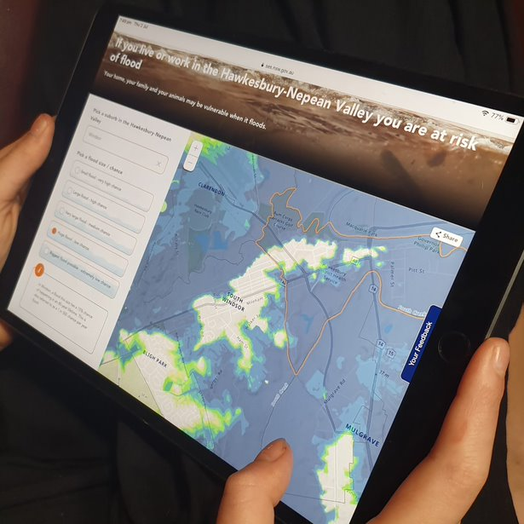
Use the NSW SES flood maps and risk information to learn about flood likelihood and risk. Source: NSW SES
Time required: 30-40 minutes

Acquiring, processing and communicating geographical information
- Pose the questions: What is the likelihood/chance of flooding for places in the Hawkesbury-Nepean Valley? What places will be flooded? Where does it flood near us?
- View Maps 1 and 2. Use the Map 1 as stimulus and location and Map 2 for students to examine the spatial distribution of the flood spread.
- Introduce the NSW SES online map https://www.ses.nsw.gov.au/hawkesbury-nepean-floods/
Explore the flood spread for each size / chance.
- Using jigsaw groupings, students use the map to investigate the flood risk for one place each: Wallacia, Emu Plains, Penrith, Richmond, Windsor, or other suburb in the Hawkesbury-Nepean Valley. They compile their information into Worksheet 2.
- Students complete Worksheet 2 – Flood Risk of Places in the Hawkesbury-Nepean.
- Go outside and measure out the flood heights reached at each place to gain an understanding of the depths. This can be done on a building or on the ground. Compare to the height of a child (say 1.3m), adult (1.75m), car (SUV= 1.6m), house (single storey = 4.3m).
For example, flood height at Windsor in 1990 was 12.9 metres above normal river height and 19.1 metres in the 1867 flood, which is the worst on record in the valley.
- Students compose a slogan that captures the essence of flood likelihood to communities in the Hawkesbury-Nepean Valley. They draft this into the space on Worksheet 2.

Terminology
- Very high chance, high chance, medium chance, low chance, extremely low chance, flood risk, occurring, depth, metres, lifetime.

Background notes
- Hawkesbury-Nepean Valley Regional Flood Study July 2019 Overview http://www.infrastructure.nsw.gov.au/media/2162/ec_insw_hawkesbury-nepean_fss-document_web.pdf
- Flood Risk in the Hawkesbury-Nepean Valley https://www.ses.nsw.gov.au/hawkesbury-nepean-floods
- Mathematics link: Refer to Mathematics K-10 Syllabus, Stage 2, Chance 2 – using the terms ‘more likely’ and ‘less likely’ to describe events https://educationstandards.nsw.edu.au/wps/portal/nesa/k-10/learning-areas/mathematics/mathematics-k-10/content/1135

Teaching tools:
- Maps 1 and 2 – print copies - one per table/group/pair or print large copies for the class to discuss
- Devices or smart TV to view NSW SES online map
- Tape measure and long string or wool to measure flood heights
- Worksheet 2 – one per student

Notes to parents/carers for use at home
If you wish to complete this activity with your child they can choose to investigate all sites named and enter the data on the worksheet or only study one or two locations. The comparison activity (measuring relative heights) can be done using your house as a reference.
Your child may like to come up with a slogan about flood risk to complete worksheet 2.

Activity 1.4 – Characteristics of the Penrith / Emu Plains Floodplain

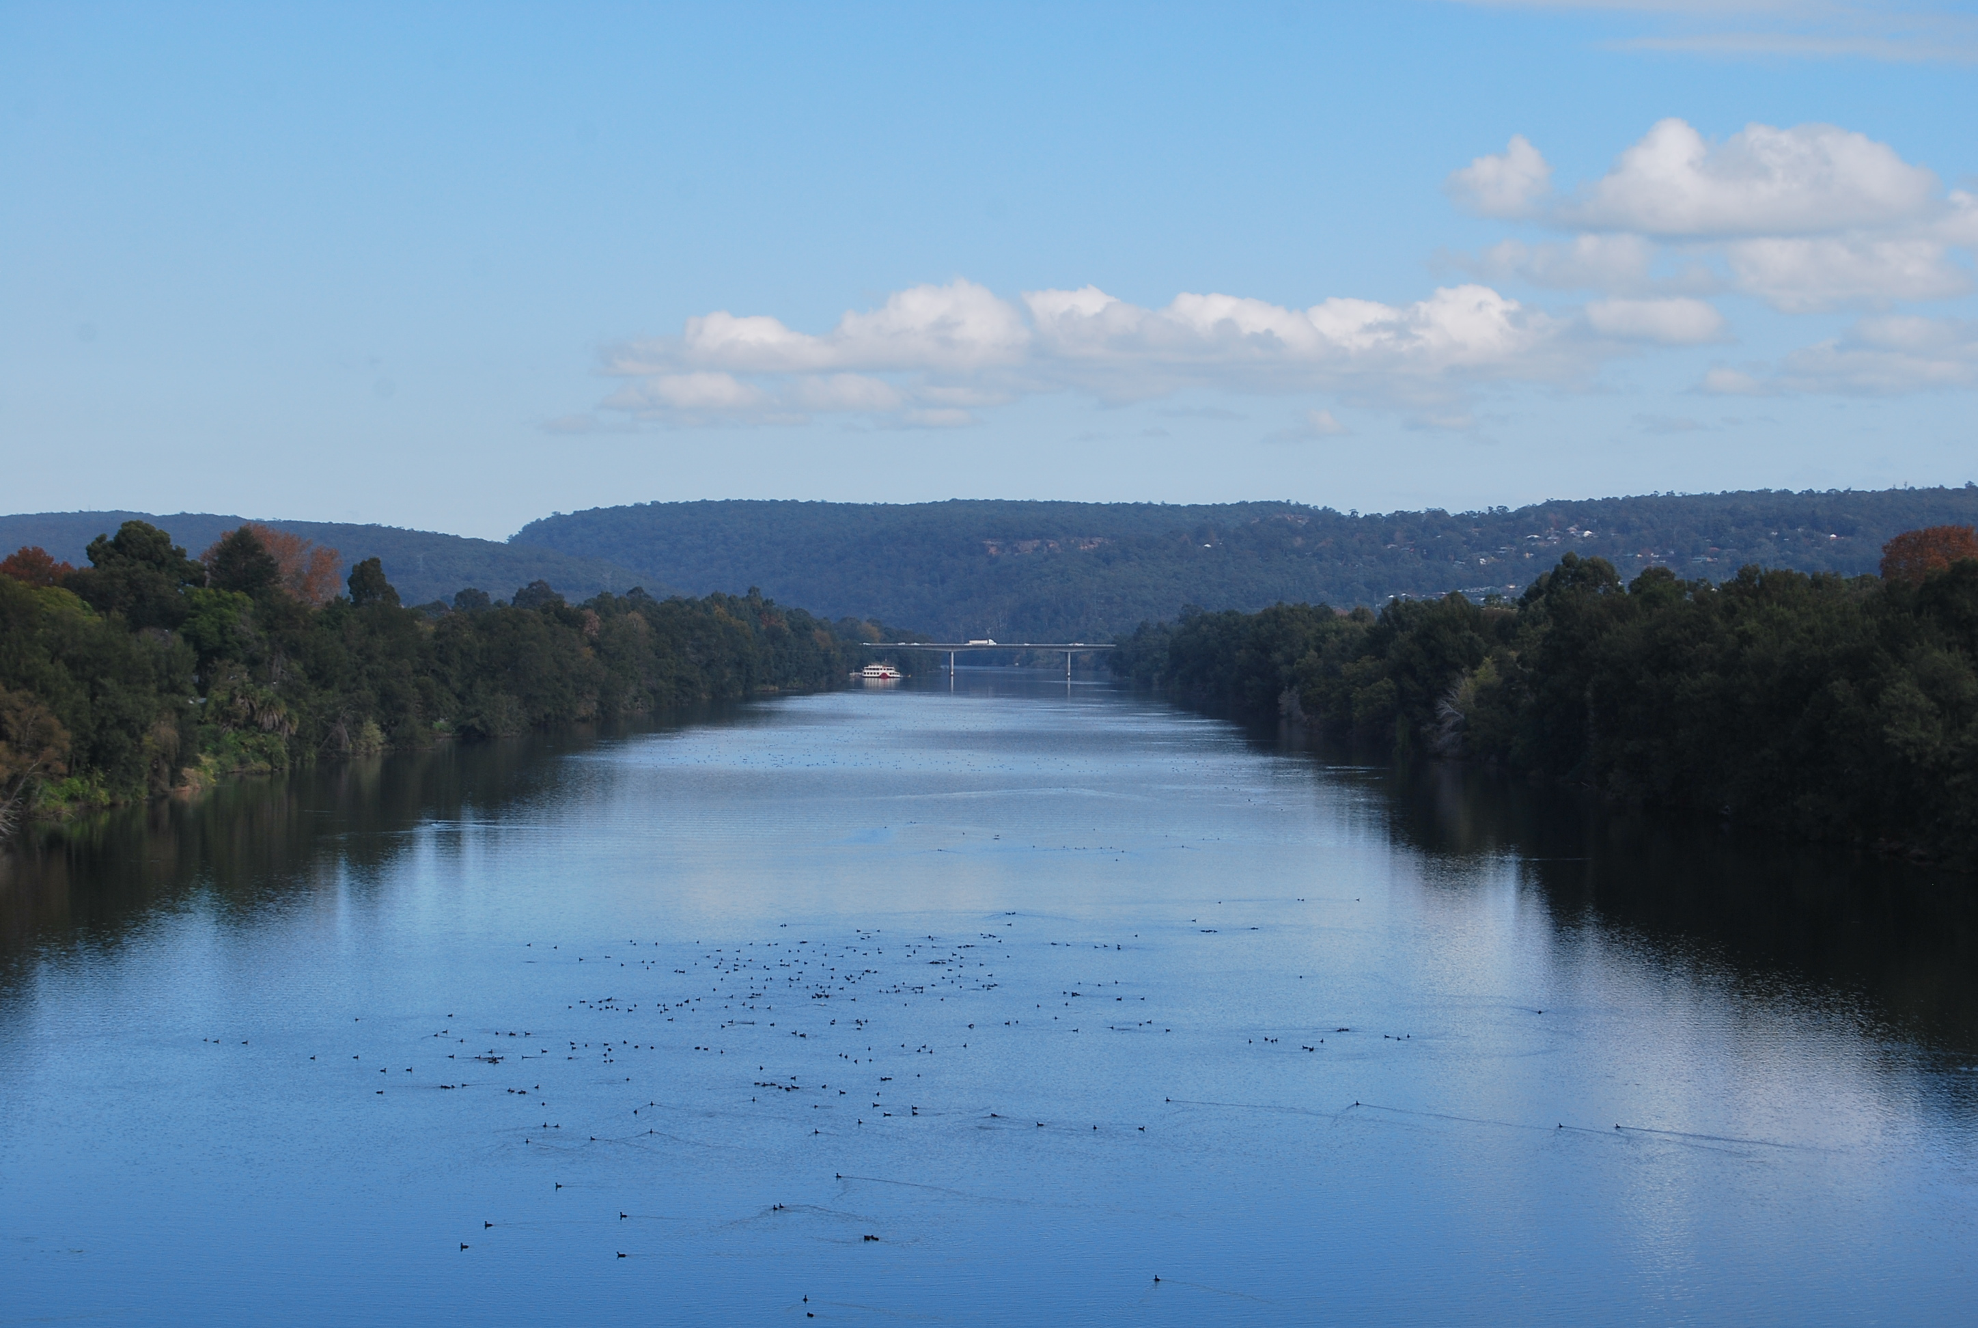
Nepean River, looking south-west to Tench Reserve Boat Ramp and the M4 motorway bridge at Jamisontown. Photograph taken from Yandhai Nepean Crossing, Penrith. Image: Western Sydney University 2019
Time required: 15 – 20 minutes

Acquiring and processing geographical information
- Pose the questions: Where is the Nepean River? What places surround it? How do people interact with those places and the environments?
- View the photograph of the Nepean River. Name the human and natural features in the photograph
- Acknowledge the traditional custodians of the area, including the Darug people. Yandhai is a traditional name for the Nepean River and Deerubbin is a traditional name of the Hawkesbury River.
- Activate prior knowledge and share personal experiences of visiting, using or crossing the river.
- Explore a bird’s-eye view by interacting with the 360º Street View image of the area https://goo.gl/maps/MfV9DYv1YJ7RDd6z8 Use the image to describe topography and name landforms: valley, floodplain, mountains, river. Differentiate between the different land uses shown in the image: residential, farmland, industrial and recreation. Name the place as the Penrith / Emu Plains Floodplain within the region of the Hawkesbury-Nepean Valley.
- Define ‘floodplain’ as an area of land near a river that is prone to flooding.
- Locate the place using Google Maps https://goo.gl/maps/ekK9E8uNmtPtpZbx6 Locate the M4 bridge, Victoria Bridge, Yandhai-Nepean Pedestrian Bridge, Jamisontown, Emu Plains, Penrith.
- Identify and name land uses by switching between map and satellite views and using the zoom function. Introduce the words used to describe human land uses: residential, commercial, industrial, recreational, agricultural, transport.
- Students complete Worksheet 3 – Land Uses of the Penrith / Emu Plains Floodplain.
- Go outside to photograph eye-level views of the local area, looking out from the school boundaries. Students create annotated photographs, identifying features and land uses.

Terminology
- Darug, Deerubbin, Yandhai, Nepean River, Hawkesbury-Nepean Valley, floodplain, land use, residential, commercial, industrial, recreational, farmland, agricultural, satellite image, bird’s eye view, zoom.

Teaching tools:
- Smart TV, or similar, to view large photograph of Nepean River
- Google maps and 360° street view via smart TV, laptops or iPads
- Worksheet 3 – one copy per student
- Digital cameras for photographing local area

Notes to parents/carers for use at home
Your child can view the photograph of the Nepean River at Penrith using a laptop or desktop computer, or similar device. If you have access to the internet at home, you will be able to do the 360° Street View activity as well.
Google Maps can be used to find out about the land uses – using satellite view will allow your child to see different types of land use across the area.
You may like to help your child take some photographs from your house of the local area and then upload them to a device so they can identify and label the different features around your home.

Worksheet 1 – Places in the Hawkesbury-Nepean Valley
Name ____________________________

Instructions
- Rule a line from each photograph to its location on the map.
- Put an orange X where you think the photographer stood.
- If your school is on this map, mark its location with a blue X
- If your home is on this map, mark it with a red X. If not, use a red arrow to show the direction to your home.
- Locate and underline in red: Castlereagh, Yarramundi, Richmond, McGraths Hill and Sackville.
- Add Windsor to the map. (Hint: the Windsor Bridge is at Windsor.)
- Use a circle to mark the location on the riverbank of Castlereagh Gorge and Sackville Gorge.
- Answer the questions below the map.
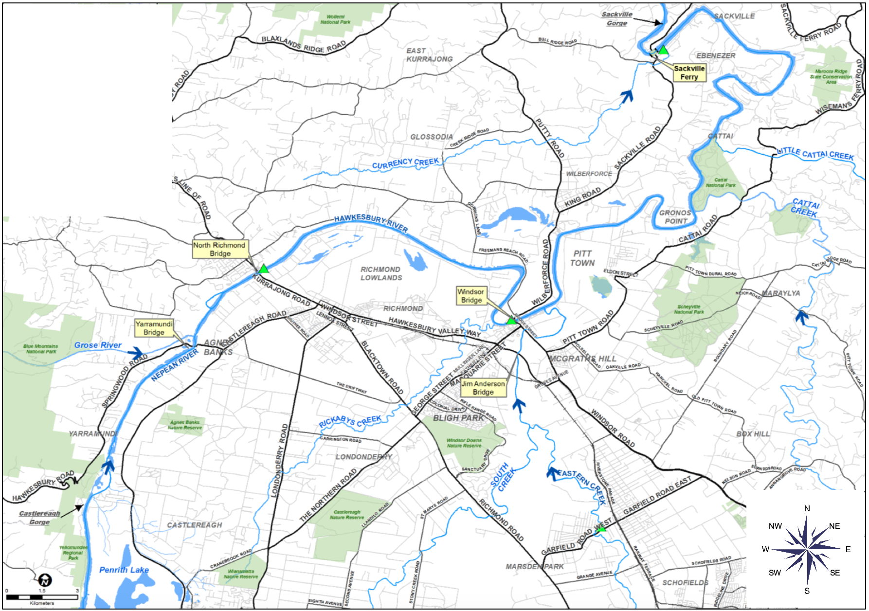
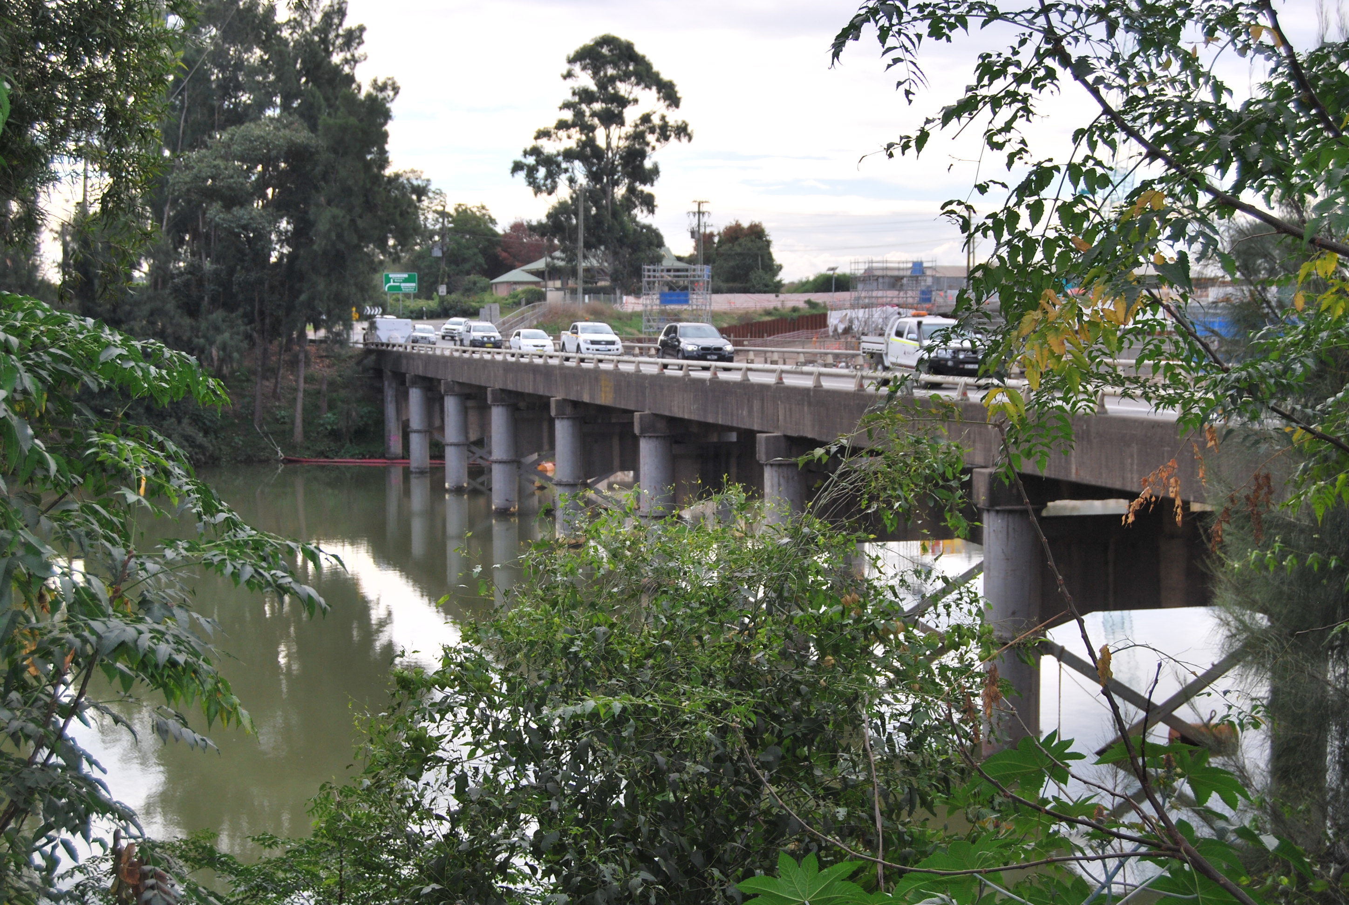
Windsor Bridge, looking north-west
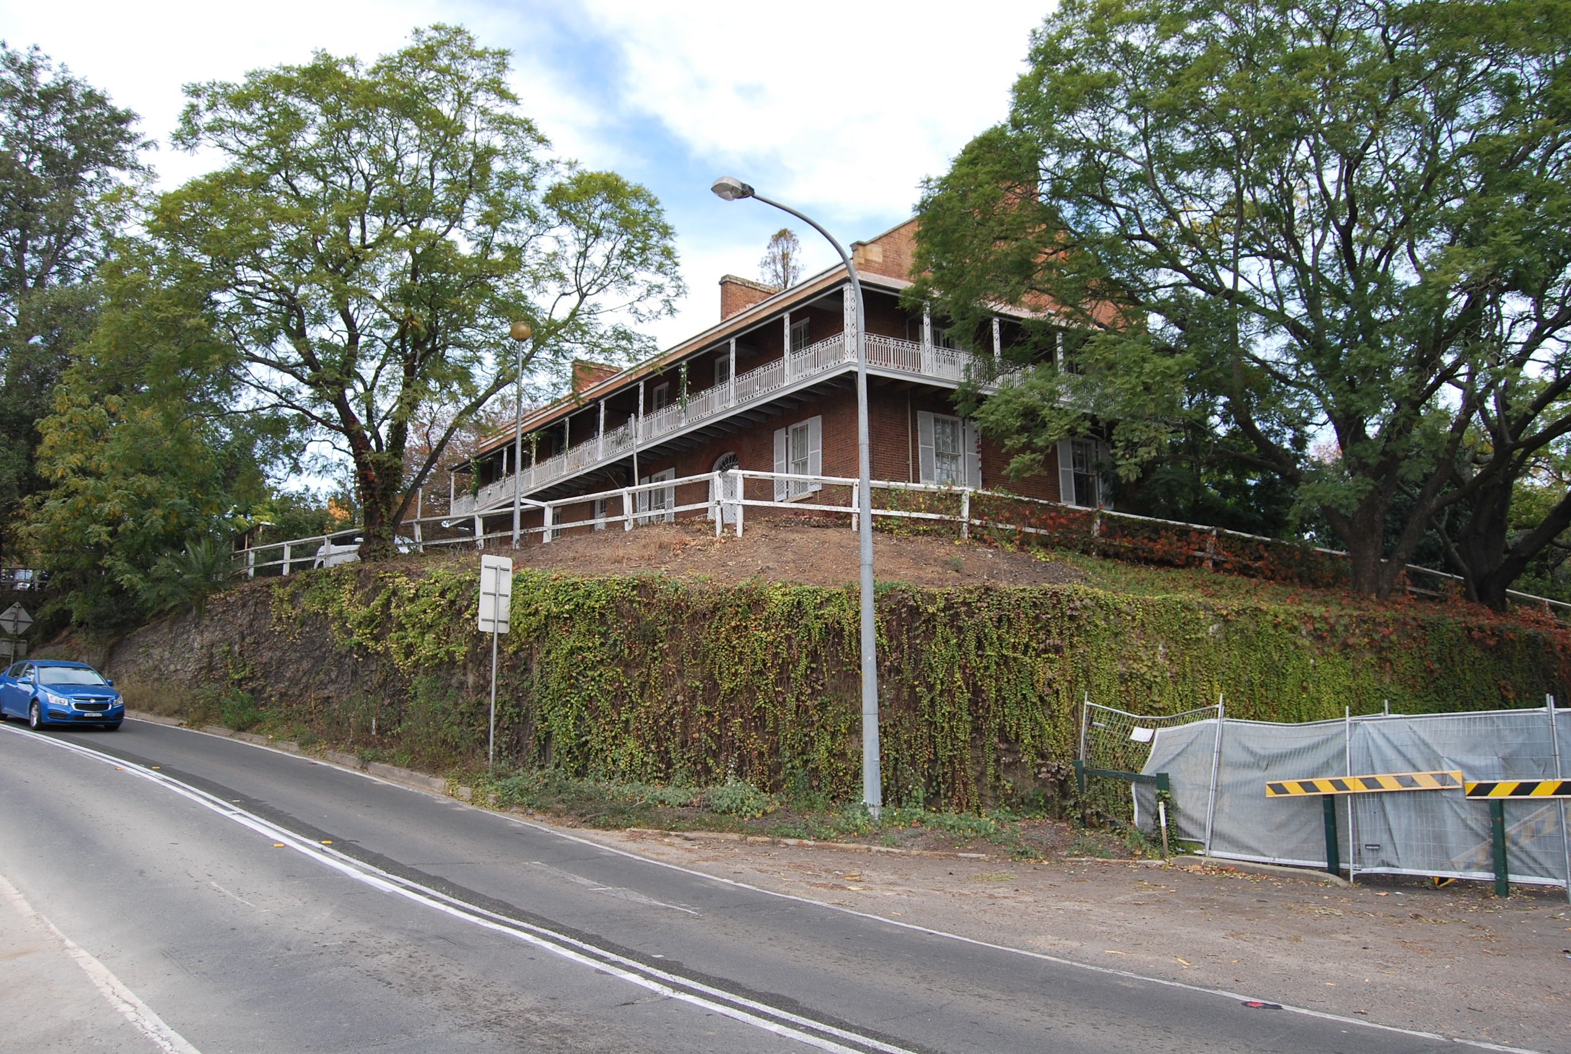
Historic Doctor’s House, Windsor, on riverbank, south of bridge
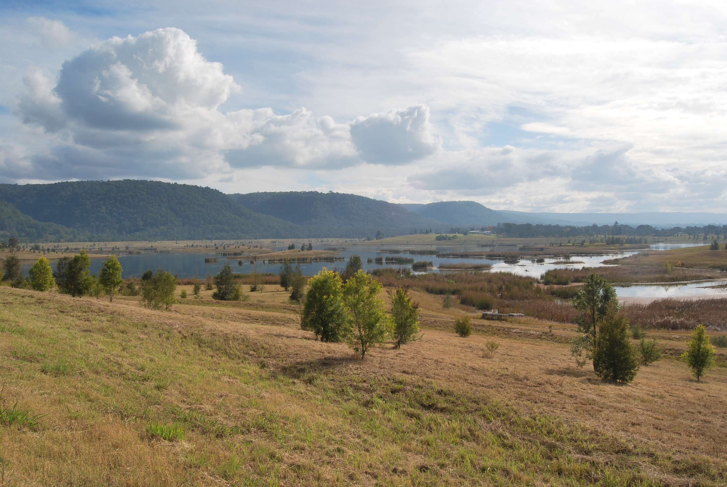
Penrith Lakes, looking south-west
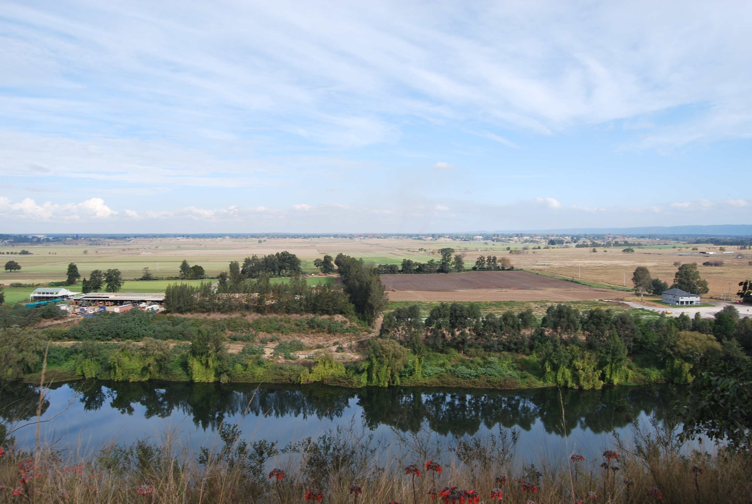
Richmond Lowlands, looking south
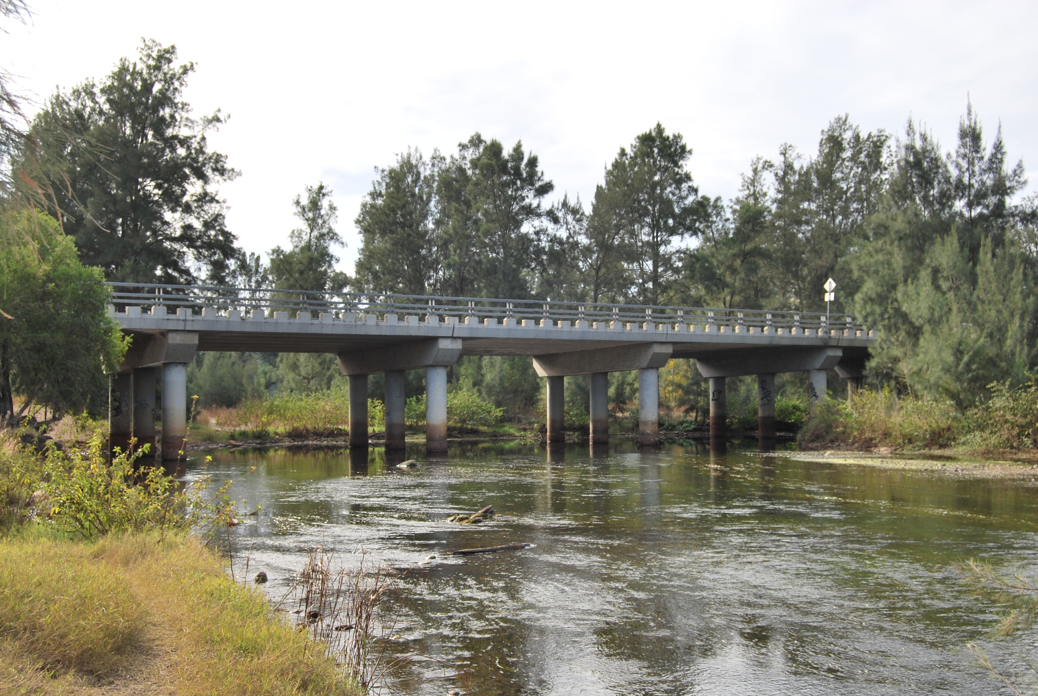
Yarramundi Bridge, looking south
Richmond / Windsor Floodplain – in the Hawkesbury-Nepean Valley

Name two of the tributaries that flow into the Hawkesbury-Nepean River.
What is the main land use in the Richmond Lowlands?
What is the main land use at Bligh Park?
On what creek is the Jim Anderson Bridge?

Worksheet 2 – Flood Risk of Places in the Hawkesbury-Nepean Valley
Name ____________________________

Instructions
- Use the NSW SES online flood risk mapping tool to find out about the flood risk for the places in the table. https://www.ses.nsw.gov.au/hawkesbury-nepean-floods
- Select each flood size / chance and view the map overlay. Complete the table using the information panel.
- Compose a headline that captures the essence of flood risk to communities in the Hawkesbury-Nepean Valley.

Table 1 – Flood risk of places in the Hawkesbury-Nepean Valley
 | WALLACIA | EMU PLAINS | PENRITH | RICHMOND | WINDSOR | MY SUBURB
Floodplain
Height of largest flood
Year of last major flood
Height of last major flood
Other key information

Slogan
Write a slogan that warns people about flood risk.

Worksheet 3 – Land uses of the Penrith / Emu Plains Floodplain
Name ____________________________

Instructions
- Open a Google map of the Penrith area https://bit.ly/2VaE6wa
- Locate the area represented below.
- Identify and name the land uses using map view, satellite view and the zoom function.
- Colour the land uses on the map below using the colours in the legend.
- In the space under the map, list at least five ways in which humans use places in this area.
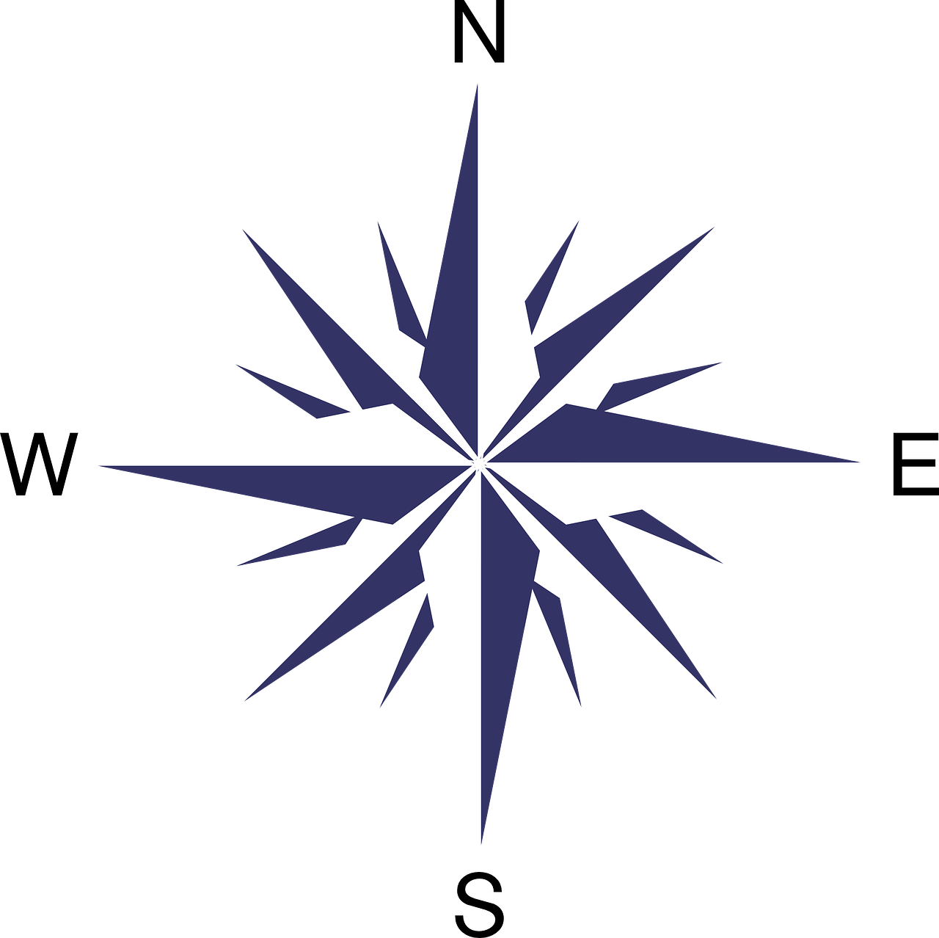
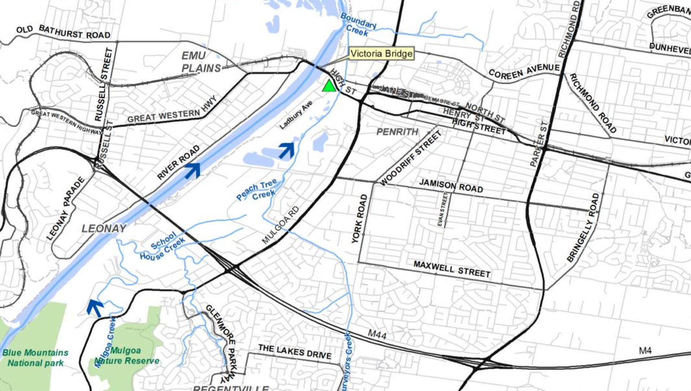
NE
SE
SW
NW
Part of Penrith / Emu Plains Floodplain – in the Hawkesbury-Nepean Valley

Source: NSW SES 2015

Legend

Human uses
Residential area
Industrial area
Commercial area (shops and businesses)
Farmland or hobby farms

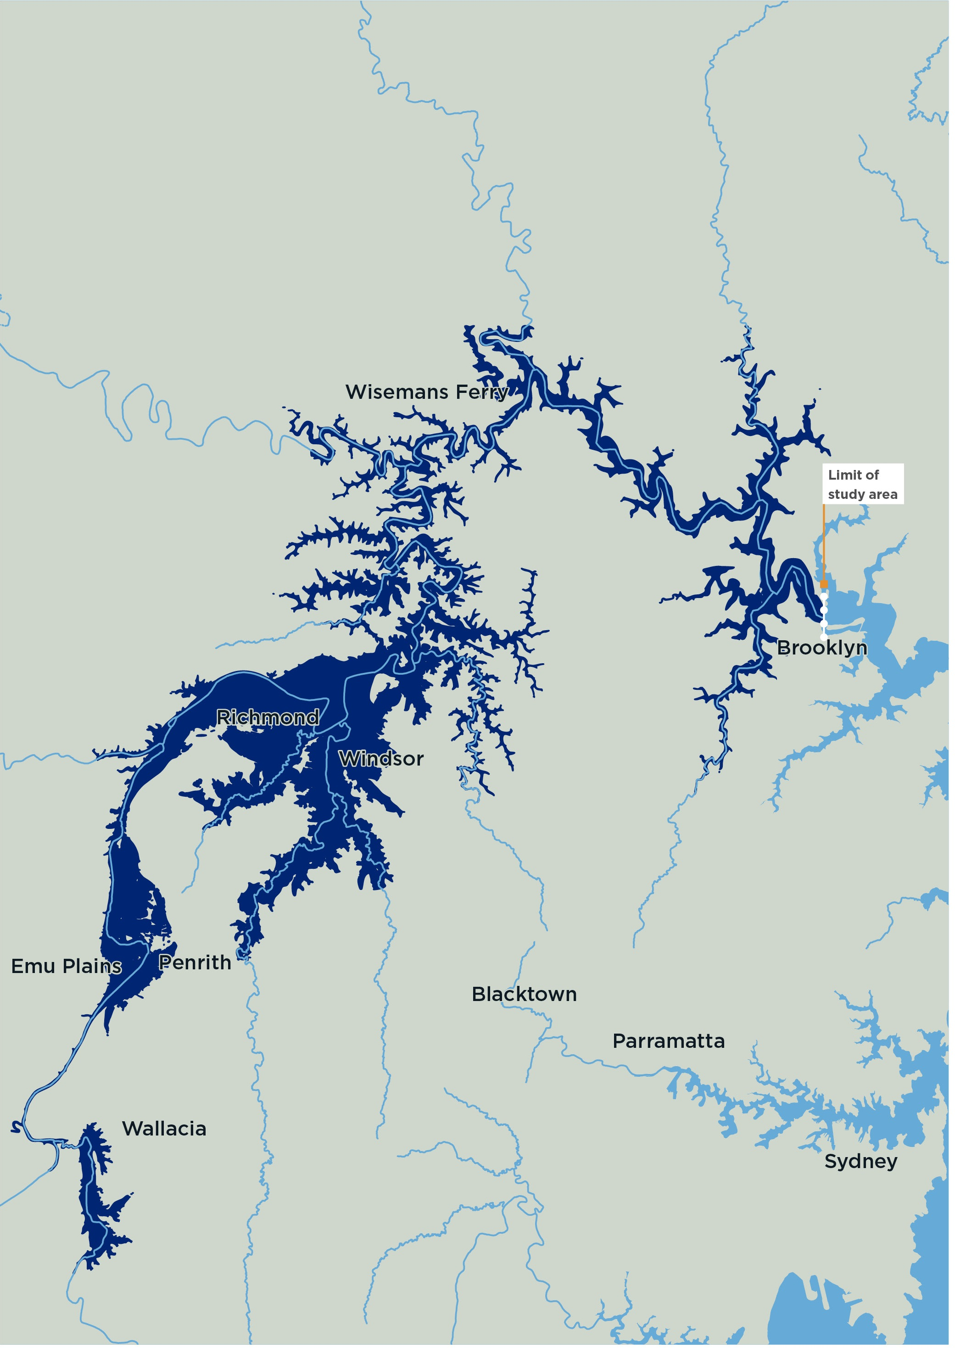
Map 1 – Flood Map for a Low Likelihood Chance per Year Flood

Hawkesbury-Nepean River flood extent for a 1 in 500 (0.2%) chance per year flood. Source: Hawkesbury-Nepean Valley Regional Flood Study July 2019 Overview, p14 http://www.infrastructure.nsw.gov.au/media/2162/ec_insw_hawkesbury-nepean_fss-document_web.pdf

Map 2 – Hawkesbury-Nepean Valley Regional Flood Study Area
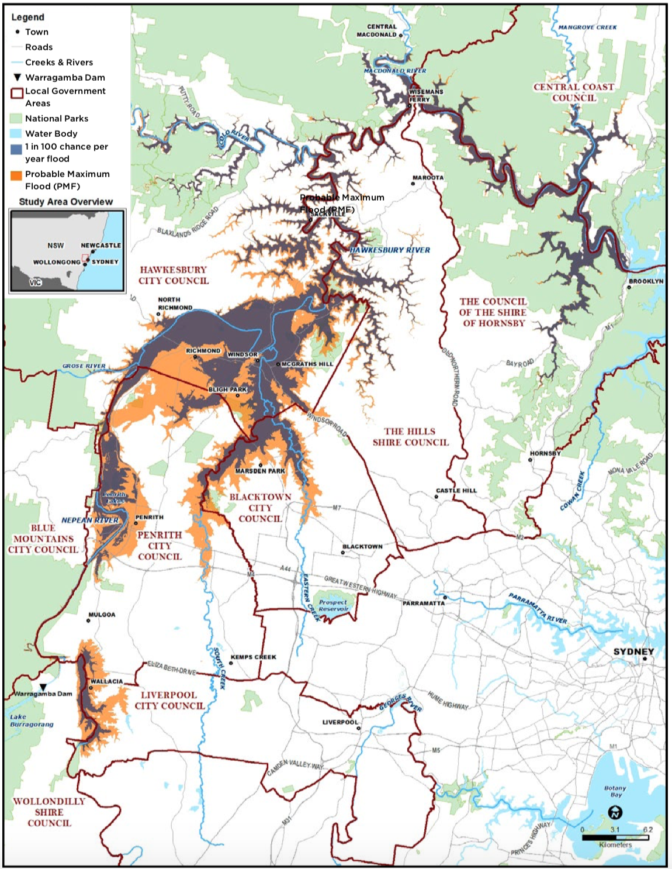
Hawkesbury-Nepean Valley Regional Flood Study Area. Source: Hawkesbury-Nepean Valley Regional Flood Study July 2019 Overview p3 http://www.infrastructure.nsw.gov.au/media/2162/ec_insw_hawkesbury-nepean_fss-document_web.pdf

