Learning Sequence 3 – Flood Decision Making

Outcomes
- GE3-2 explains interactions and connections between people, places and environments
- GE3-4 acquires, processes and communicates geographical information using geographical tools for inquiry

Inquiry questions
- What are the dangers of floods to people?
- What are good decisions and safe choices in floods?
- How should we prepare for floods? How can we be flood ready?
- How can we promote being prepared for floods?

Learning intention
We are learning about interconnections between people and places, between environments and places and between people and environments.

Geographical tools
- VISUAL REPRESENTATIONS – videos, picture books, games, photographs, hashtags

Introduction
It will flood again in the Hawkesbury-Nepean Valley. The natural features of the valley can lead to floods that are deeper and more dangerous than in other floodplains. Dangers include the speed and force of the water, floating and submerged debris and polluted floodwater. Social research in 2018 showed that only 18% of valley residents thought there was a high flood risk, 31% believed there was no risk of flooding and 79% said they had done nothing to prepare for flooding. The six steps of preparing for flood are:
- know your risk,
- know where to go,
- know who to call,
- prepare a home emergency kit,
- check insurance,
- know when to act.
Additionally, the community need to be aware of the dangers of entering floodwaters.
The teaching and learning activities in Learning Sequence 3 draw on students’ understanding of the interconnections between floods, people and places in the Hawkesbury-Nepean region, developed in Learning Sequences 1 and 2. In response to their geographical inquiry, students reinforce and promote good decisions for flood preparedness and safe choices during flood events through the design and development of a game and poster. The learning sequence primarily uses visual representations, with opportunities for students to communicate visually in creative ways.

Background notes for teachers
Refer to:
- NSW SES website https://www.ses.nsw.gov.au/hawkesbury-nepean-floods
- Hawkesbury-Nepean Valley Regional Flood Study July 2019 Overview http://www.infrastructure.nsw.gov.au/media/2162/ec_insw_hawkesbury-nepean_fss-document_web.pdf
- Geography K-10 Syllabus © 2015 NSW Education Standards Authority (NESA) for and on behalf of the Crown in right of the State of New South Wales https://educationstandards.nsw.edu.au/wps/portal/nesa/k-10/learning-areas/hsie/geography-k-10

Activity 3.1 – Dangers of Floods
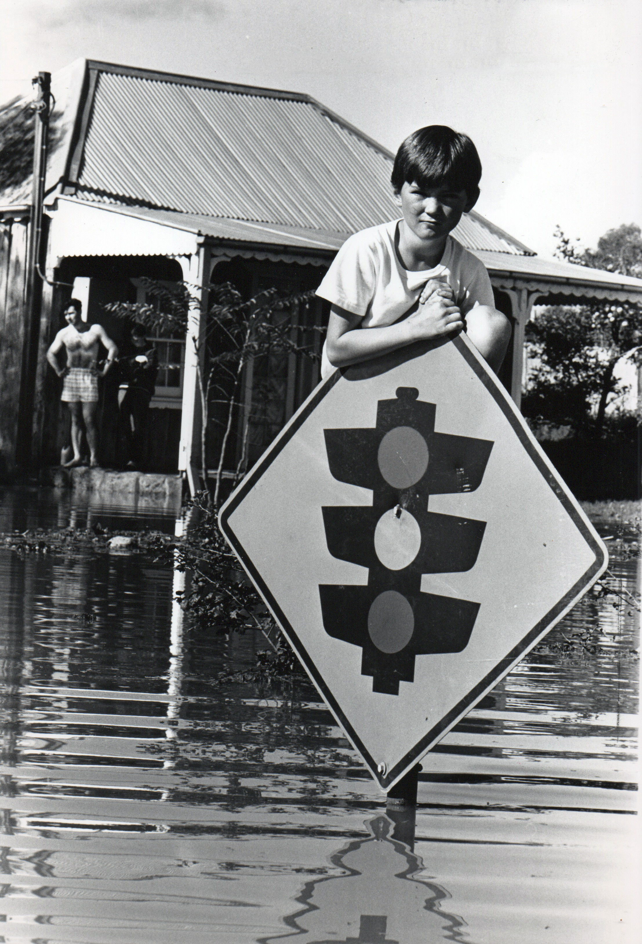
Nine year-old Damian Boyce clings to a traffic sign at Windsor during the May 1988 floods. Image: Newspix
Remember, floodwater may contain sewage, poisons, dead animals and chemicals. It can erode surfaces so we cannot tell the depth or speed of floodwater. The safest action is to never walk, ride or play in floodwater.

Approximate time required: 30 minutes

Acquiring geographical information
- Pose the questions: What are the dangers of floods to people? What are good decisions and safe choices in floods? What might be in the floodwater in the picture? How might the boy in the picture get to safety?
- View the 7News YouTube video Thousands forced to flee NSW floods - the Wagga Wagga experience 2012 https://youtu.be/NFToJ_pfx2U (5:27min – view to 2:30min) and view the ABC News YouTube video Thousands volunteer for Brisbane's flood clean-up https://youtu.be/k4N0MeGcFX8
- Re-read the picture book Flood by Alvaro F Villa. Note – this wordless text tells a similar story to the videos but at a personal level. It shows the extreme power of floodwaters and concludes with the recovery of the family.
- Make connections: text-to-self, text-to-text, text-to-world.
Discuss the preparations made by people in both texts. What were the natural warning signs? How were weather warnings communicated? What preparations did people undertake? What actions did they take? How are evacuation warnings and orders communicated? See the NSW SES factsheet: https://www.ses.nsw.gov.au/media/3233/knowing-the-signs-of-flooding-fact-sheet.pdf Listen to the Emergency Alerts: https://www.emergency.nsw.gov.au/Pages/for-the-community/alert-NSW/SEWS.aspx
- Discuss the danger to life posed by floodwaters. Describe the nature of floodwater: fast flowing, powerful, unseen debris, deep, dirty and the danger to life each presents.
- Students use ‘think-share-pair’ to list good decisions and choices people should make in preparation for and during a flood event. These can be composed on a word cloud app or in Worksheet 6.
- Students complete Worksheet 6 – Good Decisions Safe Choices.

Terminology
- Weather warnings, levee bank, sandbags, decisions, evacuate, evacuation, preparedness, community, recovery.

Background notes
- Flood by Alvaro F. Villa, Capstone Press, US, 2014
- Flood – Reader’s Guide, Capstone Young Readers https://www.teachingbooks.net/media/pdf/SingleBGs/Flood_Readers_Guide.pdf

Teaching tools
- Access to devices or Smart TV to watch 7News YouTube video and ABC News YouTube video
- Worksheet 6 – one copy per student

Notes to parents/carers for use at home
The 7News video can be viewed on any device that has access to the internet. The book Flood is available of YouTube as well. Discuss the preparations made in the two texts. Refer to your own family’s preparations. Talk about floodwater with your child. If there are stormwater drains in your area you may like to point them out on a walk around the neighbourhood. If you live near a creek or river, you could visit after rain and see what impact the rain has had, if it is safe to do so. Help your child to complete the Worksheet and discuss their responses.

Activity 3.2 – Flood Choices Game Design Task

Approximate time required: 45 minutes

Processing and communicating geographical information
- Pose the questions: How should we prepare for floods? How can we be flood ready? What are good decisions and safe choices in floods?
- Outline the challenge: for students to work in groups to create a flood game that educates players about flood preparedness and safety and which rewards the making of good decisions and choices.
- Outline the criteria and parameters of the task, listed on Worksheet 7.
- Students work collaboratively to plan, research, design and produce their flood game.
- Students complete Worksheet 7 – Flood Game DesignPlan

Terminology
- Decisions, choices, prepare, collaborate, conversation.

Background notes
- Science and Technology link: This activity supports the design and production process in the Science and Technology K-6 Syllabus https://educationstandards.nsw.edu.au/wps/portal/nesa/k-10/learning-areas/science/science-and-technology-k-6-new-syllabus/design-and-production

Teaching tools:
- Worksheet 7 - one copy per student
- Access to items for game design and playing, such as cardboard, coloured pencils/markers, tokens, dice etc

Notes to parents/carers for use at home
Your child may like to work alone to create a simple game. You could work with them, or you could adapt an existing game to a new purpose, for example Snakes and Ladders or a card game.

Activity 3.3 – Flood Ready

Approximate time required: 30 minutes

Communicating geographical information
- Pose the question: How can we promote being prepared for flood?
- View the NSW SES YouTube video Protect What You Love (2:41min) https://youtu.be/6cs1CT9wr60 and the NSW SES YouTube video clip Protect What You Love - Social Byte 7 (27sec) https://youtu.be/YrP7rawIpJE
- Re-read the NSW SES how to prepare list https://www.ses.nsw.gov.au/hawkesbury-nepean-floods
- Students create photographic posters with an appropriate hashtag that promotes flood preparedness. Examples of hashtags include #protectwhatyoulove, #3things, #floodready, #floodkit, #floodplan, #animalsafety #HNVforschools

Terminology
- Evacuation, emergency, kit, flood ready.

Background notes
- NSW SES How to Prepare https://www.ses.nsw.gov.au/hawkesbury-nepean-floods

Teaching tools
- Means to view NSW SES YouTube videos such as devices or smart TV
- Copy of NSW SES How to Prepare list (suggest one for the classroom)
- A4 or A3 paper for poster design activity, colouring pencils, pens etc.

Notes to parents/carers for use at home
This is a chance for your child to be creative and design a poster. If they have access to a camera, or you are happy for them to use your phone, they can make a photographic poster. They may choose to draw or paint or create a graffiti style piece of work.

Worksheet 6 – Good Decisions, Safe Choices

Instructions
- Work with a partner and write positive phrases and hashtags that state good decisions and safe choices people should make in preparation for and during floods. Remember that words have power, so choose wisely.
- Use a word cloud app to create a word cloud for display.

Good decisions, safe choices

Worksheet 7 – Flood Choices Game Design Plan

Instructions
- Work with a group to design a game that promotes making good decision and safe choices about floods.
- Focus on being prepared for floods and making safe choices during a flood. (It’s not about escape or rescue.)
- Structure your game so that it rewards good decisions and safe choices.
- Reinforce one or more aspects of the six steps of preparing for flood: know your risk, know where to go, know who to call, prepare a home emergency kit, check insurance, know when to act.
- Or reinforce one or more steps in keeping your animals safe in a flood emergency.
- Set your game in a particular context such as at home, at school, the paddock, at the shops.
- Decide on a game format. It could be physical to play outside (like ‘bullrush’), ground game (like hopscotch), a board game (like Snakes and Ladders or Monopoly), a card game (like Uno), digital, a quiz, ‘what am I?’ style, or another format.
PLANNING TEMPLATE
What format for the game are you considering? | What will be the context of the game?
What good decisions will be rewarded? | What poor choices will have consequences?
What else will you need to find out? | Where can you obtain information?
What is the design criteria for your game? | How will you know you’ve met the criteria?

