Learning Sequence 3 – Flooding and Our Community

Outcomes
- GE1-1 describes features of places and the connections people have with places
- GE1-3 communicates geographical information and uses geographical tools for inquiry

Inquiry questions
- What is a floodplain? What are the features of floodplains?
- Where does it flood near us? What areas will be affected?
- How will we know how to get out if a flood is predicted?
- If you had to evacuate, what three things would you take?

Learning intention
We are learning to describe and represent geographical features and people’s connections to places.

Geographical tools
- VISUAL REPRESENTATIONS – photographs, infographics, video, drawings, signage
- SPATIAL TECHNOLOGIES – interactive online maps
- MAPS – online, line, pictorial
- FIELDWORK – school grounds, local area

Introduction
Floods have always happened in Australia. The traditional custodians of the land have oral histories of floods and written records have been kept since the 1790s. People’s homes, families and animals may be susceptible when it floods. Building community understanding, preparedness and resilience is an important strategy for future floods.
The Hawkesbury-Nepean Valley has a long history of flooding and it will flood again in the future. People who live or work in the Hawkesbury-Nepean Valley are at risk of flood.
The teaching and learning activities in Learning Sequence 3 help develop students’ understanding of flood risk focusing on the Hawkesbury-Nepean Valley at an age-appropriate level. Students build fundamental understanding of the physical geography of the valley and their local area. They are introduced to regional management strategies that help people prepare for floods and evacuate to safer areas. The learning sequence uses interactive maps, photographs, games, pictorial maps and video clips to build geographical skills and understanding.

Background notes for teachers
Refer to:
- Flood risk in the Hawkesbury-Nepean Valley https://www.ses.nsw.gov.au/hawkesbury-nepean-floods
- Flood overview https://www.ses.nsw.gov.au/disaster-tabs-header/flood/
- NSW SES factsheet Know how to get out https://www.ses.nsw.gov.au/media/3174/know-how-to-get-out-fact-sheet.pdf
- Geography K-10 Syllabus © 2015 NSW Education Standards Authority (NESA) for and on behalf of the Crown in right of the State of New South Wales https://educationstandards.nsw.edu.au/wps/portal/nesa/k-10/learning-areas/hsie/geography-k-10

Activity 3.1 – Features of Floodplains
Time required: 30-40 minutes
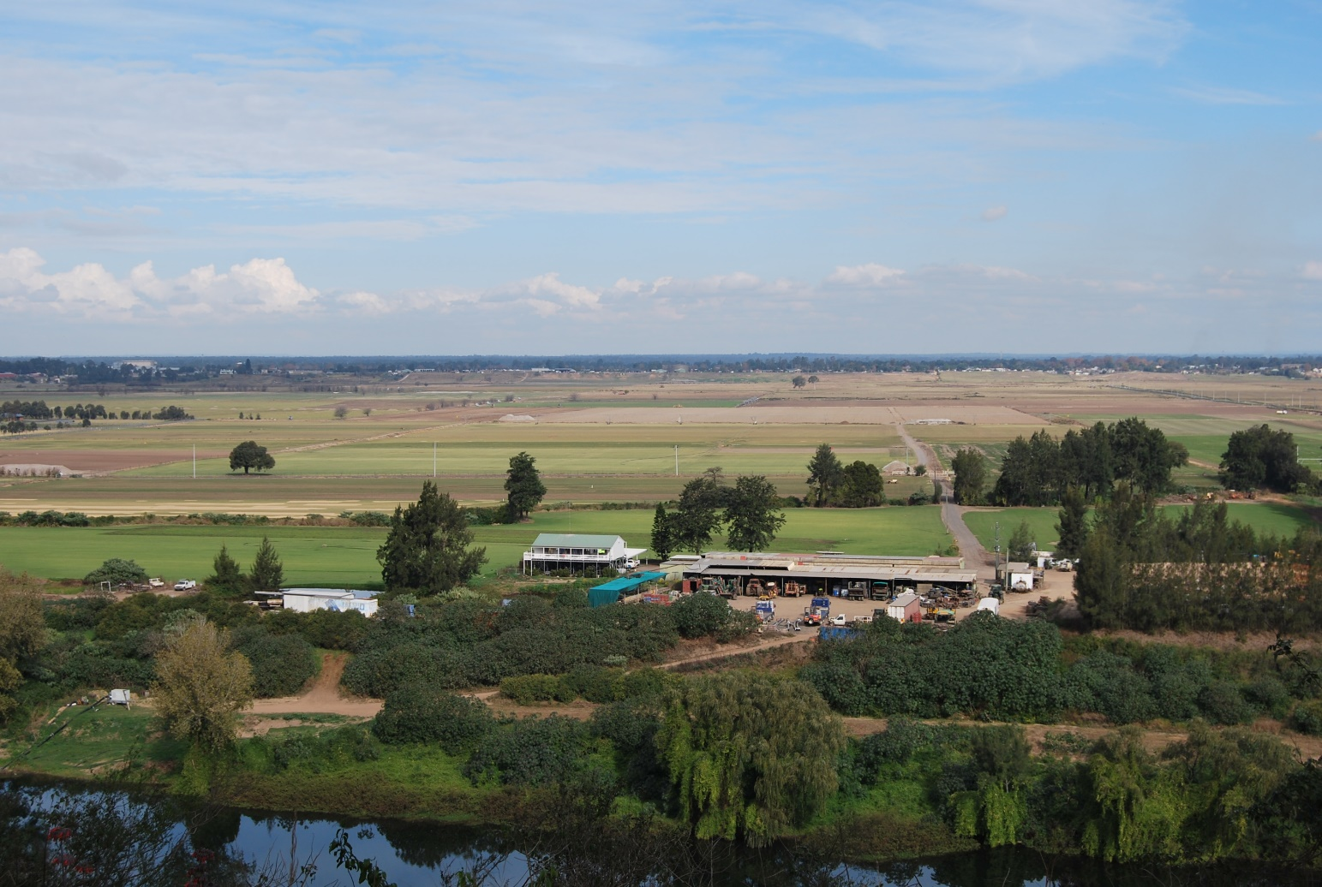
View over the floodplain from Streeton Lookout at Freemans Reach. Image: Carroll, K, WSU, 2019

Acquiring geographical information
- Pose the questions: What is a floodplain? What are the features of floodplains?
- View the photograph of the floodplain landscape as seen from Streeton Lookout at Freemans Reach. The floodplain is the low, flat middle-ground of the photograph.
- Define ‘floodplain’ as a low-lying area near a river that floods. Explain that in some floods all of the ground in the photograph could be under water.
- Students examine the photograph: What are the natural and human features? Which places do people use? What do they do there? How are people connected to other places in the area? Point out the raised house in the centre. Ask students to infer the reasons for this based on their understanding of flooding.
- Students predict impacts of flooding on the places in the photograph and the people who work, live and visit there. Use a visible thinking strategy such as ‘think-pair-share’.
- Investigate local floodplains and water bodies through a local area walk, or by making observations from the school grounds. Use maps, Street View and photographs to provide additional information. Students sketch or photograph the lowest lying areas in their local area, adding labels and annotations.

Terminology
- River, riverbank, floodplain, trees, road, house, shed, farm, paddock.

Teaching tools
- Photograph of Freemans Reach, on computers or iPads or large screen
- Photographs of local floodplains

Notes to parents/carers for use at home
Your child can look at the photo online rather than printing off if desired. Prompt your child to identify the different features, for example the natural ones and the man-made ones; those that may be covered with water during floods.
You may like to take your child on a walk around your local area to identify low lying places. You could use your phone or a camera to take some photos and upload them at home to label features.

Activity 3.2 – Flood Risk in the Hawkesbury-Nepean Valley

Time required: 20-30 minutes

Acquiring geographical information
- Pose the questions: Does it flood near us? What areas can be affected by flooding?
- View the NSW SES interactive map https://www.ses.nsw.gov.au/hawkesbury-nepean-floods/ Interpret the main geographical features of the map: rivers, lakes, roads, mountains, flat areas (plains), town.
- Interact with the NSW SES map to select a school suburb, home suburb and flood overlay for ‘very high chance’ of flood.
- Use the legend to interpret the flood overlay.
- Use satellite view to observe land use and flood spread. For instance, viewing North Richmond under a ‘medium chance’ flood shows the flood area spread widely across farmland with most housing areas above the flood. Discuss the purpose of the interactive map.
- Students interact with the map using computers or devices. They enter locations people may visit for shopping, visiting friends, sport and weekend activities.
- In ‘sharing circles’, students share their observations and wonderings. Listen to conversations and note questions, misconceptions or concerns worthy of discussion or exploration.

Terminology
- Map, satellite image, river, lake, road, mountain, depth, town, houses, location, flood.

Teaching tools
- NSW SES interactive map via computers or iPads

Notes to parents/carers for use at home
Instead of the “sharing circle” you can discuss your child’s observations and wonderings. If they have questions or misconceptions, you may like to refer to your child’s teacher, or conduct some research using the NSW SES website.

Activity 3.3 – Know How to Get Out

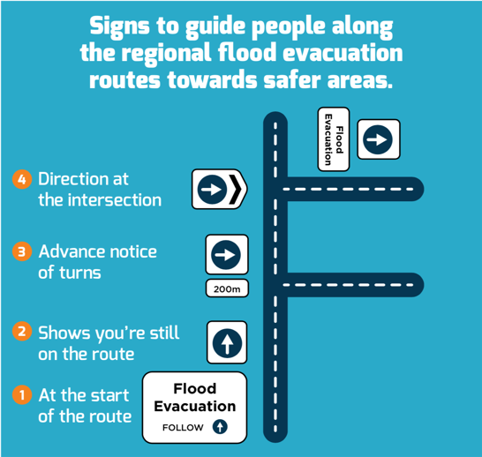
Representation of flood evacuation route signage installed in the Hawkesbury-Nepean Valley. Image: NSW SES

Time required: 40 minutes

Processing geographical information
- Pose the question: How will we know how to get out if a flood is predicted?
- Assure students that their family will take them to a safer place away from the flood. Explain that if there is going to be flooding, the NSW SES will issue flood and evacuation information.
- View the map of the flood evacuation routes on the SES NSW factsheet Know how to get out https://www.ses.nsw.gov.au/media/3174/know-how-to-get-out-fact-sheet.pdf Note the arrows at the end of each coloured route.
- Interpret the flood evacuation signage in the Hawkesbury-Nepean Valley, explained on the NSW SES factsheet Know how to get out https://www.ses.nsw.gov.au/media/3174/know-how-to-get-out-fact-sheet.pdf
- Play ‘red light green light’ with flood evacuation directional signage, printed A4 or A5. Play the game outside. Some students stand in a defined area holding arrow signs. The rest of the class pretend to drive along the ‘road’. Sign holders change the direction of the signs to direct the ‘traffic’. On ‘red light’ students freeze and ‘green light’ they go.
- Use small signs in play on road playmats and outdoor toy car tracks. Students place flood evacuation signage along driving routes for peers to follow. Refer to Resource 1 – Flood Evacuation Sign Set.
- Students complete Worksheet 4 – Know how to get out.

Terminology
- Warning, evacuate, flood evacuation, sign, follow, turn, safe.

Background notes

NSW SES factsheet Know how to get out https://www.ses.nsw.gov.au/media/3174/know-how-to-get-out-fact-sheet.pdf
Teaching tools:
- 1 set (minimum) evacuation signs, printed on A4 or A3 card. It can be good to add a stick (a ruler will do) to make it easier for students to hold up. Laminating will make them last longer,
- Small signs and play mats with cars, trucks, buses etc
- Worksheet 4 – one copy for each student. Coloured pencils

Notes to parents/carers for use at home
This activity can be done very successfully at home using a car play mat (or similar) and toy cars. You could print off the signs and your child can place them around the mat and then direct the traffic around the safe evacuation route.
If you don’t have access to a printer at home, your child could copy the picture and then colour it in.

Activity 3.4 – Protect What You Love
Time required: 30-40minutes

Processing and communicating geographical information
- Pose the question: If you had to evacuate, what three things would you take?
- View the NSW SES YouTube video clips: Protect What You Love – Social Byte 9 (27sec) https://youtu.be/sSoB5rYOsYw and Protect What You Love – Social Byte 3 (27sec) https://youtu.be/EjDgXlruq0o
- Students ‘turn and talk’ to a partner to answer the questions: What three things would you take? Why would you take those three things? Why is it good to think about this now?
- Students create 30 second video clips of each other stating what they would take. They use the same format as the NSW SES Protect What You Love videos.
- Discuss as a class: Review some of the video clips. Discuss the importance of planning and preparing before a flood.

Background notes
- Protect what you love #3things https://www.ses.nsw.gov.au/get-involved/protect-what-you-love-3things/

Other teaching tools
- Access to computer or Smart TV to view YouTube clips
- Video cameras to film 30 second video clips

Notes to parents/carers for use at home
Get your child to tell you the things they would take with them. Ask them why they chose those particular things. Consider if there are some things that may be more important for your child to have with them if they needed to evacuate.
Making a video using a mobile phone is quite an easy process. Make sure your child has prepared a “script” before starting (although of course it’s easy to delete any recordings you don’t want). If you prefer your child could write a story instead.

Worksheet 4 – Know How to Get Out
Name ____________________________
Instructions
- Follow the evacuation signs on the road to trace the 2 evacuation routes.
- Draw 4 cars driving on the road towards a safer area.
- Draw the school bus picking students up to evacuate them to a safer area.
- Draw 1 ute pulling a horse float to a safer area.
- Draw 3 trucks driving to a safer area.
- Colour the farmland on the floodplain light green.
- Colour the river blue.
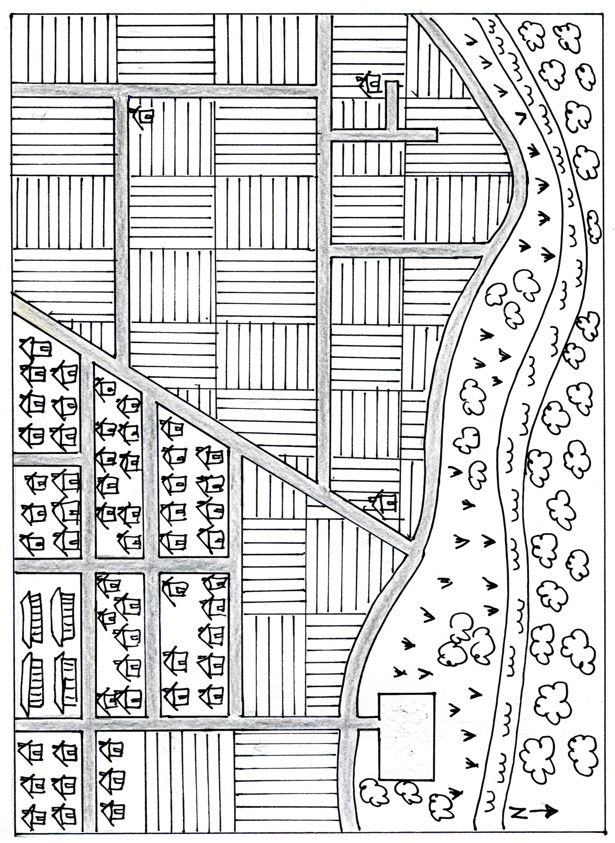
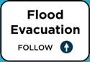
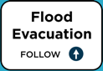
- Colour the trees and grasses on the riverbank dark green.
evacuation sign 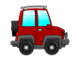car horsefloat and ute school bus 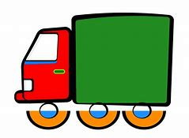truck

Resource 1– Flood Evacuation Sign Set
Create at least one set of each sign per class for Activity 3.3: Know How to Get Out
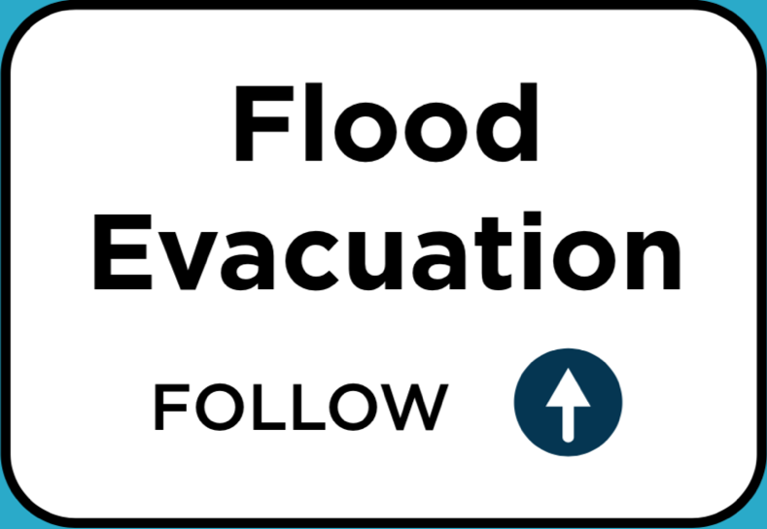
Sign located at the start of the flood evacuation route Signs indicating direction to turn at intersection

Signs indicating you are following the correct route

Signs indicating you are following the correct route

Signs giving advance notice of a turn

