Learning Sequence 2 – People and Floods in the Hawkesbury-Nepean Valley

Outcomes
- GE3-1 describes the diverse features and characteristics of places and environments
- GE3-2 explains interactions and connections between people, places and environments
- GE3-4 acquires, processes and communicates geographical information using geographical tools for inquiry

Inquiry questions
- What is the history of floods in the Hawkesbury-Nepean Valley?
- How do we know that the Hawkesbury-Nepean Valley will flood again?
- How is geographical data and information acquired, processed and communicated?
- What is the pattern of flood cycles in the Hawkesbury-Nepean Valley?
- What is our flood risk?
- Who is responsible for flood preparation and response?
- What can we do to prepare?

Learning intention
We are learning to use geographical tools to understand interconnections between environments, places and people.

Geographical tools
- MAPS – online maps, flood maps
- SPATIAL TECHNOLOGIES – interactive flood maps
- VISUAL REPRESENTATIONS – photographs, field sketches, video, infographics
- GRAPHS AND STATISTICS – dot plot graphs, tables

Introduction
Aboriginal oral history recounts a long history of flooding in the Hawkesbury-Nepean Valley. Since written records began in the 1790s, there have been about 130 moderate to major floods in the valley. The largest flood in living memory (within an 80-year lifetime) was in November 1961 when water reached 14.5 metres above normal river height at Windsor. To work out how regularly an area might flood, the chance or likelihood of different scales of flood is assessed based on scientific tests and models.
The teaching and learning activities in Learning Sequence 2 develop students’ skills in interpreting geographical information in order to build understanding of:
- the likelihood of floods in the Hawkesbury-Nepean Valley,
- the impacts of flooding on places and people,
- people’s responsibilities in preparing for flood and
- managing the risks of flooding.
The learning sequence draws on graphs, maps and information presented in a regional flood study and communication products.
Note – some students may have had experiences of different types of flooding. Be sensitive to the impacts and trauma this may have caused for individuals and families.

Background notes for teachers
Refer to:
- Hawkesbury-Nepean Valley Regional Flood Study July 2019 Overview http://www.infrastructure.nsw.gov.au/media/2162/ec_insw_hawkesbury-nepean_fss-document_web.pdf
- Geography K-10 Syllabus © NSW Education Standards Authority (NESA) for and on behalf of the Crown in right of the State of New South Wales, 2015 https://educationstandards.nsw.edu.au/wps/portal/nesa/k-10/learning-areas/hsie/geography-k-10

Activity 2.1 – History of Floods in the Hawkesbury-Nepean Valley
Approximate time required: 20 minutes

Acquiring and processing geographical information
- Pose the question: What is the history of floods in the Hawkesbury-Nepean Valley?
- Activate prior knowledge of flooding in the Hawkesbury-Nepean Valley. What are the clues that inform us that the region might flood? (Depth markers, flood signs, historical signage, geography)
- View the NSW SES YouTube video It Will Flood Again (5:59min) https://youtu.be/jo9VbKbMZ6o
- Make connections: text-to-text, text-to-self, text-to-world.
- Reflect on people’s decisions in past floods as shown in the images and newspaper clippings in the video. What were good decisions? What were poor choices? What did some poor choices lead to? Note – this may be an opportune time to introduce the Flood Choices Game Design Task outlined in Learning Sequence 3, Activity 3.2.
- Students complete Worksheet 3 – Floods Consequences Wheel.

Terminology
- Hawkesbury-Nepean Valley, population, height above, submerged, floodwaters, damage, isolated, stranded, affected, impacted, flood debris, deluge, evacuated, rescue.

Background notes
- NSW SES It Will Flood Again factsheet https://www.ses.nsw.gov.au/media/3172/it-will-flood-again-fact-sheet.pdf

Teaching tools
- Access to smart TV or devices to watch NSW SES YouTube video
- Worksheet 3 - one copy per student

Optional Extension Activity

Students research colonial settlement of the valley, investigating how the natural environment influenced settlement patterns, impacts on Country and Aboriginal people, and impacts of the 1867 flood on places and people.

Notes to parents/carers for use at home
You may like to assist your child to research flooding in the Hawkesbury-Nepean Valley online. The website of NSW SES, Water NSW, State Library of NSW are just a few sources of great information.
The NSW SES YouTube video can be watched on any device with internet access. Discuss the video with your child and ask their impressions of the decisions people made. You may like to ask your child what decisions they might have made in the circumstances.

Activity 2.2 – How the Experts Know it Will Flood Again
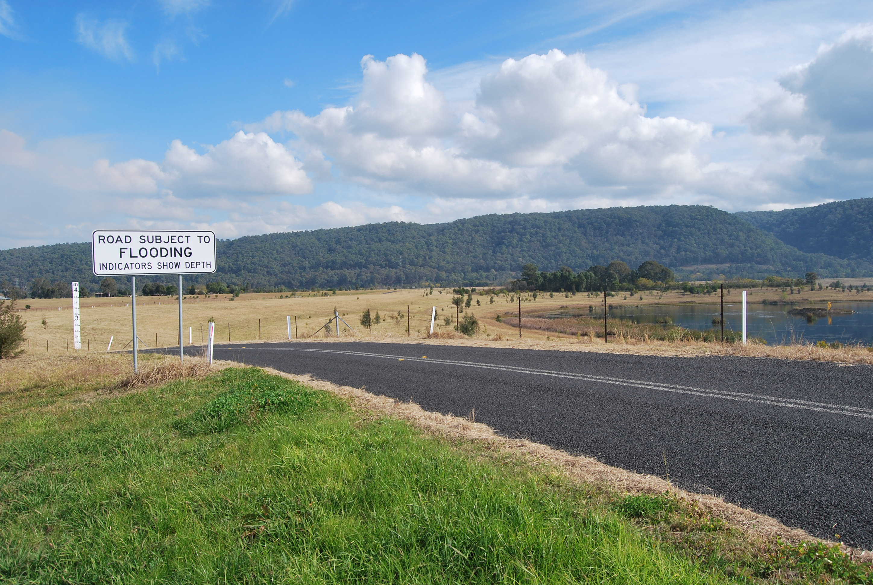
Flood indicator sign, Castlereagh Rd, Castlereagh. Image; Western Sydney University, 2019

Approximate time required: 20 minutes

Acquiring and processing geographical information
Pose the questions: How do we know that the Hawkesbury-Nepean Valley will flood again? What is the pattern of flood cycles in the Hawkesbury-Nepean Valley? How is flood and geographical data acquired, processed and communicated?
- Use the image as stimulus. Students ‘turn and talk’ to discuss the inquiry questions.
- Recall understandings developed from the catchment model created in Learning Sequence 1. Relate the observed water flow and movement to land uses and livelihoods in the Hawkesbury-Nepean Valley, for instance inundation of roads, houses, paddocks and businesses in low-lying areas.
- Browse the flood study overview – Hawkesbury-Nepean Valley Regional Flood Study Overview, July 2019, http://www.infrastructure.nsw.gov.au/media/2162/ec_insw_hawkesbury-nepean_fss-document_web.pdf Align the flood study process summarised on page 11 with the steps in the geographical inquiry process.
- Note the geographical tools used in the report: maps, photographs, graphics, tables, graphs.
- Students complete Worksheet 4 – Interpreting Flood Study Findings.

Terminology
- Strategy, management, regional, flood modelling, technical, chance, frequency, probable maximum flood (PMF), frequent, infrequent, hydrology.

Background notes
- NSW SES It Will Flood Again factsheet https://www.ses.nsw.gov.au/media/3172/it-will-flood-again-fact-sheet.pdf
- Hawkesbury-Nepean Valley Regional Flood Study July 2019 Overview http://www.infrastructure.nsw.gov.au/media/2162/ec_insw_hawkesbury-nepean_fss-document_web.pdf
- The NSW Government released Resilient Valley, Resilient Communities – Hawkesbury- Nepean Valley Flood Risk Management Strategy (Flood Strategy) in May 2017. The Flood Strategy details how the NSW Government, local councils, businesses and the community work together to reduce and manage the flood risk in the Hawkesbury-Nepean Valley. One of the actions in the Flood Strategy was to prepare a new regional flood study for the valley. This was published in July 2019 as three comprehensive documents plus an overview document (http://www.infrastructure.nsw.gov.au/media/2162/ec_insw_hawkesbury-nepean_fss-document_web.pdf) that summarises the key findings for the community. A series of factsheets focusing on key areas was also published. These are available on the NSW SES website https://www.ses.nsw.gov.au/hawkesbury-nepean-floods
- Mathematics link: This activity supports Mathematics K-10 Syllabus, Stage 3, Data 2 – MA3-18SP ‘uses appropriate methods to collect data and constructs, interprets and evaluates data displays, including dot plots, line graphs and two-way tables’ and Chance 2 – MA3-19SP ‘describes and compares chance events in social and experimental contexts’ https://educationstandards.nsw.edu.au/wps/portal/nesa/k-10/learning-areas/mathematics/mathematics-k-10/content

Teaching tools
- Photograph/s of flood indicator sign as above and other similar signs, either on large screen TV or devices
- Access to Hawkesbury-Nepean Valley Regional Flood Study July 2019 Overview
- Worksheet 4 – one copy per student

Notes to parents/carers for use at home
Worksheet 4 shows the pattern of flooding in the Hawkesbury-Nepean Valley. You may like to help your child interpret the data and answer the questions. You can access the Hawkesbury-Nepean Valley Regional Flood Study July 2019 Overview on any device with internet access. You may like to encourage your child to look up any words or terms that are unfamiliar and create their own glossary.

Activity 2.3 – Knowing Flood Risk
Approximate time required: 25 minutes

Acquiring and processing geographical information
- Pose the question: What is our flood risk?
- View the Maps 1 and 2. Examine the spatial distribution of the floods described in these maps (that is 1 in 100 chance per year flood, 1 in 500 chance per year flood and the probable maximum flood (PMF) which is approximately a 1 in 45 000 chance per year flood.)
- Introduce the NSW SES online map https://www.ses.nsw.gov.au/hawkesbury-nepean-floods/
Explore its scale and interactive features.
- Students interact with the online map to determine the flood risk for where they live, their school and places they frequently visit within the Hawkesbury-Nepean Valley. They examine the flood overlays and compile information into the table in Worksheet 5.
- Go outside and measure out the flood heights reached at each place to gain an understanding of the depths.
- Students complete Worksheet 5 – Our Flood Risk.

Terminology
- Flood risk, chance, depth, metres, access.

Background notes
- Flood Risk in the Hawkesbury-Nepean Valley https://www.ses.nsw.gov.au/hawkesbury-nepean-floods
- Hawkesbury-Nepean Valley Regional Flood Study July 2019 Overview http://www.infrastructure.nsw.gov.au/media/2162/ec_insw_hawkesbury-nepean_fss-document_web.pdf

Teaching tools
- Copies of Maps 1 and 2. Can be online, printed for each child/group/block, or large copies made for the classroom
- Access to devices or other means to view NSW SES online map/s
- System for measurement of flood heights such as long pieces of string or twine
- Worksheet 5 – one copy per student

Notes to parents/carers for use at home
You may choose to print the maps if you have access to a printer at home, but your child can also study them online. The NSW SES online map can be viewed on any device with internet access. You may like to help your child navigate the flood overlays and complete Worksheet 5. Outside, your child can measure flood heights against familiar things such as the house, a tree, other local buildings.

Activity 2.4 – Flood Responsibilities
Approximate time required: 30-40 minutes

Processing and communicating geographical information
- Pose the questions: Who is responsible for flood preparation and response? What can we do to prepare?
- View the YouTube video NSW SES Storm and Flood Volunteers (1:05min) https://youtu.be/uxRNPd6Ar0w
- Students create ‘graffiti boards’, in groups, listing the organisations, groups and individuals with responsibilities during floods and their roles. They include, for example themselves, their family, pet owners, neighbours, schools, local community, local council, NSW SES, Bureau of Meteorology, ABC News.
- Students use the NSW SES website and factsheets to clarify information https://www.ses.nsw.gov.au/hawkesbury-nepean-floods
- Students create a 20 second rap that reinforces the six steps of how to prepare: know your risk, know where to go, know who to call, prepare a home emergency kit, check insurance, know when to act.

Terminology
- Emergency, flood evacuation, information.

Background notes
- NSW SES website and factsheets https://www.ses.nsw.gov.au/hawkesbury-nepean-floods
- Knowledge Hub for National Strategy for Disaster Resilience: https://knowledge.aidr.org.au/resources/national-strategy-for-disaster-resilience/

Teaching tools
- Means to view NSW SES YouTube video such as smart TV or devices
- A3 paper for creating graffiti boards
- Access to NSW SES Factsheets

Notes to parents/carers for use at home
The NSW SES YouTube video can be viewed on any device with internet access.
Encourage your child to make a “graffiti board’ (poster) listing the different organisations with responsibilities during floods. They may also like to create a rap, poem or song.

Worksheet 3 – Flood Consequences Wheel

Instructions
- In the inner ring state impacts of floods on places.
- In the outer ring state impacts of floods on people.

FLOOD
PEOPLE

Worksheet 4 – Interpreting Flood Study Findings
PLACES
Use the graph to answer the following questions. 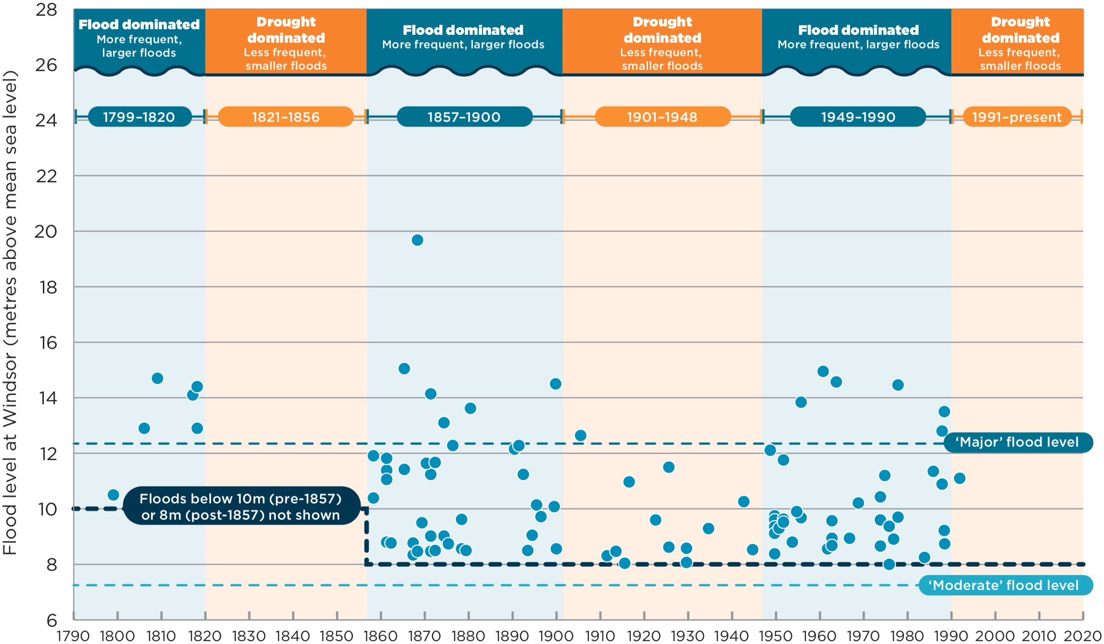
Patterns of floods – Hawkesbury-Nepean floods at Windsor from 1790 to present; Hawkesbury-Nepean Valley Regional Flood Study July 2019 Overview p9 http://www.infrastructure.nsw.gov.au/media/2162/ec_insw_hawkesbury-nepean_fss-document_web.pdf
1. What do the blue and orange columns represent? ____________________________________________________
2. How many years does each period cover? Complete the table.
FLOOD | DROUGHT | FLOOD | DROUGHT | FLOOD | DROUGHT

3. What does this pattern indicate for the future in the Hawkesbury-Nepean Valley? ___________________________
4. What does each axis represent? X-axis __________________________ Y-axis _________________________
5. In what decade (10 year period) was the highest flood on record? ________________
6. In what year did the last major flood occur? ________________
7. What was the height of the last flood? ________________
8. What is the key information this graph communicates to the community? _________________________________
_____________________________________________________________________________________________
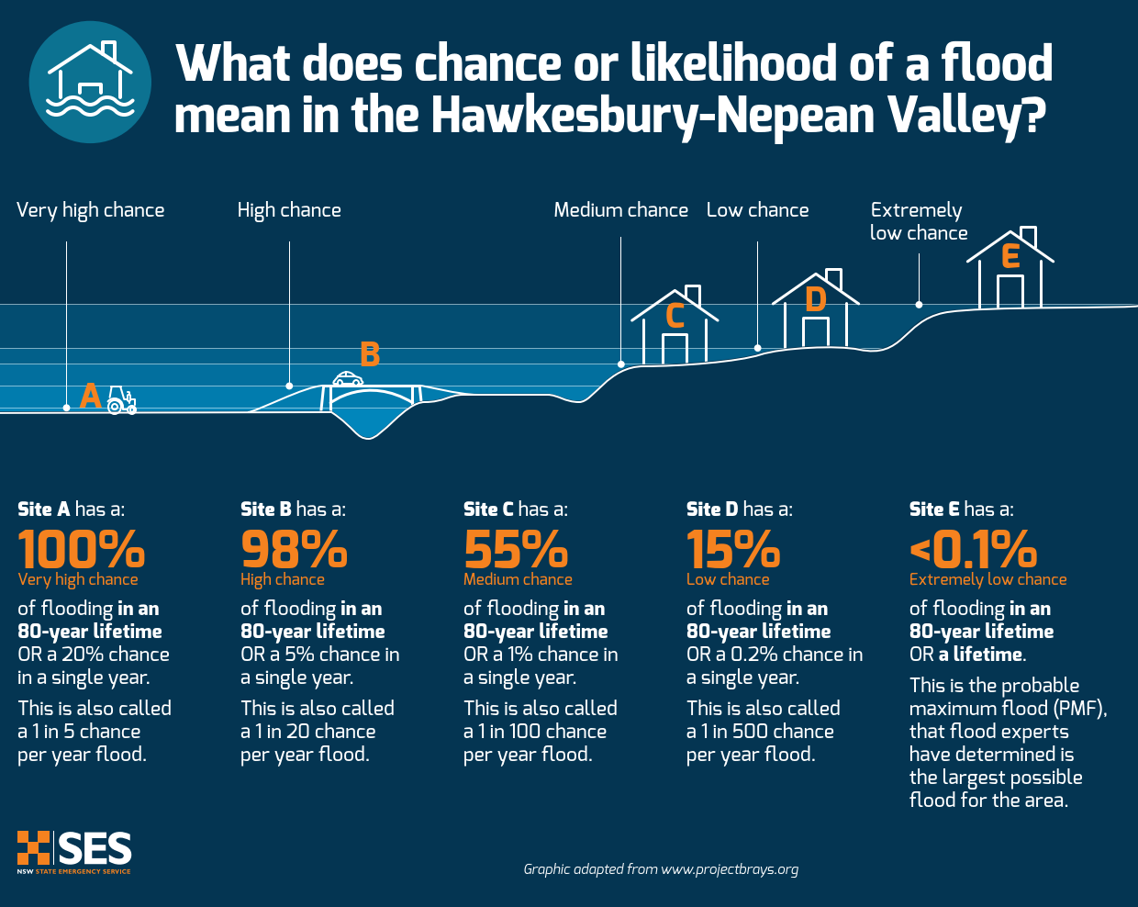

Comparison and effects of the likelihood of different flood events in an 80-year lifetime.
Source: https://www.ses.nsw.gov.au/media/3232/explaining-flood-likelihood-graphic.pdf

9. How is the likelihood/chance of flood in the Hawkesbury-Nepean Valley described? Use the diagram to complete the table.
Chance in an 80-year lifetime | 100% | 98% | 55% | 15% | <0.1%
% chance per single year
1 in x chance per year
Descriptive words

Further information
- NSW SES It Will Flood Again factsheet https://www.ses.nsw.gov.au/media/3172/it-will-flood-again-fact-sheet.pdf
- Hawkesbury-Nepean Valley Regional Flood Study July 2019 Overview http://www.infrastructure.nsw.gov.au/media/2162/ec_insw_hawkesbury-nepean_fss-document_web.pdf

Worksheet 5 – Our Flood Risk
- Use the NSW SES Online flood risk mapping tool to find out about the flood risk for your suburb, school and 3 other places in the Hawkesbury-Nepean Valley. https://www.ses.nsw.gov.au/hawkesbury-nepean-floods Note - if you live or study outside the Hawkesbury Nepean Valley, you can obtain flood risk information from the local council and/or select a suburb within the Hawkesbury Nepean Valley.
- Select each flood likelihood and examine the flood overlay on the map.
- Complete the table using the information panel.
- Download and examine the 1 in 100 chance per year map, available in the information panel.
 | MY SUBURB | MY SCHOOL | PLACE 1 | PLACE 2 | PLACE 3
Place
Floodplain
In what chance flood may there be impacts?
Potential impacts
Height of largest flood
Chance of that flood occurring
Height of last major flood
Chance of that flood occurring
Other information
Questions

Map 1 – Flood Map for a 1 in 500 (0.2%) Chance per Year Flood
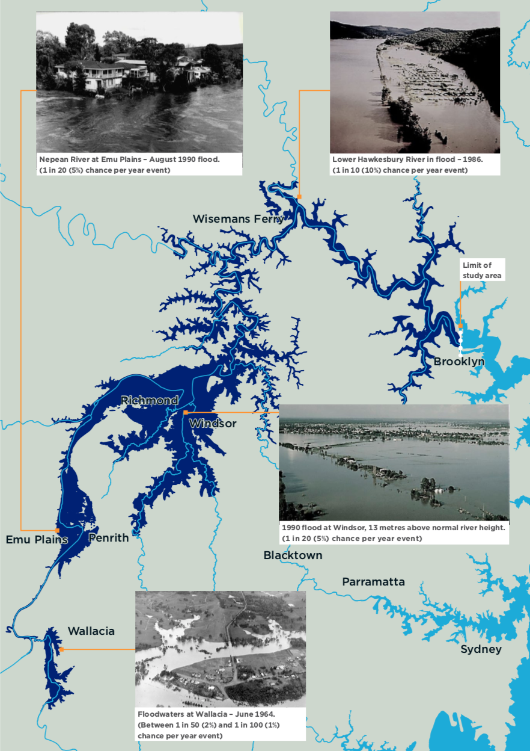
Hawkesbury-Nepean River flood extent for a 1 in 500 (0.2%) chance per year flood. Source: Hawkesbury-Nepean Valley Regional Flood Study July 2019, Overview, p14 http://www.infrastructure.nsw.gov.au/media/2162/ec_insw_hawkesbury-nepean_fss-document_web.pdf

Map 2 – Hawkesbury-Nepean Flood Study Area
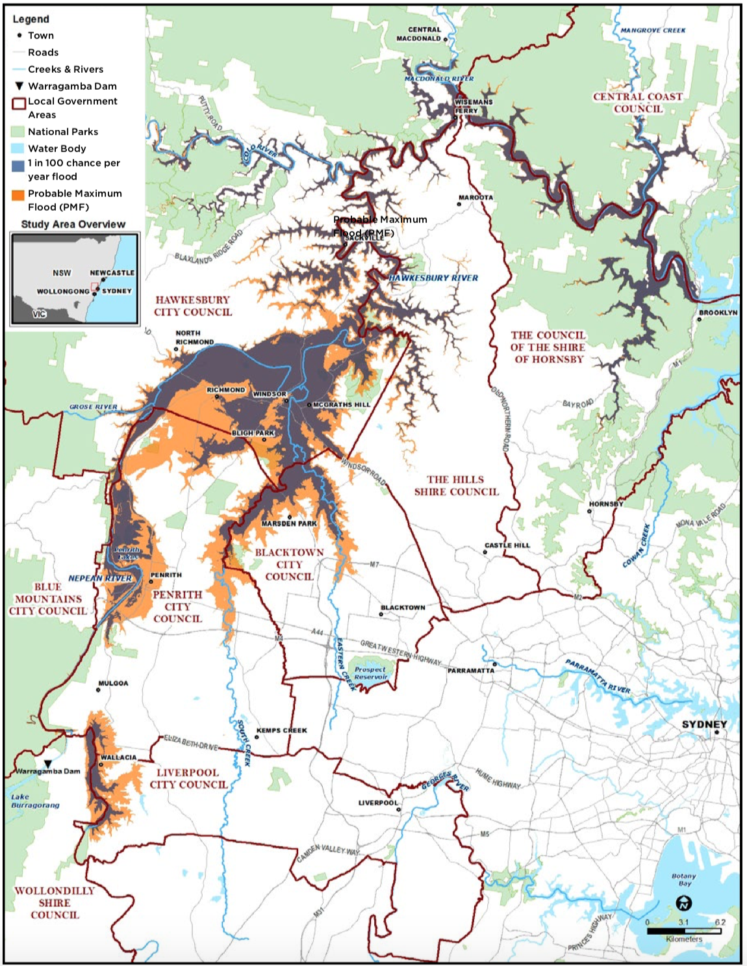
Hawkesbury-Nepean Valley Regional Flood Study Area. Source: Hawkesbury-Nepean Valley Regional Flood Study July 2019, Overview, p3 http://www.infrastructure.nsw.gov.au/media/2162/ec_insw_hawkesbury-nepean_fss-document_web.pdf

