Learning Sequence 1 – Natural Environment of the Hawkesbury-Nepean River and its Catchment

Outcomes
- GE3-1 describes the diverse features and characteristics of places and environments
- GE3-2 explains interactions and connections between people, places and environments
- GE3-4 acquires, processes and communicates geographical information using geographical tools for inquiry

Inquiry questions
- Where is the Hawkesbury-Nepean Valley? Where is its catchment?
- What are the natural features of the Hawkesbury-Nepean Valley?
- How does water flow and behave in a catchment?
- How do the unique natural features of the Hawkesbury-Nepean Valley affect flooding?
- What are the natural warning signs of floods, and where can people obtain information?

Learning intention
We are learning about ways that natural environments influence places and people.

Geographical tools
- MAPS – online maps, catchment maps
- SPATIAL TECHNOLOGIES – online maps, satellite images
- VISUAL REPRESENTATIONS – photographs, videos, 3D modelling, diagrams, infographics, picture books

Introduction
The Hawkesbury-Nepean Valley stretches along the Nepean and Hawkesbury rivers from Bents Basin near Wallacia to Brooklyn Bridge at Brooklyn. Its catchment extends past Goulburn in the south, Lithgow in the west and Putty in the north. The unique natural features of the valley mean that following heavy rain in the catchment water can flow in faster than it can be released through the narrow Sackville Gorge. This is known as the “bathtub effect” and can result in rapid and deep flooding over large areas of the floodplain. The traditional custodians of the land on the southern banks of the Hawkesbury River are the Darug people. The river and the surrounding floodplains, lagoons and bushland provided rich resources for Aboriginal people.
The teaching and learning activities in Learning Sequence 1 develop students’ understanding of catchments, water flows and the features of the natural environment of the Hawkesbury-Nepean Valley. They interpret geographical information to describe ways in which the natural environment influences places and people, with a focus on flood behaviour. The learning sequence uses maps and visual representations to build skills and understanding.

Background notes for teachers
Refer to:
- Flooding in the Hawkesbury-Nepean Valley factsheet, Infrastructure NSW http://www.infrastructure.nsw.gov.au/media/1525/hnvflooding_factsheet_feb2018.pdf
- Hawkesbury-Nepean Valley Regional Flood Study July 2019 Overview http://www.infrastructure.nsw.gov.au/media/2162/ec_insw_hawkesbury-nepean_fss-document_web.pdf
- Geography K-10 Syllabus © 2015 NSW Education Standards Authority (NESA) for and on behalf of the Crown in right of the State of New South Wales https://educationstandards.nsw.edu.au/wps/portal/nesa/k-10/learning-areas/hsie/geography-k-10

Activity 1.1 – Features of the Hawkesbury-Nepean River and its Catchment
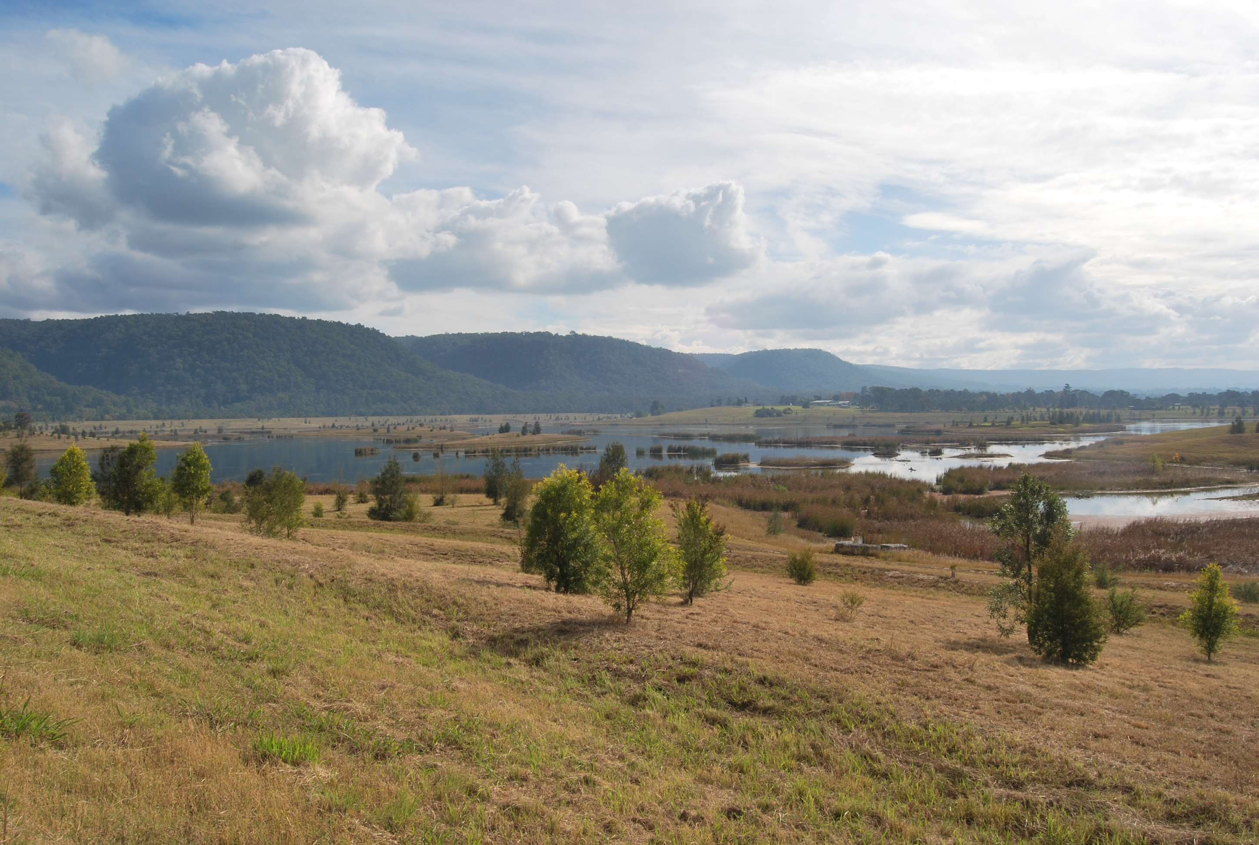
View of the lower Blue Mountains and Penrith Lakes in the Hawkesbury-Nepean Valley, from Castlereagh Road, Castlereagh. Image: Western Sydney University, 2019

Approximate time required: 20-30 minutes

Acquiring geographical information
- Pose the questions: Where is the Hawkesbury-Nepean Valley? What are the features of its catchment?
- View the photograph of the Hawkesbury-Nepean Valley. Name the landforms and natural features.
- Acknowledge the traditional custodians of the area, including the Darug people, Deerubbin as a traditional name of the Hawkesbury River and Yandhai as a traditional name for the Nepean River.
- Use an online map to locate Castlereagh Road, Castlereagh. Switch to satellite view for an aerial view of the landforms and land uses shown in the photograph.
- Examine the formations of the mountains to the west of the Nepean River, in satellite view on the map. How do the natural features influence the location of the roads and settlements (built on ridges)?
- If your school is not in the Hawkesbury-Nepean Valley, find a map of your local area. What are the similarities and differences between your area and the Hawkesbury-Nepean Valley?
- Locate the rivers and creeks that flow into the Nepean and Hawkesbury Rivers. Explain that the river and valley ‘catch’ water that flows through creeks and off the land.
- Define ‘catchment’ as ‘an area where water is collected by the natural landscape’ (Water NSW).
- Examine the Hawkesbury-Nepean Catchment map at Figure 1 http://www.insw.com/media/2163/hnv-regional-flood-study-final-jul19-vol1-main-report-figs-1-22.pdf (Note the west orientation of the map.) Locate: Warragamba Dam, Wallacia, Penrith, North Richmond, Windsor, Grose River and South Creek. Describe the location of the Hawkesbury-Nepean Catchment in relation to Sydney.
- Find a map of your catchment. Identify the rivers and tributaries that flow into your catchment area.

Terminology
- Hawkesbury-Nepean Valley, Nepean River, Hawkesbury River, Darug, Deerubbin, mountain, ridge, valley, lake, slopes, plains, floodplain, catchment.

Background notes
- What is a catchment? Water NSW https://www.waternsw.com.au/water-quality/education/learn/catchment

Teaching tools:
- Photograph of the Hawkesbury-Nepean Valley from Castlereagh Rd, Castlereagh on large screen or on devices
- Access to online maps such as Google maps, through devices or Smart TV
- Map/s of local area
- Copies of catchment map at Figure 1

Notes to parents/carers for use at home
Your child can view the photograph on a screen, or you may choose to print it off for them. Any device can be used to view maps on Google Maps; however, a larger screen such as a laptop will make the images clearer and easier to examine and locate the features.
You may like to find out in which catchment area your home is located.

Activity 1.2 – Crumpled Paper Catchment Model
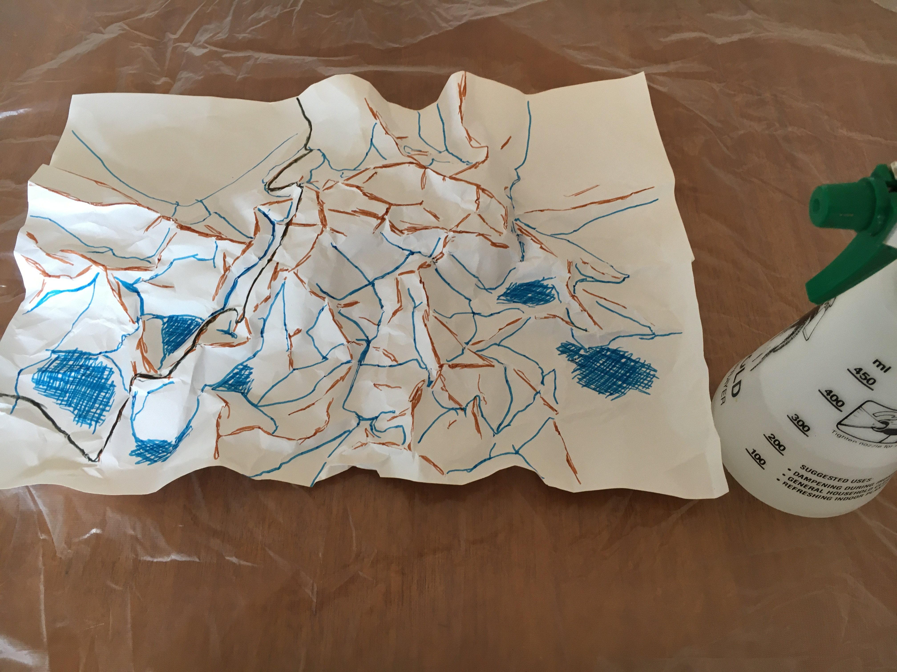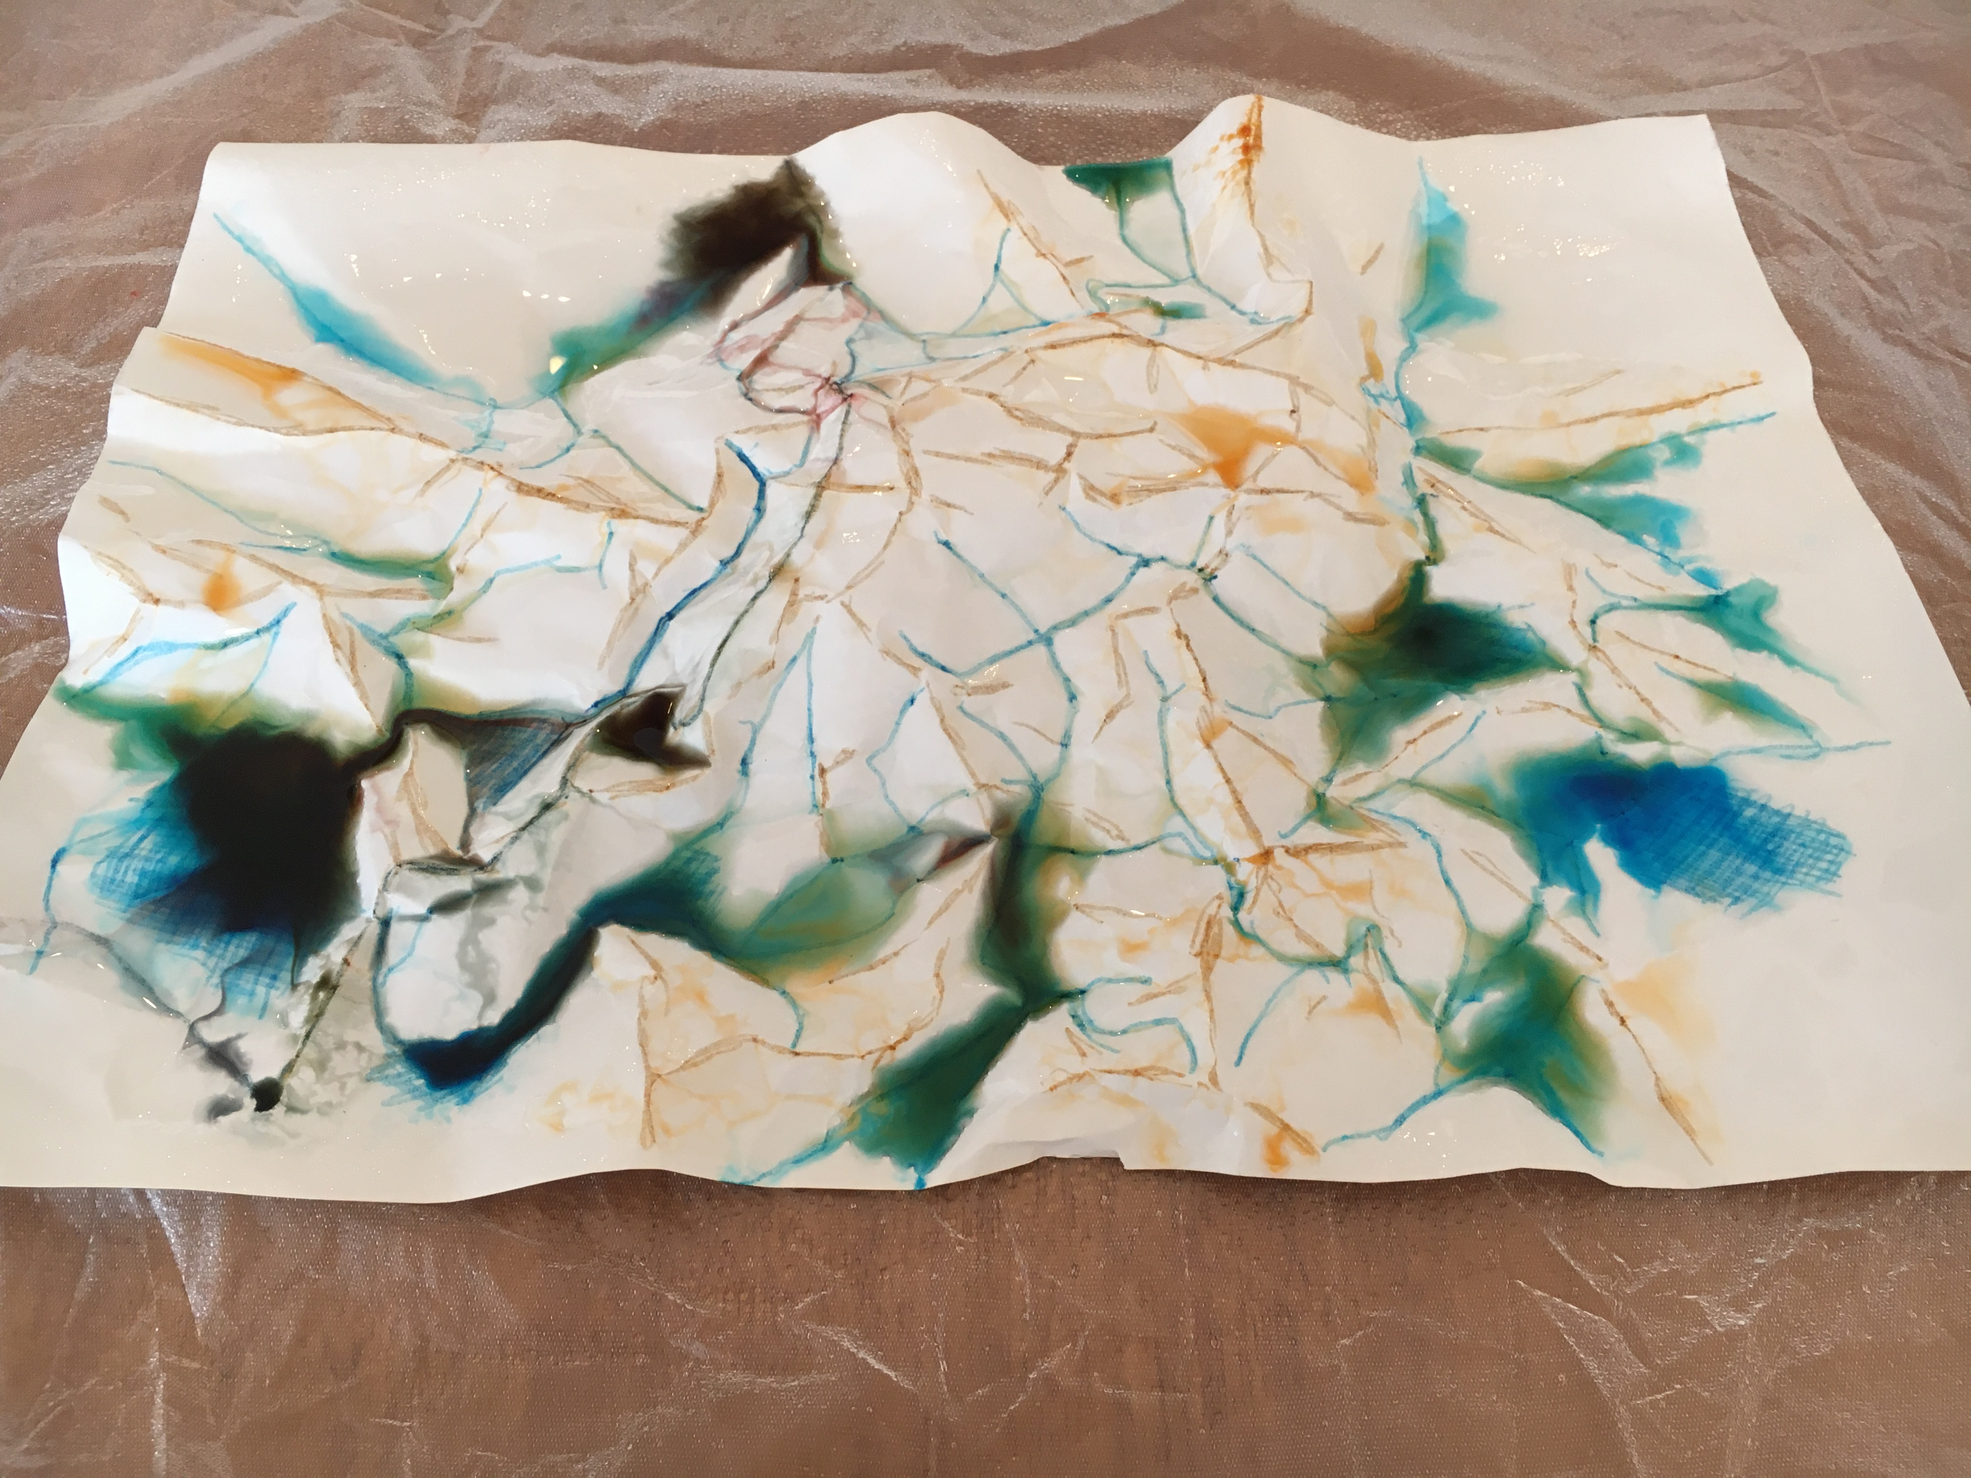

Approximate time required: 15-20 minutes

Acquiring and processing geographical information
- Pose the question: How does water flow and behave in a catchment?
- Recall the definition of a catchment from Activity 1.1.
- Students create 3D models of a catchment using crumpled paper. They work in groups and follow the procedure outlined in Worksheet 1.
- Reflect on and discuss the colour of the pooled water in the lowest lying areas and apply to real-life scenarios. Is it clean? What substances would be washed off roads and other hard surfaces or from farmland into low-lying areas?
- Students complete Worksheet 1 – Crumpled Paper Catchment Model.

Terminology
- Ridge, valley, rain, lake, flood, catchment, water flow.

Background notes
- Science and technology link: This activity supports Science and Technology K-6 Syllabus Stage 3, Earth and Space: ST3-1WS-S ‘plans and conducts scientific investigations to answer testable questions, and collects and summarises data to communicate conclusions’ and ST3-10ES-S ‘explains regular events in the solar system and geological events on the Earth’s surface’ https://educationstandards.nsw.edu.au/wps/portal/nesa/k-10/learning-areas/science/science-and-technology-k-6-new-syllabus

Teaching tools (Note: full details of this activity are found in Worksheet 1)
- Art paper, 1 sheet per block or small group of students
- Coloured markers
- Tote trays or similar
- Water spray bottles or similar
- Worksheet 1 – one copy per student

Notes to parents/carers for use at home
This is such a fun and easy activity and a brilliant way to demonstrate the features of a catchment. It is best to put something down to protect the table from spills, such as a sheet of plastic or a beach towel, or you could do the activity outside. Crumple the paper then place in a large shallow plastic container, such as a big cake container. Textas or watercolour paints can be used to colour the crumpled paper, then a spray bottle or jug used to pour the “rain” into the catchment. A strainer or sieve makes great rainfall.

Activity 1.3 – Unique Landscape of the Hawkesbury-Nepean Valley

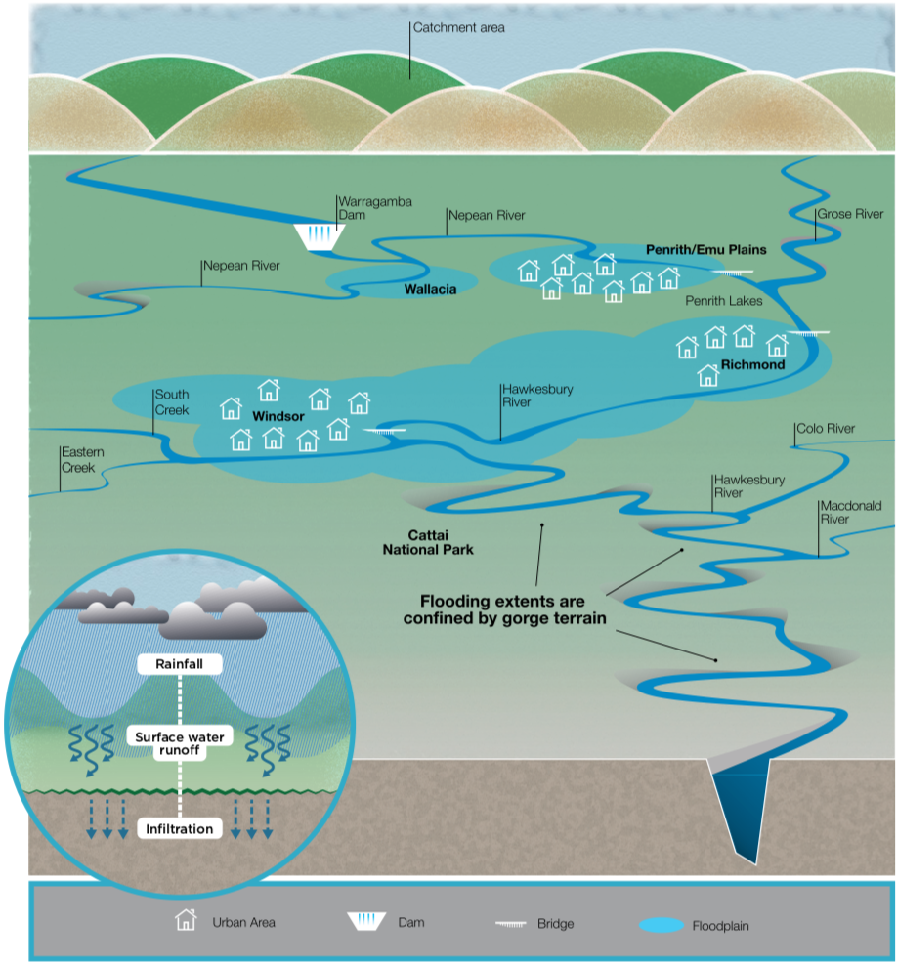
Hawkesbury-Nepean Valley Landscape, Infrastructure NSW

Approximate time required: 20-25 minutes

Acquiring and processing geographical information
- Pose the questions: What are the unique natural features of the Hawkesbury-Nepean Valley? How do they affect river flows in floods?
- Activate prior knowledge, drawing on experiences in the Hawkesbury-Nepean Valley and understandings developed in Activities 1.1 and 1.2.
- Examine the graphic representing the landscape of the Hawkesbury-Nepean Valley in Graphic 1 (and above). Note the west orientation of this stylised map. Students interpret the graphic individually and then use ‘think-pair-share’ to share three pieces of information the graphic is communicating.
- View the NSW SES YouTube video Why Hawkesbury-Nepean Floods Are So Dangerous (2:30min) https://youtu.be/28SN9KixO2I
- Discuss the information presented in the video. Students recall the causes and effects explained in the video and graphic.
- Go outside into the school grounds or to a high point to observe the surrounding landscape and identify any features similar to those described in the video. On a walk around the school grounds, students predict the areas that would flood first, justifying their predictions using the concept of ‘cause and effect’.
- Students complete Worksheet 2 – Interconnections in the Hawkesbury-Nepean.

Terminology
- ‘Bathtub’ effect, tributary, gorge, choke point, downstream, extreme, dangers.

Background notes
- Flooding in the Hawkesbury-Nepean Valle factsheet, Infrastructure NSW, http://www.infrastructure.nsw.gov.au/media/1525/hnvflooding_factsheet_feb2018.pdf
- Knowing the Signs factsheet, NSW SES https://www.ses.nsw.gov.au/media/3233/knowing-the-signs-of-flooding-fact-sheet.pdf

Teaching tools:
- Access to NSW SES YouTube video via smart TV or devices
- Worksheet 2 – one copy per student

Notes to parents/carers for use at home
Your child can watch the video on any device with internet access. You can view the graphic online or print off a copy for your child.
You can demonstrate the Bathtub Effect at home in the bathroom. Turn the basin taps on as hard as possible and leave the plug out of the plughole. Ask your child what they notice about the water level in the basin. Then ask them to image there were five taps running into the basin. (Using the basin rather than the bath uses less water for the same effect.)

Activity 1.4 – Natural Warning Signs
Approximate time required: 30 minutes

Acquiring and communicating geographical information
- Pose the question: What are the natural warning signs of floods? Where can people obtain information?
- Share the picture book Flood by Alvaro F. Villa. This wordless text visually describes the progress of a flood from the appearance of heavy clouds to extreme rain, through damaging flooding to recovery. (Alternative text – Big Rain Coming by Katrina Germein and Bronwyn Bancroft.)
- Make connections: text-to-self, text-to-text, text-to-world.
- Read about the natural warning signs in the NSW SES Knowing the Signs factsheet https://www.ses.nsw.gov.au/media/3233/knowing-the-signs-of-flooding-fact-sheet.pdf
- Bureau of Meteorology Information for students and teachers http://www.bom.gov.au/climate/data-services/education.shtml
- Bureau of Meteorology National Warnings Summary http://www.bom.gov.au/australia/warnings/
- Students create a 20 second mime, with sound effects, to communicate the natural warning signs of flood in four scenes: ‘looks like’, ‘sounds like’, ‘feels like’, and ‘where to find out more’.

Terminology
- Sustained rainfall, deluge, torrential, catchment, predict, advice, warning, severe, order, evacuate.

Background notes
- NSW SES Knowing the Signs factsheet https://www.ses.nsw.gov.au/media/3233/knowing-the-signs-of-flooding-fact-sheet.pdf
- Flood by Alvaro F Villa, Capstone Press, US, 2014
- Big Rain Coming by Katrina Garmin (author) and Bronwyn Bancroft (illustrator), Penguin Australia, 2002
- Flood – Reader’s Guide, Capstone Young Readers https://www.teachingbooks.net/media/pdf/SingleBGs/Flood_Readers_Guide.pdf

Notes to parents/carers for use at home
Both books are available on YouTube. You can read along with your child, or your child can listen to them being read. Talk to your child about any of the signs they may have noticed that let them know a storm is coming.

Worksheet 1 – Crumpled Paper Catchment Model

Materials
- Large sheet of art paper (non-absorbent, shiny side up)
- Water-based felt markers or watercolour paints and fine brushes
- Spray bottle with water
- Tote trays or similar and plastic table cover/s

Procedure
Scrunch the paper then lay it down gently in a tote tray so that it forms mountains, valleys and plains.
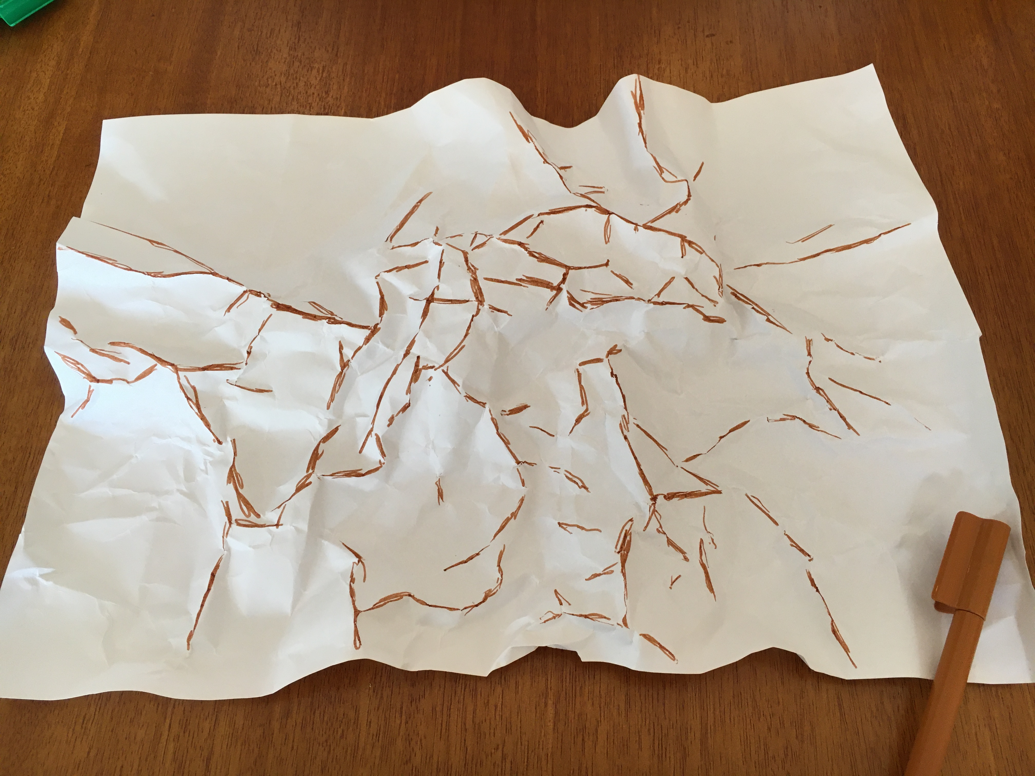 | 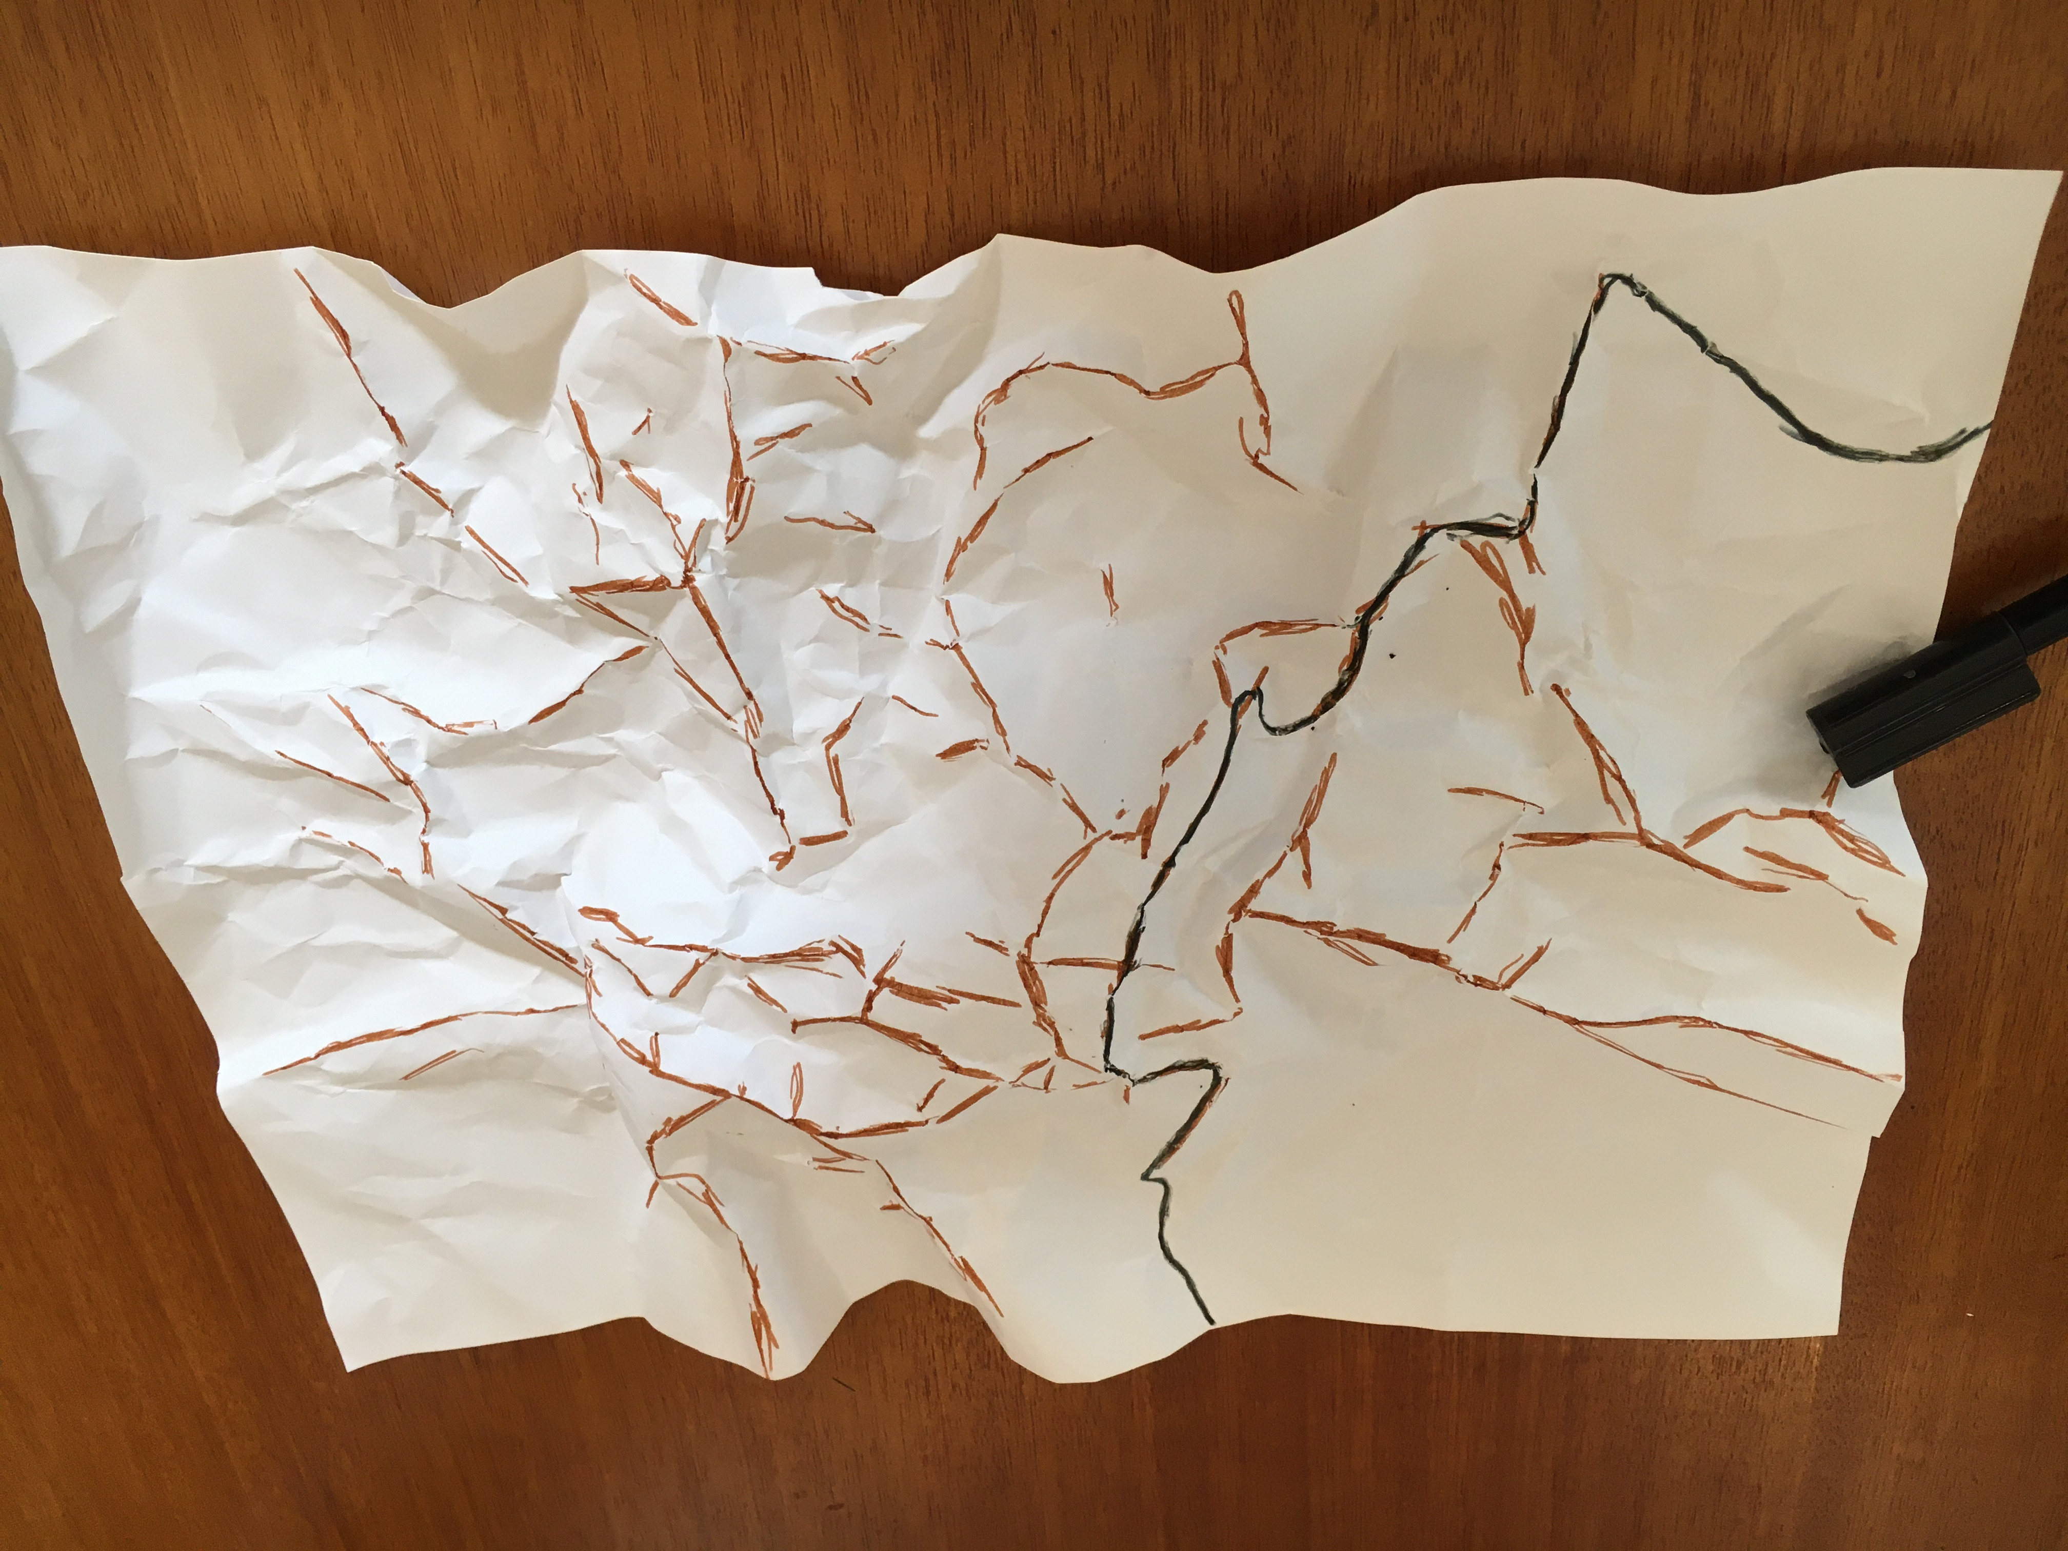 | 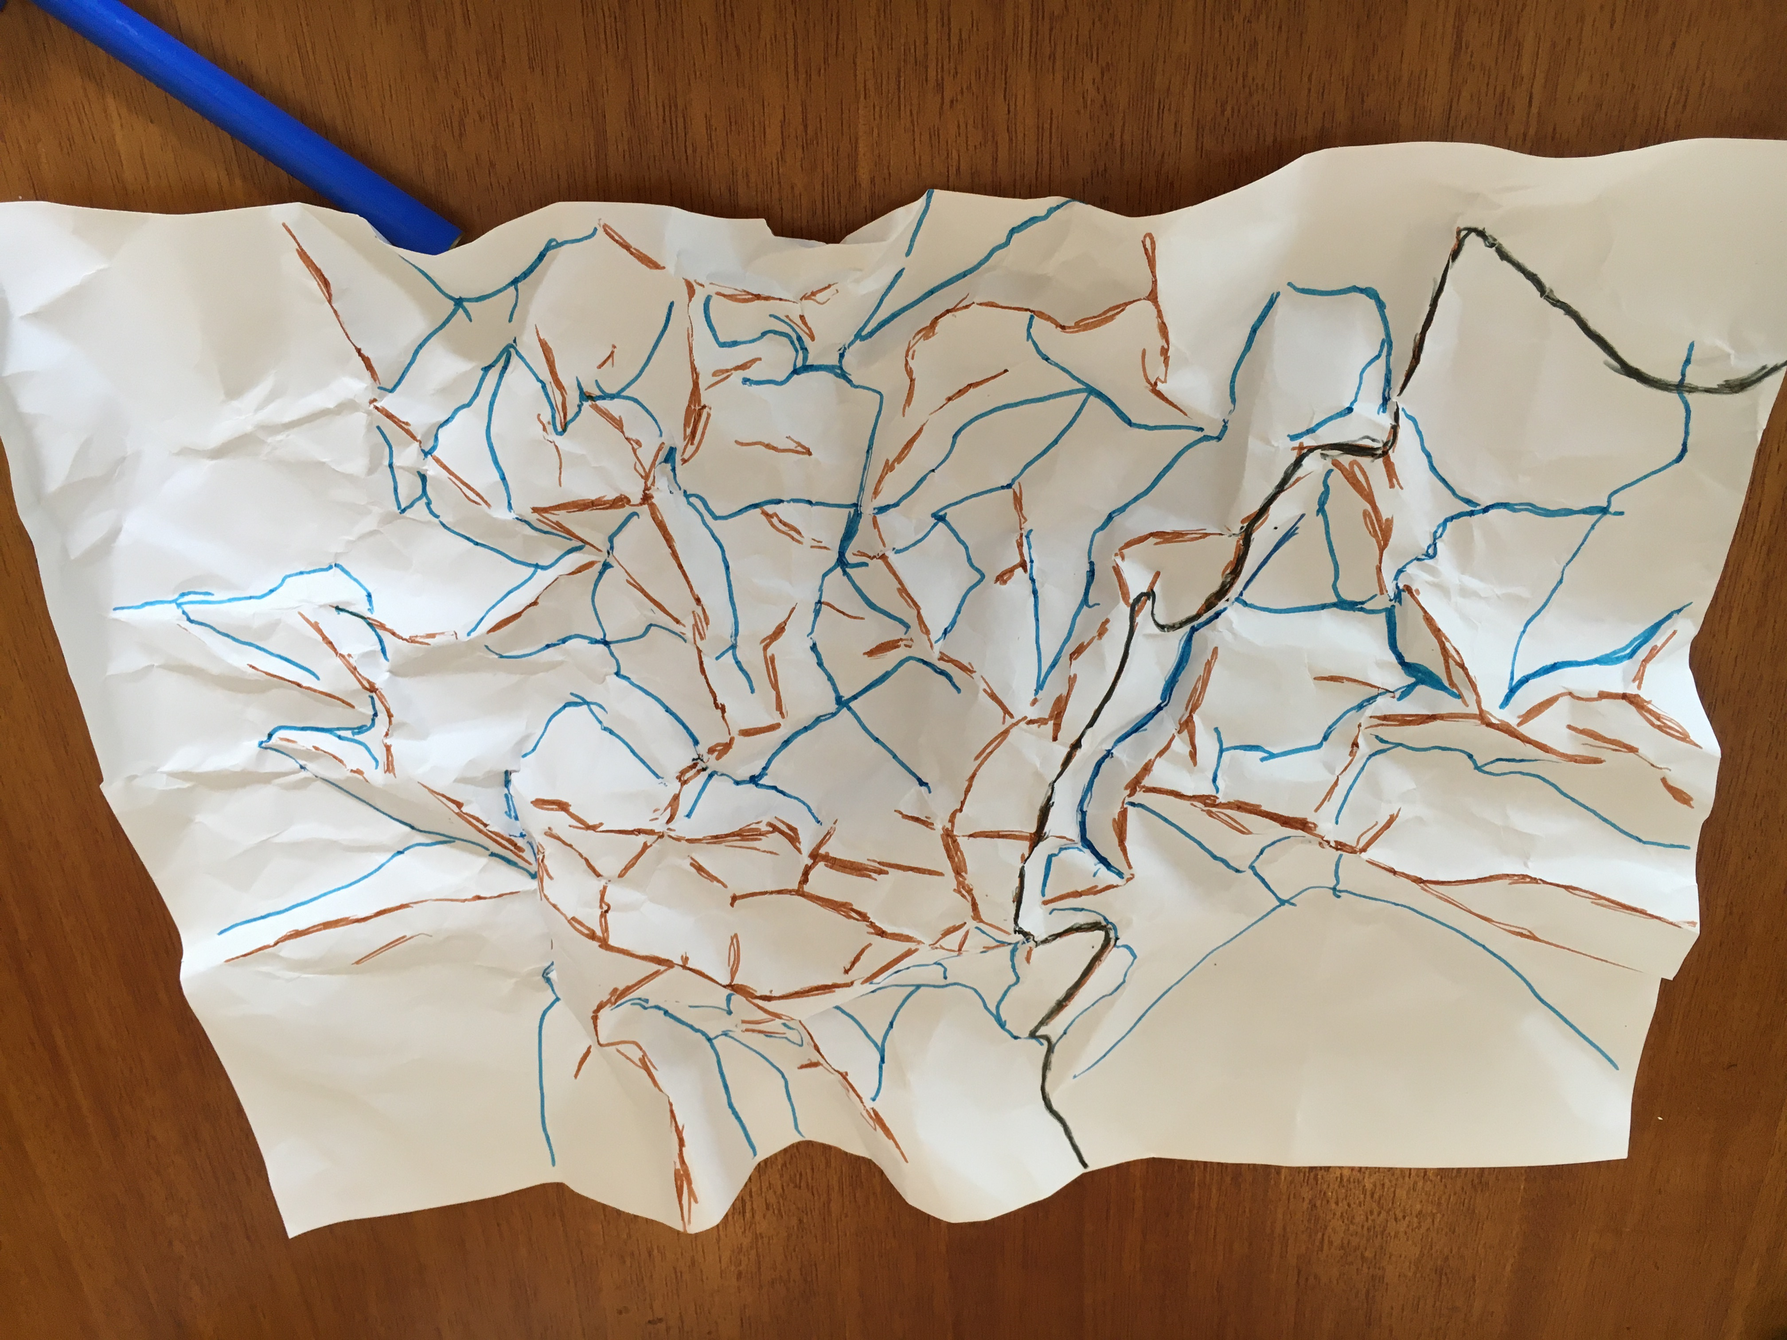 | 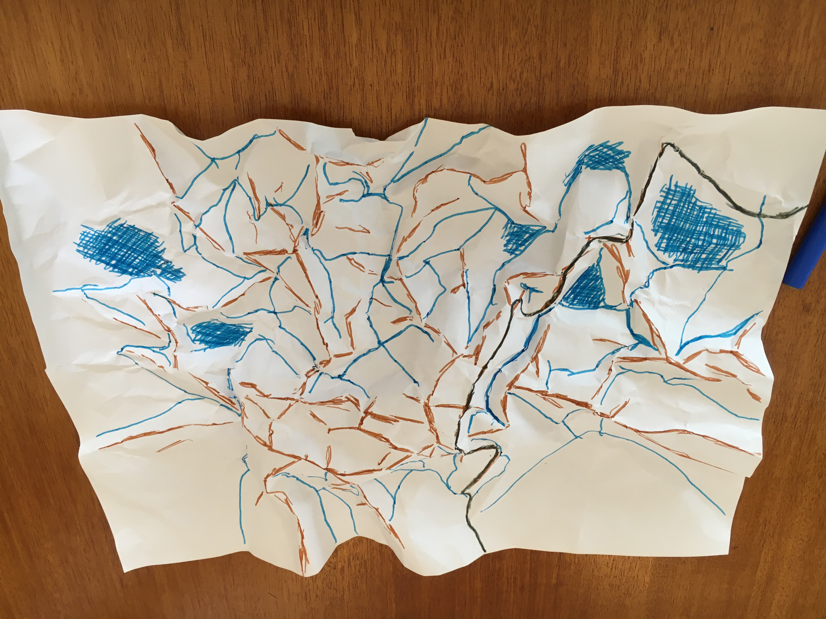
Use a brown marker or watercolour paint to colour along the tops of all the ridges. | Use black to draw in one or two roads from the plains and across the mountains along the ridges. | Use blue to draw water courses in the creases (valleys). | Predict where you think the water will flow to and pool if it ‘rains’. Colour those areas blue. | Spray the catchment with water to represent rain. Observe the flow and pooling of the water.

RESULTS | EXPLANATIONS
Draw and label a diagram to describe water movement. Hint: use an aerial view. | Draw a diagram to explain the colour of the pooled water in the lowest lying areas. Hint: use an eye-level view.
Compare the results to your prediction and account for any differences. | Outline what the model helped you understand about catchments and water movement.

Worksheet 2 – Interconnections in the Hawkesbury-Nepean

Instructions
- View the NSW SES YouTube video Why Hawkesbury-Nepean Floods Are So Dangerous (2:30min) https://youtu.be/28SN9KixO2I and Graphic 1 – Hawkesbury-Nepean Valley Landscape.
- Outline the effects of each natural feature on the behaviour of floodwaters in the Hawkesbury-Nepean Valley.
NATURAL FEATURE | EFFECTS ON FLOODING OF PLACES IN THE VALLEY
Catchment area – mountains, waterways
Rivers and tributaries flowing into the Hawkesbury-Nepean Valley – Warragamba River, Nepean River, Grose River, South and Eastern Creeks, other tributaries
Narrow valley at Wallacia
Naturally high riverbanks at Penrith
Low lying areas south of Penrith
Narrow sandstone gorges between Sackville and Brooklyn
Flat, wide floodplain at Richmond / Windsor

Word bank
Flood, tributary, natural chokepoint, bathtub effect, confined, floodplain, riverbanks, flood, extreme, downstream.

Graphic 1 – Hawkesbury-Nepean Valley Landscape
Most river valleys tend to widen as they approach the sea. This is not the case for the Hawkesbury-Nepean River. Narrow sandstone gorges between Sackville and Brooklyn create natural chokepoints. The floodwaters from the five major tributaries back up and rise rapidly, causing deep and widespread flooding across the floodplain. It is much like a bathtub with five taps turned on, but only one plughole to let the water out.
Sources: Graphic – Hawkesbury-Nepean Flood Study July 2019 Overview, p7 http://www.infrastructure.nsw.gov.au/media/2162/ec_insw_hawkesbury-nepean_fss-document_web.pdf
Quote – Flooding in the Hawkesbury-Nepean Valley factsheet, Infrastructure NSW, http://www.infrastructure.nsw.gov.au/media/1525/hnvflooding_factsheet_feb2018.pdf

