Learning Sequence 2 – Effects of Flooding on People and Places

Outcomes
- GE1-1 describes features of places and the connections people have with places
- GE1-3 communicates geographical information and uses geographical tools for inquiry

Inquiry questions
- How does flooding change places?
- How does flooding affect people and their connections to places?
- Who works with the community to prepare for flooding and during a flood?

Learning intention

We are learning to describe connections between people, places and natural events.

Geographical tools
- VISUAL REPRESENTATIONS – picture books, role play, videos, drawings, graphic organisers
- SPATIAL TECHNOLOGIES – interactive aerial photographs https://www.ses.nsw.gov.au/hawkesbury-nepean-floods

Introduction
Floods can be very dangerous to people and damaging to places. Images of past flood events can be used to build people’s understanding of the impacts of flooding and the risk to individuals and their families. Organisations and communities can also learn lessons from past floods and improve their readiness for, response to and recovery from flooding.
The teaching and learning activities in Learning Sequence 2 develop students’ understanding of the effects of flooding on places, the impacts of floods on the people who have connections to those places and the role of the NSW State Emergency Service (NSW SES) before, during and after a flood event. People’s connections include working, living, going to school, visiting or travelling within places that may flood. The learning sequence uses narrative, photographs, interactive aerial imagery, games and pictorial maps to build geographical skills and understanding.
Note – some students may have had experiences of different types of flooding. Be sensitive to the impacts and trauma this may have caused for individuals and families.

Background notes for teachers
Refer to:
- Story Maps – learn from past flood events https://www.ses.nsw.gov.au/resources-folder/story-maps/
- Explainer: What is a Flood? Bureau of Meteorology http://media.bom.gov.au/social/blog/2156/explainer-what-is-a-flood/
- Geography K-10 Syllabus © 2015 NSW Education Standards Authority (NESA) for and on behalf of the Crown in right of the State of New South Wales https://educationstandards.nsw.edu.au/wps/portal/nesa/k-10/learning-areas/hsie/geography-k-10

Activity 2.1 – Elmer and the Flood
Time required: 30 minutes

Acquiring geographical information
- Pose the question: How does flooding change places?
- Share the picture book Elmer and the Flood by David McKee with the students. (There are readings on YouTube if the text isn’t available.)
- Make connections: text-to-text, text-to-self, text-to-world.
- Recall the changes to the environment caused by floodwater. Note the debris floating in the water and the high places not affected by floodwaters.
- Add words to the word wall created in Learning Sequence 1: torrential rain, flooded, debris, island, floating, floodwater.
- Students ‘step into the story’. In role as one of the animals who had been sheltering from the rain, they enact leaving the cave and ‘turn and talk’ to a partner to state something that had changed due to the flood.
- Discuss the impacts of the floodwaters on the elephants and other animals. How did the young elephant get stuck on an island? Is it usually an island? Why was Elmer happy to stay on the island?

Terminology
- Shelter, torrential rain, river, debris, floating, island, rescue. floodwater.

Picture book
- Elmer and the Flood by David McKee, Anderson Press, UK, 2015

Notes to parents/carers for use at home
Elmer and the Flood is on YouTube. If your child completed the word wall previously they may like to add new words to it. If not, they can begin one now. If you have a dress-up box, it can be a fun way for your child to express their thoughts about the impact of the flood on the animals (it can be as simple as a headband, t-shirt or socks.)

Activity 2.2 – Impacts of Floods on People and Places
Time required: 30 minutes

Acquiring and processing geographical information
- Pose the questions: How does flooding affect places and people’s connections to places? How can we find out?
- Students view before and after aerial photographs of the Brisbane floods on the ABC News page https://www.abc.net.au/news/specials/qld-floods/ Explain this is a “bird’s eye view” – photographs taken from above looking down. Students work in pairs using computers or devices and move the slider to view the images taken before and after flooding.
- Encourage talk among students about their observations and reactions. Listen to students’ conversations and note points raised, fears, concerns and misconceptions worthy of whole class discussion.
- Create a mind map or consequences chart of the observed impacts of flooding on places, such as roads covered, houses and shops submerged, and paddocks and playgrounds under water. Add the inferred impacts to people, for example, can’t get home, can’t go to places, need to move pets and animals, need to go to safer places. Refer to water quality: “Why is the water brown?” Refer to safety: “Would it be safe to swim or surf in the water? Would it be safe to drive through it?”
- Students complete Worksheet 2 – Flooding Consequences Chart.

Terminology
- Road, house, school, paddock, animals, people, park, playground, fences, bridge, submerged, dangerous, unsafe.

Teaching tools
- Access to computers or iPads to view photographs
- Worksheet 2 – one copy per student

Notes to parents/carers for use at home
You may need to explain the concept of the bird’s eye view in the aerial photographs.
You can talk with your child about the impacts of flooding to help them complete the worksheet.

Activity 2.3 – NSW SES and Floods
Time required: 20 minutes
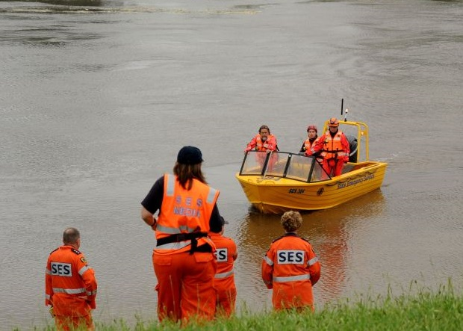
NSW State Emergency Service (NSW SES) volunteers assist the community in flood and storm emergencies. Image: NSW SES

Acquiring and processing geographical information
- Pose the question: Who works with the community to prepare for flooding and during a flood? What can you and your family do to be prepared?
- View the YouTube video NSW SES Storm and Flood Volunteers (1:05min) https://www.youtube.com/watch?v=uxRNPd6Ar0w
- Make connections: text-to-text, text-to-self, text-to-world.
- View other NSW SES YouTube videos such as Community Action Team – Deb Bewick (1:33min) https://www.youtube.com/watch?v=-9F3Fx270lQ Browse the videos of volunteers linked to the page Volunteer with NSW SES https://www.ses.nsw.gov.au/get-involved/volunteer/
- Recall and clarify the roles and jobs of NSW SES volunteers shown in the videos.
- Students create ‘freeze frames’ of the actions, jobs and roles undertaken by NSW SES volunteers. Use outdoor spaces for authenticity.
- Students complete Worksheet 3 – NSW SES and the community

Terminology
- State Emergency Service, SES, volunteer, community.

Background notes

Volunteer with NSW SES https://www.ses.nsw.gov.au/get-involved/volunteer/

Teaching tools:
- Access to computer or smart TV to watch videos
- Worksheet 3 – one copy for each student

Notes to parents/carers for use at home
Watch the YouTube video with your child and talk to them about the role of NSW SES volunteers. You could ask them whether they have seen them at work, why they might wear orange clothing, in what other sorts of emergencies they might help people. Help your child complete the worksheet.

Worksheet 2 – Flooding Consequences Chart
Name ____________________________

Instructions
- In the first column write or draw how places change when they are flooded.
- In the second column write or draw how this affects people’s lives.
How does flooding change these places? | How might this affect people’s lives?
Roads
Houses
Sports fields and parks
Farmland

Worksheet 3 – NSW SES and the Community
Name ____________________________

Instructions
- Draw pictures of NSW SES volunteers working with people before, during and after a flooding event.
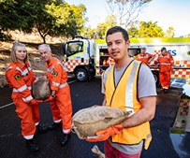
- Colour the uniforms of the NSW SES volunteers orange.
During flooding
During flooding
NSW SES volunteers carry sandbags to prepare for a flood
Before flooding
After flooding or a storm

