Learning Sequence 1 – Rainwater and Floods

Outcomes
- GE1-1 describes features of places and the connections people have with places
- GE1-3 communicates geographical information and uses geographical tools for inquiry

Inquiry questions
- What is a rainstorm?
- What happens during and after a rainstorm?
- Where does the rainwater go?
- Where does the rainwater go at school?
- What is a flood and what causes flooding?
- What natural signs warn us of flooding?

Learning intention
We are learning to name and describe features of places and to make inquiries using geographical tools.

Geographical tools
- VISUAL REPRESENTATIONS – picture books, 3D modelling, diagrams, images, table
- MAPS – locations on map of Australia
- FIELDWORK – school grounds

Introduction
Flooding is a natural process that brings life to river ecosystems but can also bring devastating damage and loss to places where people live, work and visit. All rivers in NSW flood from time to time. The Hawkesbury-Nepean Valley is an area prone to flooding. It has always flooded and will continue to flood. To understand the effects and impacts of flooding on places and people, students need to develop conceptual understandings of floods and flooding.
The teaching and learning activities in Learning Sequence 1 develop students’ understanding of the causes of floods and key terminology relating to flooding. The learning sequence uses narrative, manipulative play, 3D modelling and school-based fieldwork to build understanding.

Background notes for teachers
Refer to:
- Bureau of Meteorology Explainer: What is a Flood? http://media.bom.gov.au/social/blog/2156/explainer-what-is-a-flood/
- NSW SES factsheet Knowing the signs https://www.ses.nsw.gov.au/media/3233/knowing-the-signs-of-flooding-fact-sheet.pdf
- Geography K-10 Syllabus © 2015 NSW Education Standards Authority (NESA) for and on behalf of the Crown in right of the State of New South Wales https://educationstandards.nsw.edu.au/wps/portal/nesa/k-10/learning-areas/hsie/geography-k-10

Activity 1.1 – Big Fella Rain
Time required: 30-40 minutes.
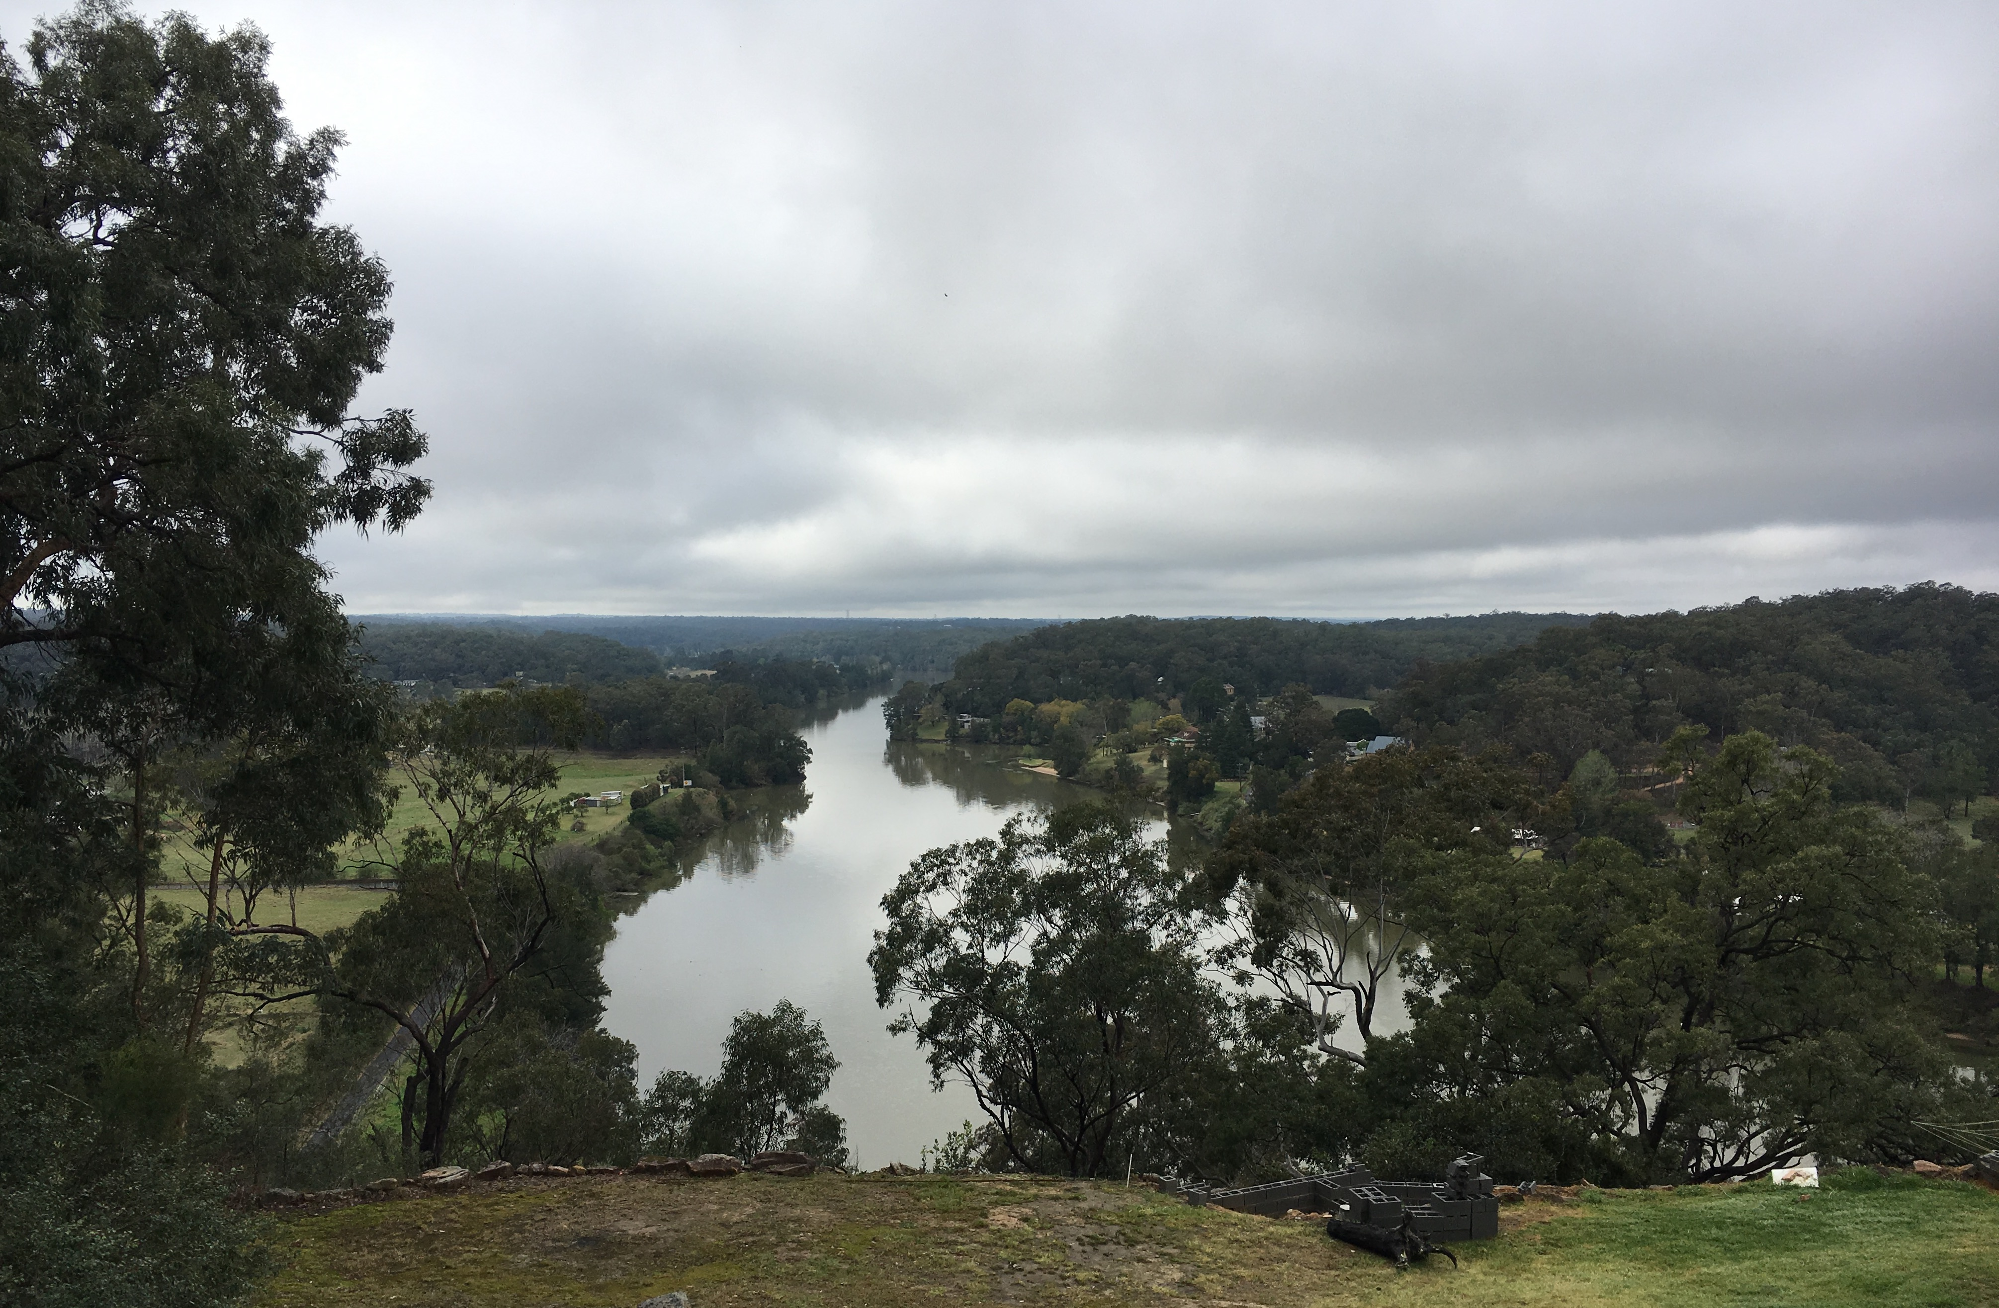
Clouds over the Hawkesbury River at Sackville North; Image: Western Sydney University, 2019

Acquiring geographical information
- Pose the questions: What is a rainstorm? What happens during and after a rainstorm? (3-5 minutes)
- Share the picture book: Big Fella Rain by Beryl Webber and Fern Martins. (Alternate or additional text: Big Rain Coming by Katrina Garmin and Bronwyn Bancroft.) (10 minutes)
- Make connections: text-to-text, text-to-self, text-to-world. (3 minutes)
- Recall the sequence of natural signs and natural events in the text: lightning to heavy rainstorm to rising rivers to flooded land. (3 minutes)
- Create a word wall of nouns relating to weather and landforms. Refer to the terminology below. (5 minutes)
- View the photograph of the Hawkesbury-Nepean Valley. Locate it and the Top End using a map of Australia. Explain that Big Fella Rain is set in Australia’s Top End and that the plants and animals rely on flooding for survival. (3 minutes)
- Explain that the Hawkesbury-Nepean Valley also floods and because people live, work and visit there the floodwaters can cause challenges for people. There are also many other places in NSW that flood. Discuss places that may flood near school. (5 minutes)

Terminology
- Storm, lightning, clouds, thunder, raindrops, puddle, pool, stream, creek, billabong, wind, river, waterfall, flood, floodwater, valley, run-off, Hawkesbury-Nepean Valley.

Picture Books
- Big Fella Rain by Beryl Webber (author) and Fern Martins (illustrator), Magabala Books, Australia, 2017
- Big Rain Coming by Katrina Garmin (author) and Bronwyn Bancroft (illustrator), Penguin Australia, 2002

Teaching Tools
- Butchers paper or similar for word wall
- Map of Australia (or Google maps)
- Copy of photograph of Hawkesbury-Nepean Valley

Note to parents/carers for use at home
There are readings of both these books available on YouTube. You can create a wordwall on a whiteboard, chalkboard or simply on a sheet of paper. Your child may like to put the wordwall in an exercise book to keep for future reference.

Activity 1.2 – Rainwater at School
Time required: 20 minutes

Acquiring geographical information
- Pose the questions: Where does rainwater go? Where does rainwater go at school? How can we find out where it goes? Explain that when it rains some water will soak into the ground, some will run off across the land into creeks and rivers, and some will run across hard surfaces (such as roofs, buildings, streets and playgrounds) into stormwater drains. Many stormwater drains discharge into creeks and rivers.
- Take the students outside to investigate the flow, collection and drainage points of rainwater in the school grounds. Select sites with slopes, ditches and drains.
- Replicate rainfall using watering cans, cups or buckets of water. Students observe the flow, pooling and exit of the water. Ensure students understand that water pools and fills the lowest areas first. Alternatively, this activity can be completed following a rainstorm. Students can observe where the rain has collected and pooled, and where it drains away. Leaf litter is often a good guide after a rain storm.
- Students predict what would happen if it kept raining and the water couldn’t drain away.

Terminology
- Rainwater, run-off, flow, drain, puddle, blocked, empty, fill, full, stormwater drains, pooling.

Teaching tools
- Watering cans, cups or buckets

Notes to parents/carers for use at home
This activity can easily be completed at home in the garden using a watering can, bucket or strainer (this makes a very good rain shower). Your child may like to create a “landscape” with hills and valleys in a garden bed or sand pit and watch what happens when rain falls on it. On a walk around your local neighbourhood your child can locate stormwater drains. Going for a walk around after rain will be a great demonstration of where rainwater pools and where it flows.

Activity 1.3 – Full, Overflowing, Flooded
Time required: 30 minutes

Acquiring geographical information
- Pose the questions: What is a flood? What causes flooding? How can we find out about flooding?
- Use water trays, tote trays or the school’s sandpit for students to undertake water play to investigate what happens when water can’t get away.
- Place plastic containers into the trays to represent rivers, ponds and pools. Rocks and other objects could represent buildings and landforms.
- Students pour ‘rain’ into the small plastic containers so that they fill, overflow and flood the tray.
- Students verbally recount the effects of continuous ‘rain’. They draw and label diagrams that illustrate the terms ‘full’, ‘overflowing’ and ‘flood’.

Terminology
- Rain, full, overflow, overflowing, flood, flooded, floodwater.

Teaching tools
- Water trays or tote trays
- Small plastic containers such as take away food containers, empty yoghurt pots etc
- Small stones and/or rocks to represent buildings
- Small containers for pouring water
- Plastic cloths to protect tables and desks

Notes to parents/carers for use at home
You may like to do this activity outside in the garden, or in the laundry or bathroom. A large shallow plastic container makes a great substitute for a tote tray, with smaller containers such as empty yoghurt pots and stones from the garden placed in it. Your child can use a jug or small watering can to pour “rain” into the containers until they flood and observe what happens.

Activity 1.4 – Know the Natural Signs
Time required: 30 minutes

Processing geographical information
- Pose the question: What natural signs warn us of flooding?
- Name the weather and environmental signs that preceded the storm in the picture books Big Fella Rain and Big Rain Coming. State that all people can use those natural signs as a warning of possible flooding.
- Recall the sequence of weather events and effects on the landscape in the picture book Big Fella Rain by Beryl Webber and Fern Martins.
- Students complete Worksheet 1 – Know the natural signs. (10 minutes)

Background notes
- NSW SES factsheet Knowing the signs https://www.ses.nsw.gov.au/media/3233/knowing-the-signs-of-flooding-fact-sheet.pdf
- Bureau of Meteorology Information for students and teachers http://www.bom.gov.au/climate/data-services/education.shtml
- Bureau of Meteorology Weather Words http://www.bom.gov.au/info/wwords/
- Big Fella Rain by Beryl Webber (author) and Fern Martins (illustrator), Magabala Books, Australia, 2017

Teaching tools
- Worksheet 1 – printed on card, one copy per student
- Coloured pencils, scissors

Notes to parents/carers for use at home
There are readings of both these books on YouTube.
Talk with your child about the signs they may have noticed before a storm – the build-up of dark clouds, a flash of lightning, the rumble of thunder.
If doing the worksheet, you can stick the picture onto cardboard to make it stronger. It is also possible to number the sentences and match to the corresponding picture without cutting out.

Worksheet 1 – Know the Natural Signs

Name ____________________________

Instructions
- Cut out the pictures and sentences.
- Sequence the pictures to show what can happen after a storm and heavy rain.
- Match the sentences to the pictures.

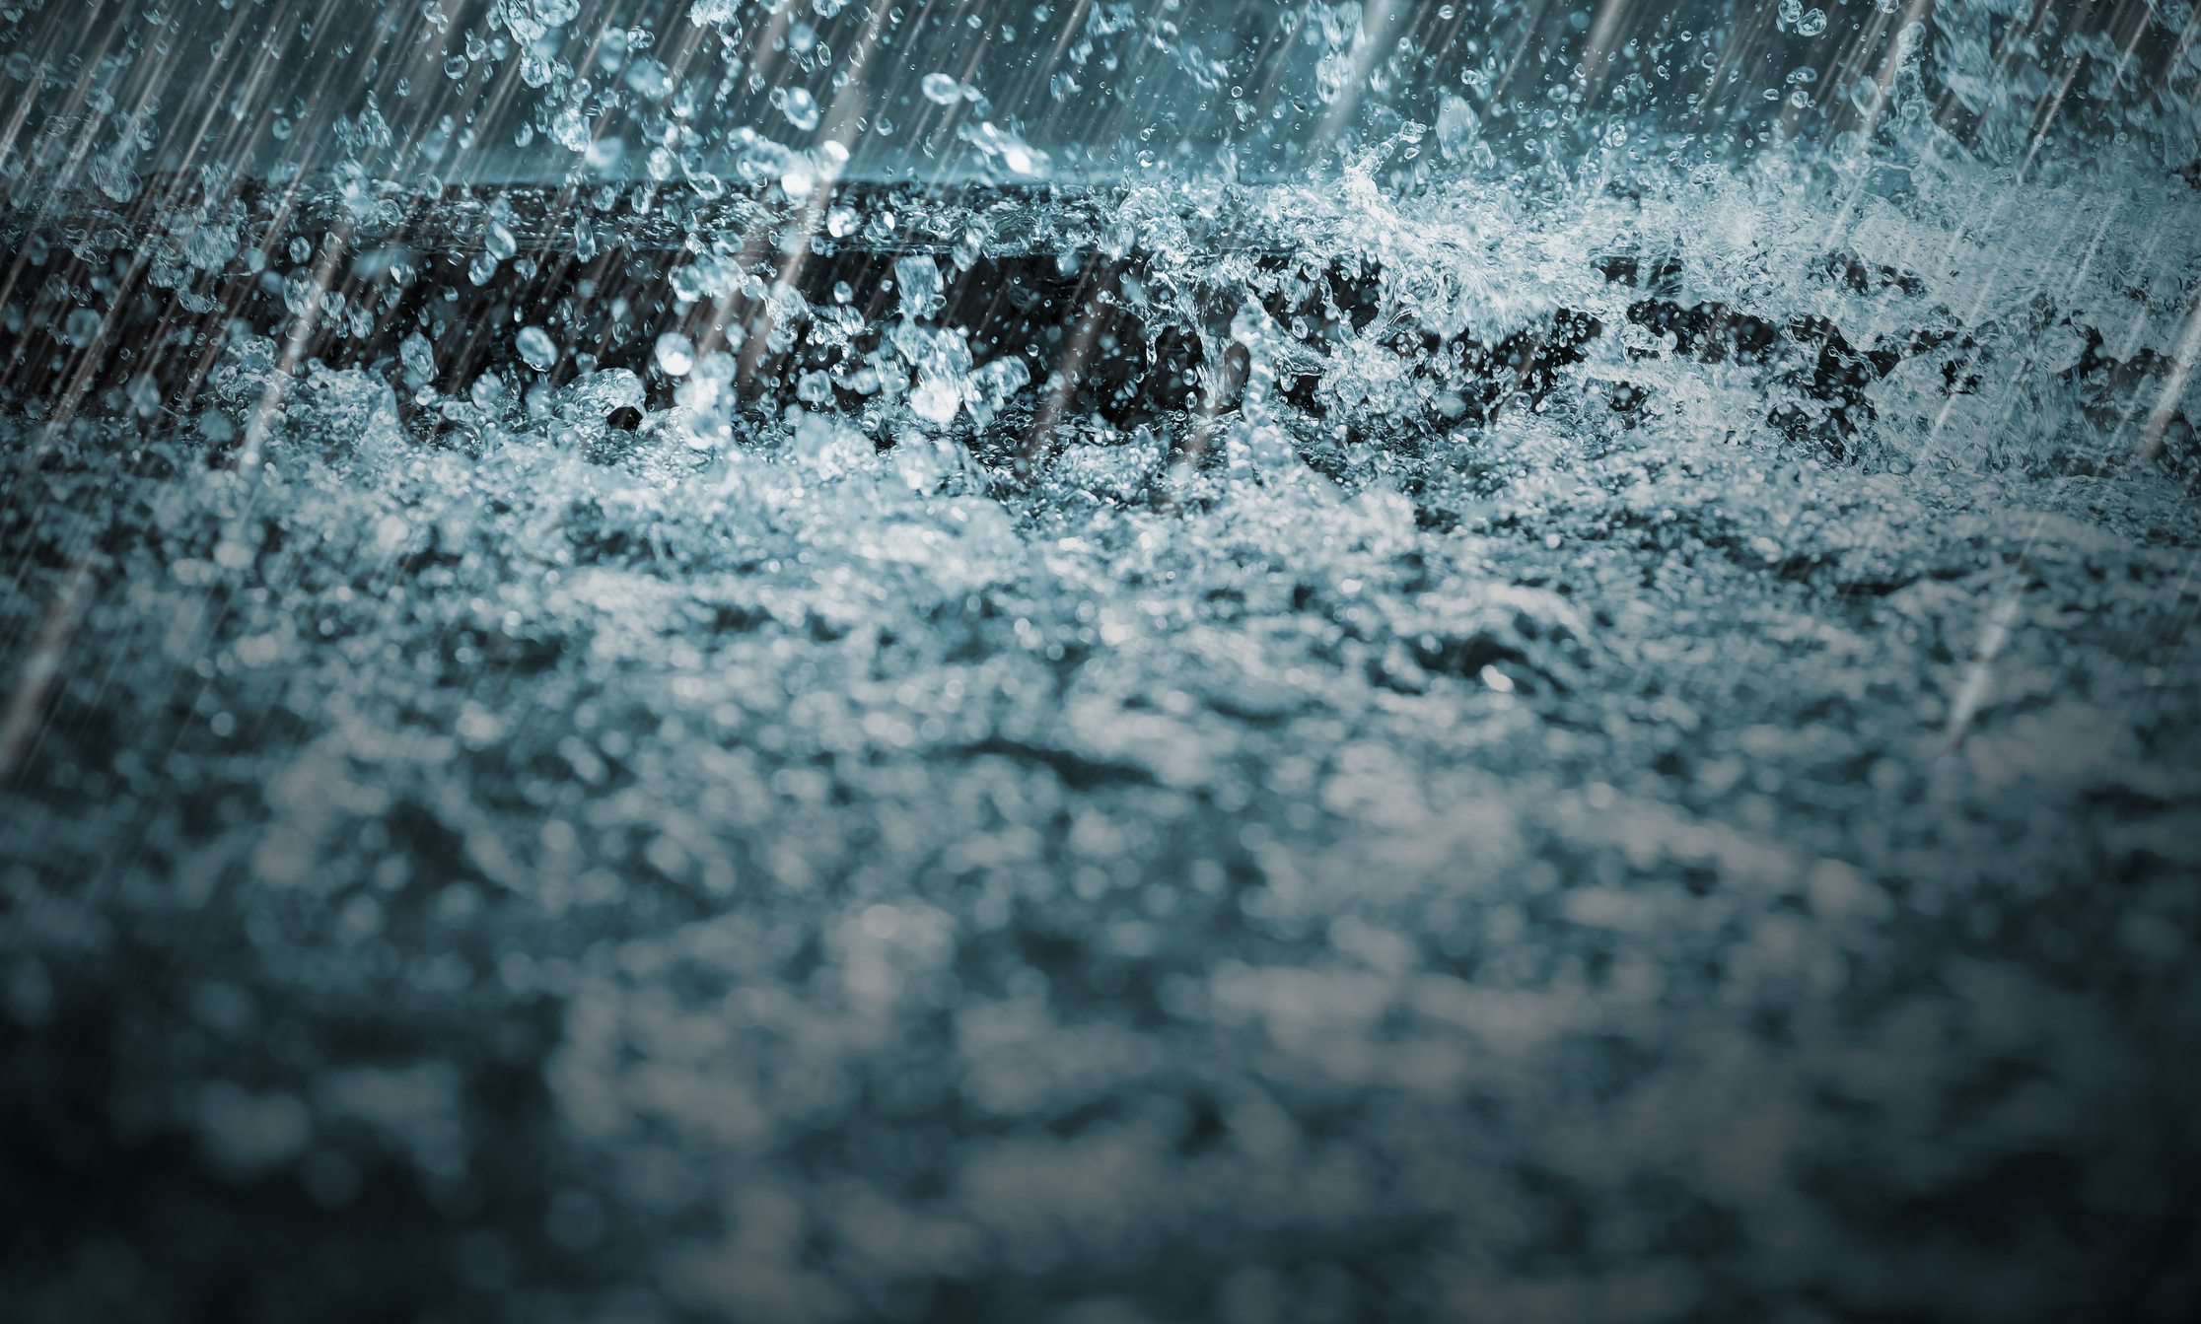 | 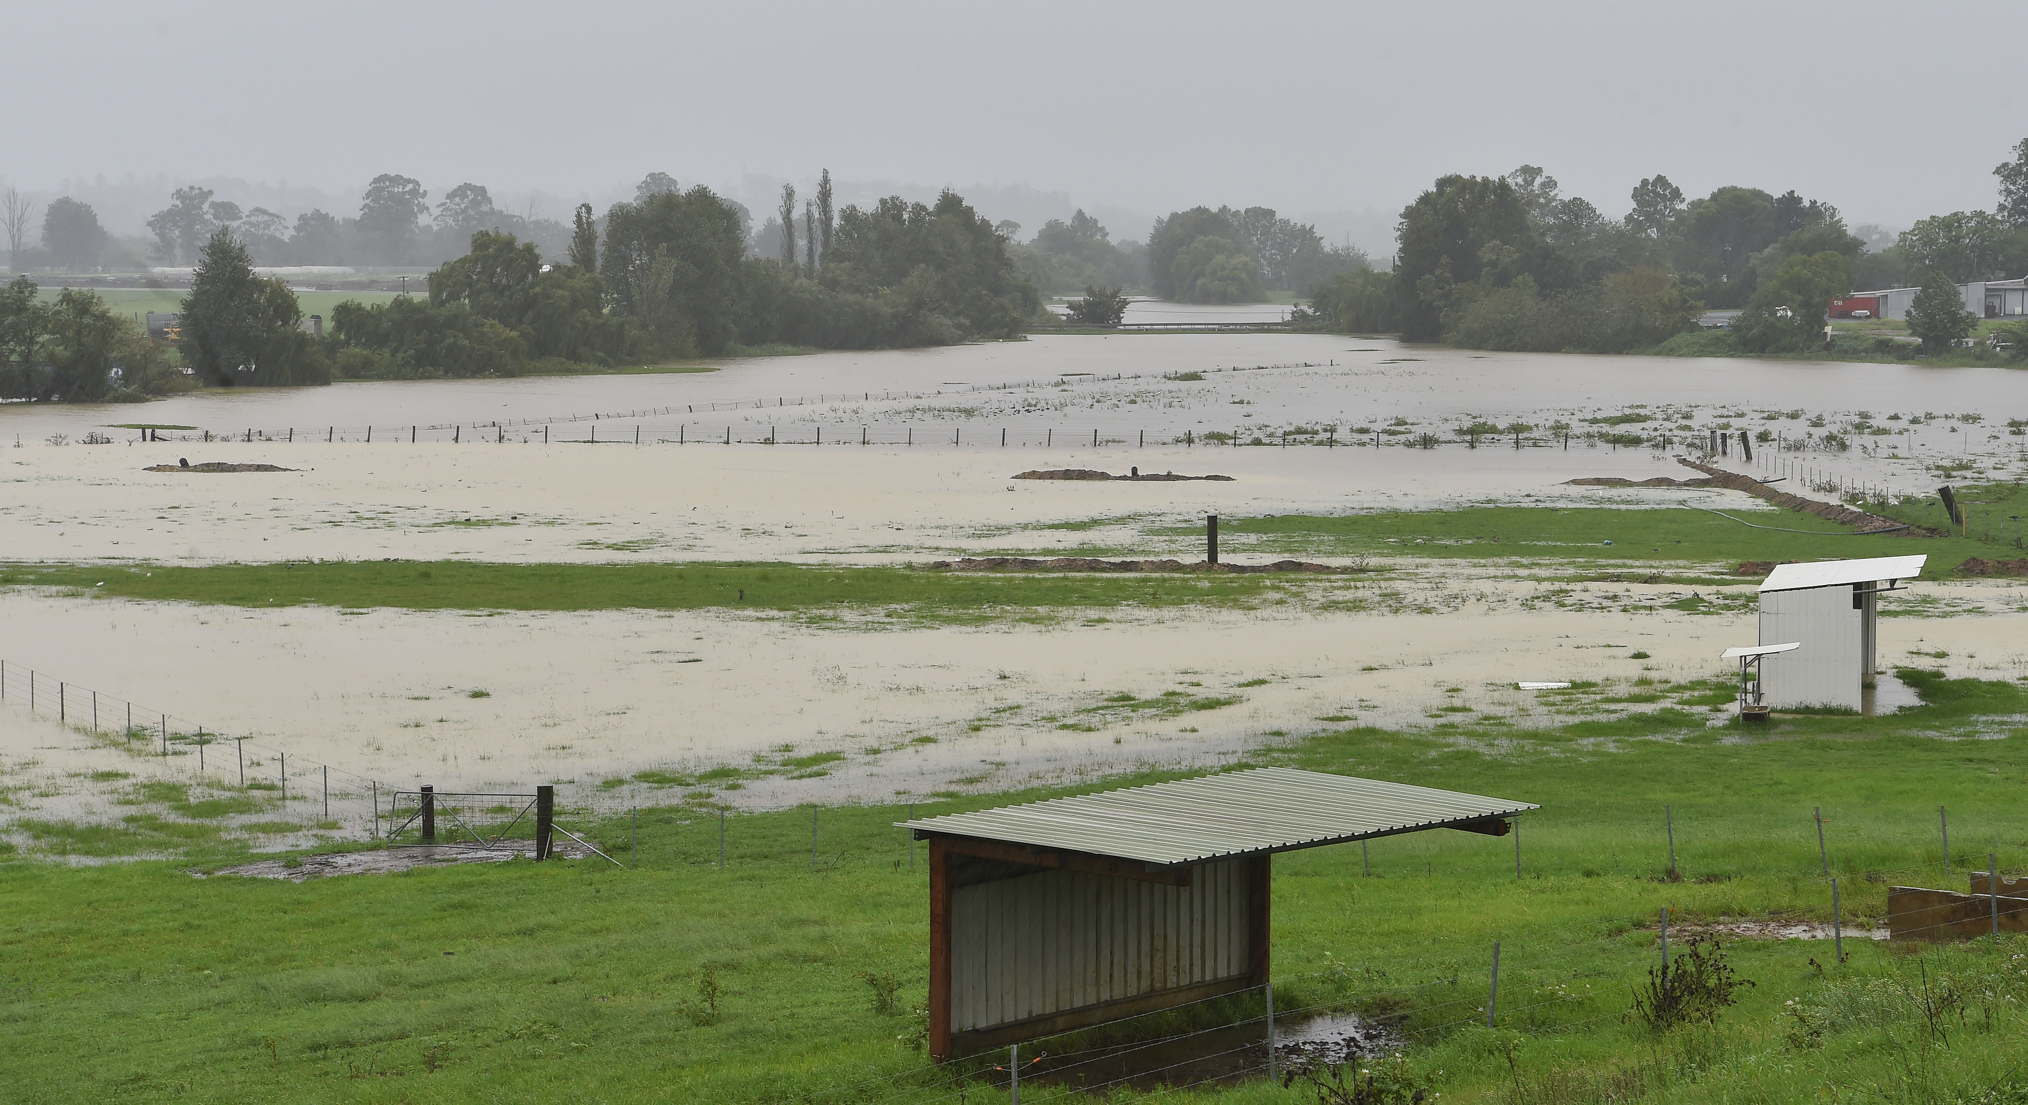
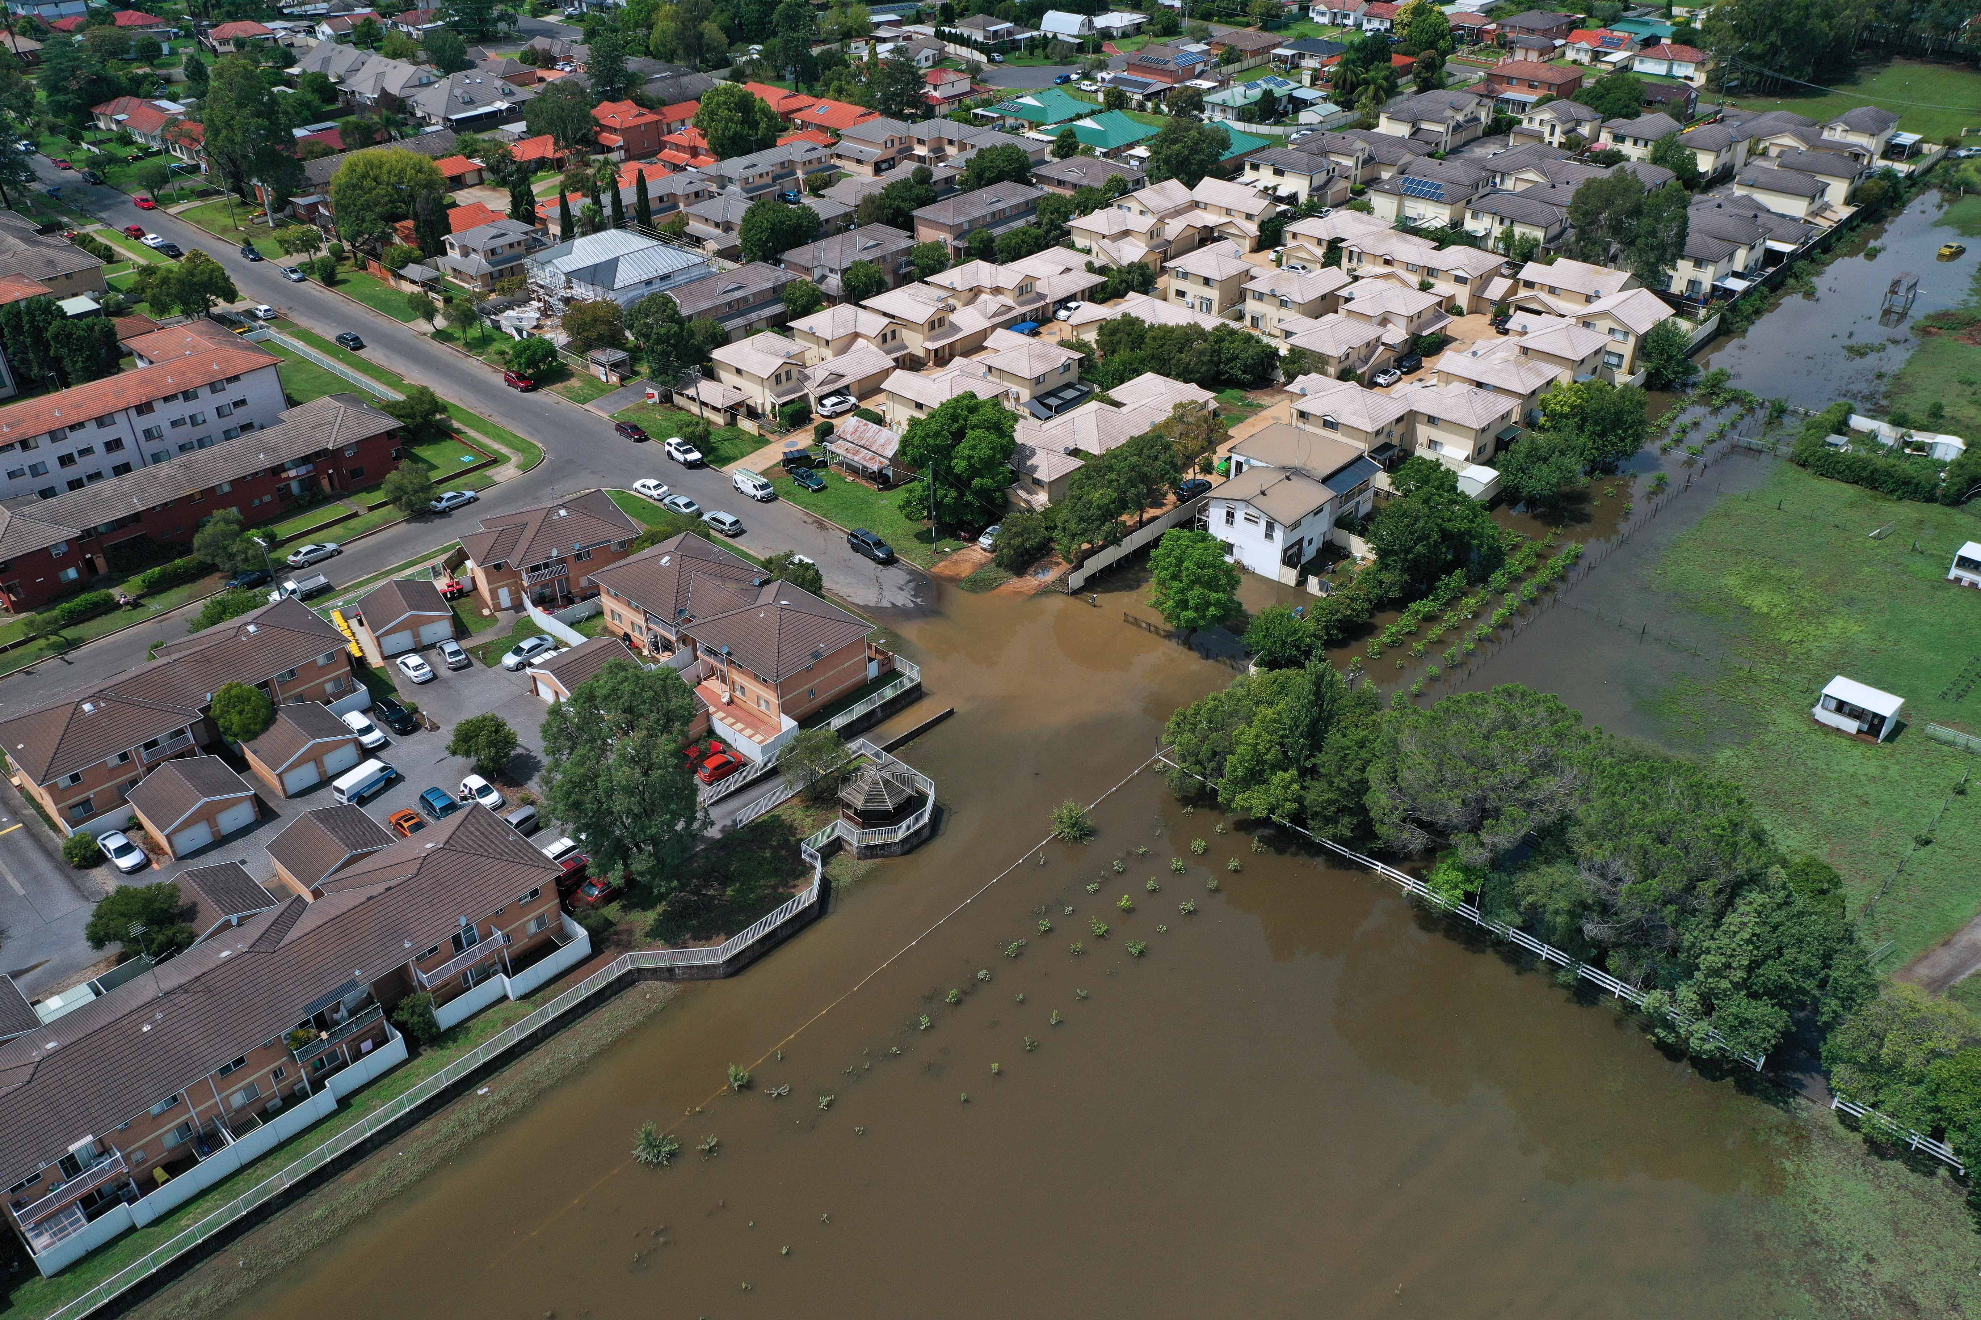 | 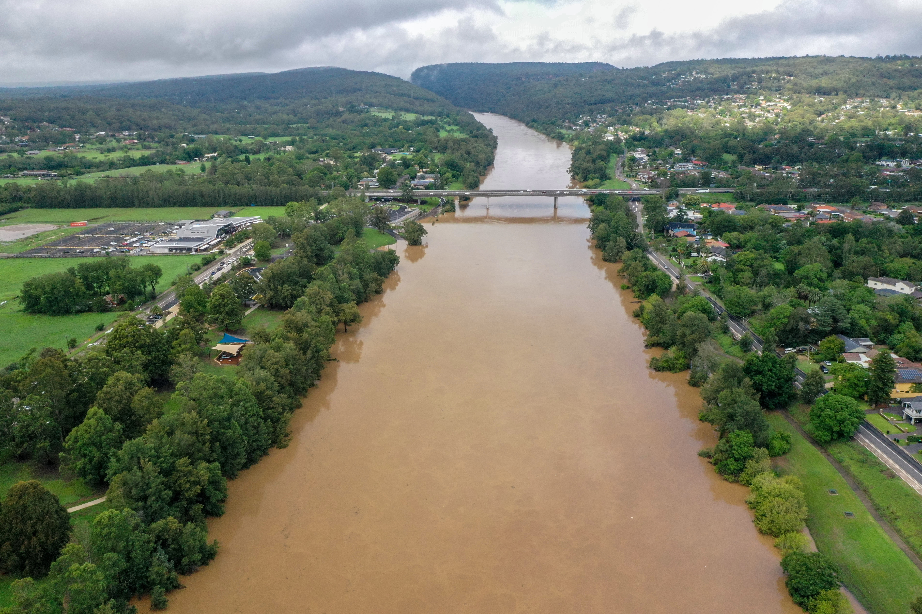
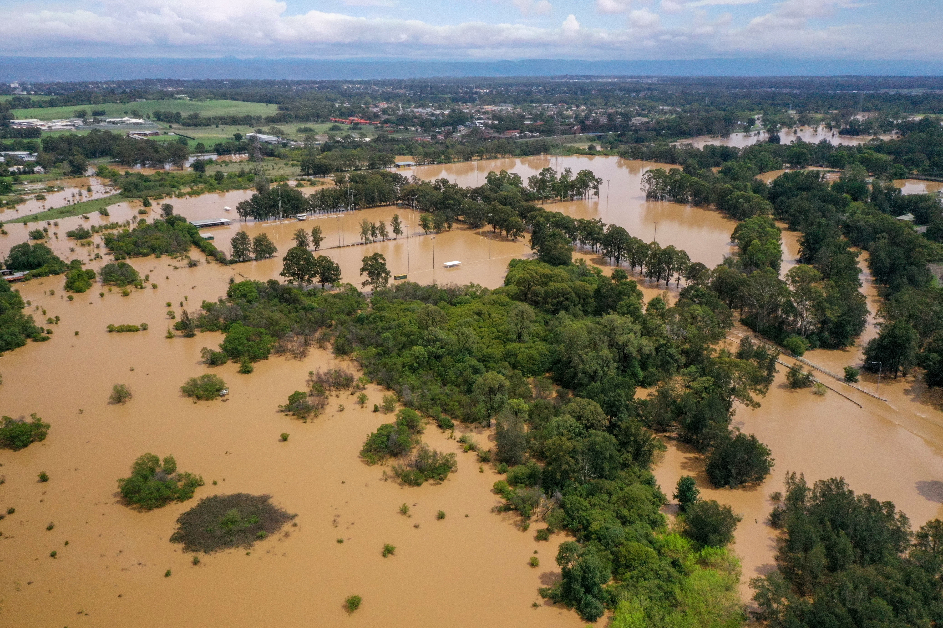 | 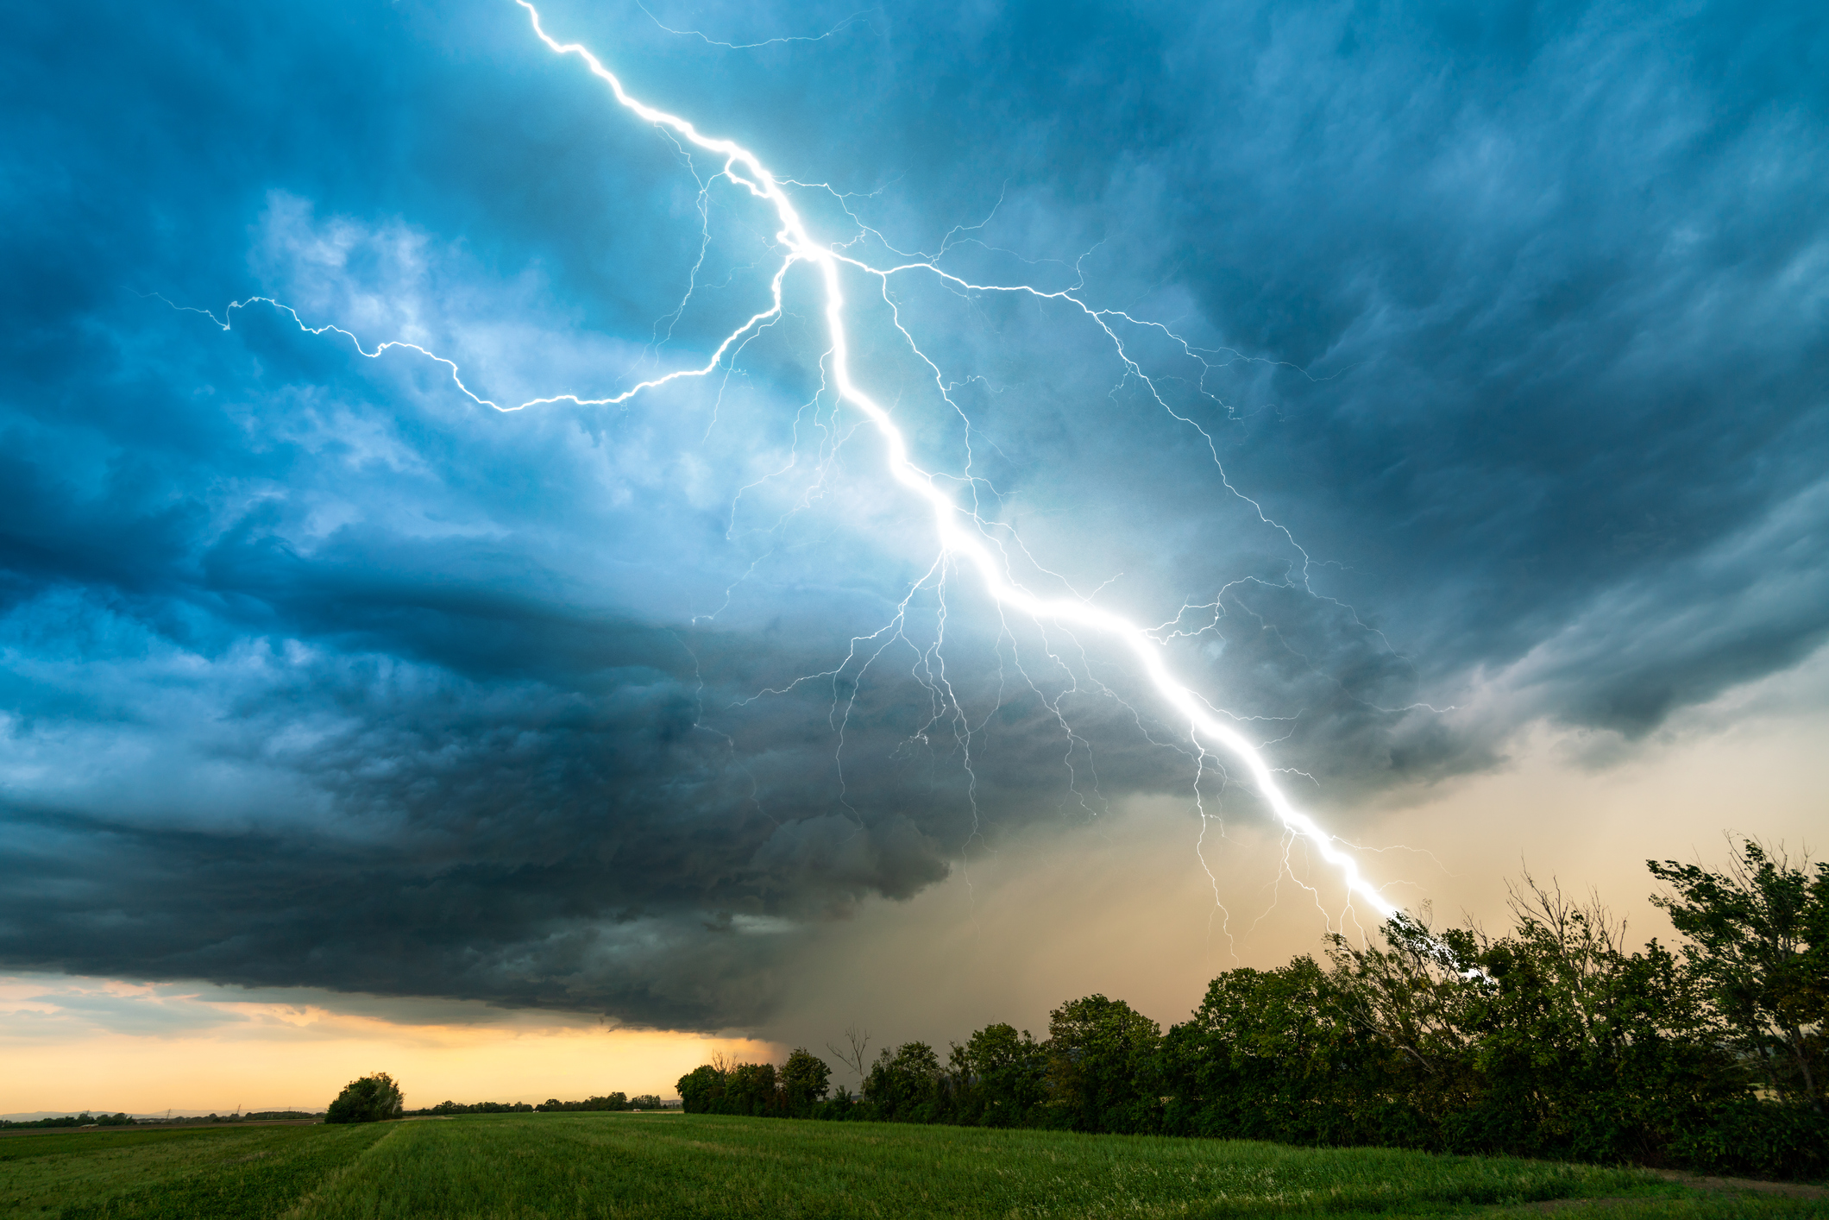
Thunder and lightning are signs that a storm is coming. |  | Heavy rain falling is a sign that there might be flooding.
Very full rivers might overflow onto the land. |  | Heavy rain fills up low areas of the ground.
Heavy rain fills up creeks and rivers. |  | When rainwater cannot get away some places might get flooded.

