Script 1: Georgie finds out about the weather and climate.
Inquiry Questions:
- How do we know about the weather, climate, precipitation and natural hazards?
- What is the Bureau of Meteorology?
- What data is collected about precipitation, wind, East Coast Lows, river heights, temperature and waves?
- What are some of the skills and tools that agencies such the Bureau of Meteorology use daily?

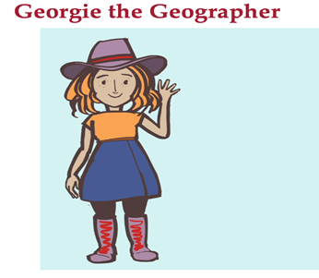
Hi!
I wonder sometimes who actually tracks the rain, water and weather around the globe? What a job it must be? Imagine understanding water around the whole world! across countries, oceans mountain ranges and all the places I hope to see one day when I travel?
Well…here in Australia we have the Bureau of Meteorology – they do the lot! They understand where and when the weather and water move about, it’s amazing!
Imagine being part of this global weather information and putting it together to be able to predict what will happen here in Australia…like air temperatures, winds and cloud movements all the information that gives us the daily weather…
Do you have a weather app on your phone?
I bet your parents do! Most of the weather information in Australia used by all different services and apps comes from the Bureau of Meteorology.

The Bureau keeps the weather and water data for Australia, and makes predictions or forecasts about the weather and climate. It is impossible to calculate everything about nature – but the Bureau uses the best and latest technology. And they work with other countries to share information.
They use thousands of weather stations around Australia to gather data - using Radar for weather systems, anemometers for wind speed, hydrological equipment like rain gauges for rainfall, and river gauges to measure river heights …and they can forecast flood levels too!
The Bureau keeps track of tide and wave buoys to give information about wave size and surf conditions, and help warn people of dangerous weather systems or phenomena.
It’s the Bureau that tracks water cross the country and gives Australians our water accounts,
Yep they know how much water is in river systems across the country plus they give us the early warning of any storms, floods, cyclones or a tsunami.
They do a pretty good and important job, and help tell us whether we should take an umbrella to school, an extra jumper, or if our sport is likely to be cancelled on the weekend.
Find out more about what the Bureau of Meteorology does.
I wonder if any of you will one day work for the Bureau of Meteorology?

